12. Architecture and Construction Cluster - Carpentry Careers (4 hours)
Purpose/Abstract: To introduce students to the different carpentry careers and the skills required within the Architecture and Construction cluster.
NCCCS Adult Education Standards: R.3.1.6, R.3.2.6, W.5.1.1, M.2.1.1
Learning Objective:
By the end of the session, students will be able to:
- Describe key skills required for carpentry
- Use graphic organizers to define new words
- Apply mathematical principles a to build a small carpentry project
Soft Skills | Teamwork  Problem solving and critical thinking | Resources | Skills to Pay the Bills (STPTB) (for instructor reference to define each soft skill category)  47-2031.00 - Carpenters  47-3012.00 - Helpers--Carpenters  Kara's Creative Place: Ruler Basket Folder Holder Teacher Gift (for instructor reference to understand the steps and to share the image of the finished product with the students)  NC Career Clusters Guide  Handouts:  - Reading Comprehension - 1 for each student  - Vocabulary Words - 1 for each student  - Indirect Measurements - 1 for each pair  - Carpentry Careers - 1 for each student
Additional Materials
- Reading comprehension handout, one for each student (print scaffolded version as required)
- Vocabulary words, one for each pair
- Indirect Measurements handout, one for each pair
- Carpentry careers handout, one for each student
- Materials for the carpentry project, one set for each group
  - Six 12-inch rulers
  - One 1x4 piece of wood that is 12 inches long
  - Two 1x4 pieces of wood that are 6 inches long
  - Wood glue (or nails if preferred)
  - Safety goggles
  - Hammer (if using nails)
- Optional, for the instructor: Drill and drill bit for pre-drilling nail holes if opting to use nails
- Supplies for measuring objects (blocks, erasers, rulers, notebooks, etc.)
- Art supplies (glue, glitter, markets, etc.)
- Pencils, paper
- Computers for student use
Icons | 💭 Activity ✔Check-In ⟲ Review

PREPARATION
- Reading comprehension handout, one for each student (print scaffolded version as required)
- Indirect measurement handout, one for each pair.
- Review the Instructional Support Guide and print/prepare referenced scaffolds.
- Print handouts.
- Familiarize yourself with the OneStop Career Clusters.
- Familiarize yourself with O*NET
- Familiarize yourself with Skills to Pay the Bills, though it won’t be used directly in this lesson.

INTRODUCTION (30 min)
Begin by welcoming the students to class!

Ask a few students to share what they remember from the previous lesson on construction careers.
Guide a short discussion about carpentry and its relevance in the architecture and construction cluster. Consider including the points below in the discussion:
- Within the architecture and construction cluster, carpentry plays a vital role in translating architectural designs into physical structures, ensuring structural integrity, and creating aesthetically pleasing finishes through the skillful use of wood and other materials.
- Carpentry involves the precise measurement, cutting, shaping, and assembly of wooden components used in building structures, such as houses, buildings, and bridges.
- Carpenters construct frameworks, install doors and windows, build staircases, and create intricate woodwork, enhancing the functionality and visual appeal of architectural projects.

Show students images of carpentry tools, construction projects, and carpenters at work.

Ask students what else they know about carpentry and what they think carpenters do. Encourage them to share their ideas and experiences.

Introduce the key skills required for carpentry by discussing the importance of manual dexterity, problem-solving abilities, attention to detail, and mathematical skills.
Discuss the soft skills of teamwork, problem-solving, and critical thinking and explain how they are relevant to a career in carpentry.

Instructor notes:
You can choose to either print out images of carpentry tools, projects, and carpenters or project them during the discussion.
VOCABULARY, READING, and WRITING (45 min)

Reading Comprehension
Pair up the students after distributing the reading comprehension worksheets. Give them 20 minutes to read the passage and answer the questions. Encourage students to read out paragraphs to each other to improve their reading skills.

Vocabulary
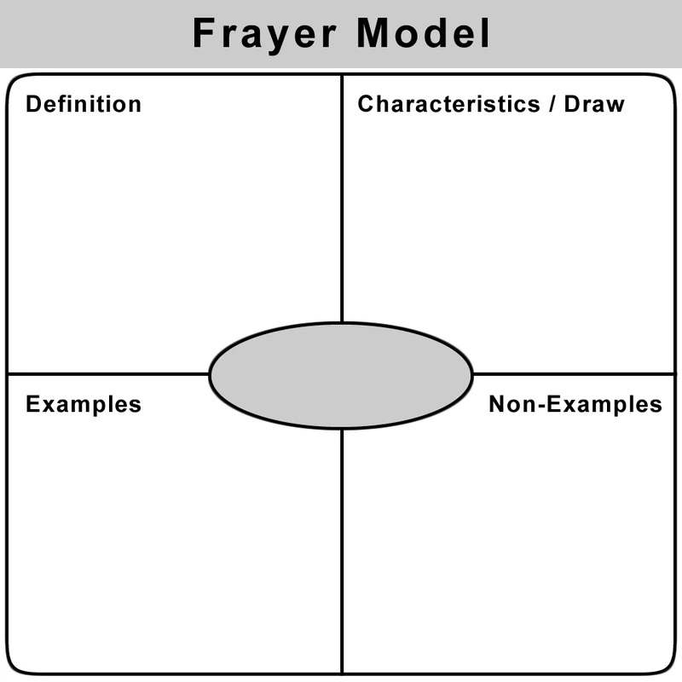
Draw the Frayer model on the board.
Write the following vocabulary words on the board:
- carpenter
- saw
- measure
- blueprint

Begin by reviewing the purpose of the Frayer model. Explain to students that it is a graphic organizer designed to help them understand and remember new vocabulary words by exploring their definitions, examples, non-examples, and characteristics.

Distribute the Vocabulary Words handout to each student.

Tell them you will demonstrate how to fill out the graphic organizer for each vocabulary word from the passage.

Read the first vocabulary word, "carpentry," aloud to the class. Ask students to take a moment to think about what they already know or infer about the word. Remind them to draw on their prior knowledge or make logical connections.

In the "Definition" section of the Frayer Model handout, instruct students to write a clear and concise definition for the word "carpentry." Encourage them to use their own words and understanding of the term. Write down what students share.

In the "Examples" section, write down specific examples or instances that relate to carpentry. Prompt students to think about real-life scenarios or tasks associated with carpentry. For example, they can mention building houses, crafting furniture, or constructing sets. Write down their ideas.

In the "Non-examples" section, explain that students should identify situations or objects that are not related to carpentry. Emphasize that non-examples should contrast with or be different from the meaning of carpentry. For instance, write down activities like gardening or painting, which are not considered carpentry.

In the "Characteristics" section, write down the key features or attributes associated with carpentry. Encourage students to share the skills, tools, or actions involved in carpentry. For example, they can mention skills like measuring accurately or using tools like saws and drills. Write down their responses on the board.
Instruct students to read the directions in the handout and copy the graphic organizer format in their notebook, and fill it for each word on the board.

💭 REFLECTION (5 minutes)
✔Ask a few volunteers to present their completed graphic organizers.

Invite 1-2 students to share their reflections on using this template to improve their understanding of the word's meaning.
Lower Level | Higher Level
Pair students with a more advanced learner to work together on the graphic organizer. Offer individual assistance as they complete the organizer, and encourage them to draw their answers. | Challenge students to find more words related to carpentry and use the Frayer model to explore their definitions.
Instructor notes: If there is additional time, consider assigning more words from the passage for students to practice.

MATHEMATICS (45 min)

Discuss the importance of accurate measurement and how it is used in various real-life situations, such as construction, carpentry, crafting, and design.

Define indirect measurement as a method of determining the length of an object by using a shorter object as a unit of measurement. Explain that the length of an object can be expressed as a whole number of length units, where each unit is the same size.
Give examples of indirect measurements, such as measuring the length of a table using pencils or measuring the length of a room using tiles.

Demonstrate the process of indirect measurement by selecting an object and a shorter length unit (e.g. the edge of a table and a pencil) to measure it. Lay multiple copies of the shorter length unit end to end along the object, ensuring there are no gaps or overlaps.
Count the number of length units required to span the object and express it as the length of the object.
Provide guided practice by asking students to measure all edges of the table using pencils and share their answers. Encourage them to work in pairs.
Circulate around the classroom to support and provide feedback to students as they practice.

Distribute the indirect measurement handout to each student.
Identify a variety of objects of different lengths and sizes around the room, such as windows, whiteboards, chairs, notebooks, and doors.
Provide students with a selection of shorter objects they can use for measurements, such as blocks, erasers, rulers, and notebooks.
Instruct students to choose one of the shorter objects and use it to measure the lengths of the objects around the room.
Instruct students to lay the shorter object end to end along each object they want to measure, making sure there are no gaps or overlaps.
Ask students to count the number of shorter objects used and express the length of each object as a whole number of these shorter units.
Remind students to record their measurements and the corresponding lengths of the objects using the chosen shorter units.

Encourage students to try using different shorter objects for measuring an object. For example, students can use an eraser and then a pencil to measure the length of a notebook. Similarly, they can use a ruler to measure the length of a window and a notebook the next time.

💭 REFLECTION (10 minutes)
✔ Collect and review the students' work to assess their understanding of the concept.

Select 2-3 volunteers and ask them to share their observations about how the length measurement varied depending on the object they used. Facilitate a short discussion with the class on how to determine which object is suitable for measurement in different scenarios.

Lower Level | Higher Level
Pair them up with a supportive partner. Demonstrate individually how to solve the first problem in the worksheet. | Challenge students to explore different objects and lengths, including irregular shapes or non-standard units of measurement. Encourage them to analyze and compare the results obtained when using different objects for measurement. Encourage students to explore real-life scenarios where indirect measurement is used, such as interior design or architectural blueprints, and discuss the challenges and considerations involved.

GROUP WORK (60 min)

Inform students that they will work in groups on a small carpentry project. The project will help them apply the measurement skills they practiced as well as provide them with a basic understanding of working with wood and a few carpentry tools.

Before starting the project, ensure that all students are wearing gloves. Remind students to handle tools and materials with care and to be mindful of sharp edges. Emphasize the importance of working in a well-ventilated area and using tools and adhesives according to safety guidelines. Provide guidance and supervision throughout the project to ensure the safe handling of tools and materials.

Introduce the project and show students the reference link Kara's Creative Place: Ruler Basket Folder Holder Teacher Gift to provide an example of the finished product.
Divide the students into groups of 4-5.
Distribute the required materials to each group, including rulers, 1x4 pieces of wood, wood glue, safety goggles, and an optional drill.
Instruct the groups to follow these steps:
- Take the 12-inch piece and two 6-inch pieces.
- Attach the two 6-inch pieces to the 12-inch piece using wood glue or nails. Make sure to follow the photo as a guide for proper attachment.
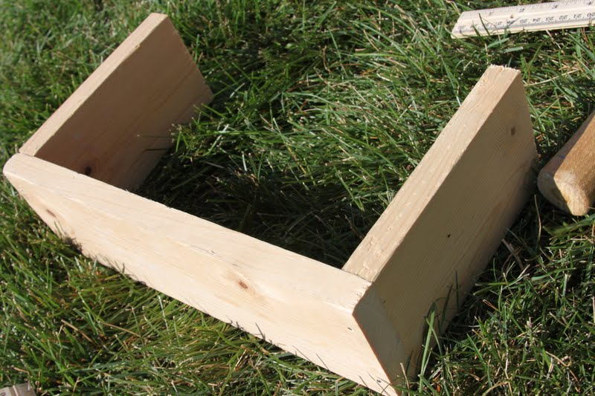
- Space out three rulers on each side of the board according to your desired placement.
- Apply some wood glue to each spot or nail the rulers into place.
- Ensure that the rulers are securely attached by firmly pressing them onto the glued spots.
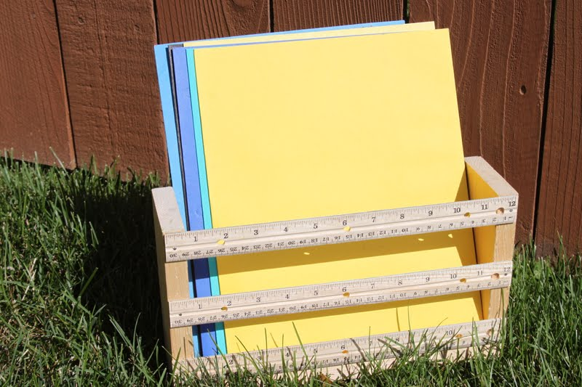
- Allow the wood glue to dry completely, following the manufacturer's instructions, before moving on.
- Optional: Decorate the folder holder by painting or staining the wood, or adding decorative elements.
While the wood glue is drying, engage the students in a discussion about the skills they used during the project, such as measurement, applying wood glue evenly, and working together as a team.
Once the folder holders are dry, students can use them to store folders, notebooks, or other items.

💭 REFLECTION (10 minutes)
Check for understanding by asking students to share their experiences, the challenges they faced, and the strategies they used to overcome them.
Encourage students to share how they demonstrated teamwork and problem-solving skills.
Wrap up the activity by having each group present their finished folder holder to the class, explaining their design choices, and demonstrating how it can be used.
Lower Level | Higher Level
Consider assigning groups considering students’ dexterity levels. | Encourage students to research other small carpentry projects they can try at home.
Instructor notes: Remind students to prioritize safety, ask for assistance if needed, and clean up the work area after completing the project.
PARTNER WORK TIME (45 min)
Inform students that they will work with a partner to read more about jobs related to carpentry and write a short summary as specified in the handout.

Pair students up and share these two links:
- Carpenters at My Next Move
- Helpers--Carpenters at My Next Move

Distribute the Carpentry Careers handout to each student.
Read out the instructions in the handout and clarify any questions.

After students complete part A, encourage them to share their reflections with their partner and to take turns discussing what they wrote or drew.

💭 REFLECTION (10 minutes)

Ask 3-4 volunteers to read out their paragraphs.
Guide a discussion around the potential challenges students might face in carpentry careers and how they can overcome them.
Lower Level | Higher Level
Pair students up based on their language skills so they can support each other. Offer to spell out words on the board if students need help. Provide the following sentence starters to help students:  When comparing my skills to the ones needed for carpentry roles, I noticed that...  I think I am good at...  One strength I have that aligns with carpentry is...  I realized that I might need to work on...  I can improve my skills in carpentry by...  One thing I can do to develop my carpentry skills is...  I am excited to learn more about carpentry and practice...  I think with practice and guidance, I can become better at...  I am determined to improve my skills in carpentry because...  Overall, I feel confident/enthusiastic about pursuing carpentry because... | Encourage students to spend time reading about the personality traits that help people excel in these roles and reflecting on how they match their personalities. Have a few of them share their thoughts with the class.
Instructor notes: Depending on the time available, you can assign both parts for this activity or only Part-A for the whole class, and if students complete it ahead of time, assign Part-B as well. This activity is designed to help students practice inferencing from texts and use dictation, drawing, and words to present a summary of what they read.

WRAP-UP & REFLECTION (15 min)
Ask 2-3 volunteers to share what they learned in this lesson.

Distribute exit slips to students.
Ask for a few volunteers to share their reflections.
Collect and review the answers.

Reading Comprehension
Name: ______________________ Date: _________________

Directions:
- Read the text below with your partner and answer the questions that follow.
- Reach out to your instructor if you have any questions.

Carpentry

Carpentry is an important skill in the fields of architecture and construction. Carpenters work with wood to build and repair structures. They use various tools like hammers, saws, and drills to bring their creations to life. Let's explore some exciting carpentry careers and learn about the skills needed to succeed in this field.

One carpentry career is that of a residential carpenter. Residential carpenters specialize in building and renovating houses. They work on tasks like framing walls, installing doors and windows, and constructing staircases. Residential carpenters need to be skilled at measuring accurately using tools like measuring tapes and rulers. They also refer to blueprints, which are detailed plans or drawings, to guide their work.

Another carpentry career is that of a cabinetmaker. Cabinetmakers are experts in crafting customized cabinets and furniture. They create beautiful and functional pieces for homes, offices, and other spaces. Cabinetmakers use precision tools like saws to cut wood with accuracy. They also rely on blueprints to ensure they create the desired designs and dimensions.

A third carpentry career is being a scenic carpenter. Scenic carpenters work in the entertainment industry, creating sets and props for theaters, movies, and TV shows. They bring the imaginative worlds of stories to life. Scenic carpenters measure and cut wood to construct elaborate sets based on the provided blueprints. They use various types of saws to achieve different cuts and shapes.

Lastly, we have finish carpenters. Finish carpenters focus on the final touches of a construction project. They install moldings, trim, and other decorative elements that make a space look polished and complete. Finish carpenters rely on accurate measurements and precise cutting with saws to ensure the perfect fit and alignment of these finishing touches.

Carpentry careers offer a wide range of opportunities for those who enjoy working with wood and using their hands. Whether it's building houses, crafting furniture, creating theatrical sets, or adding the finishing touches, carpentry can be a fulfilling and rewarding profession. Carpenters use tools like saws, measure with precision, and refer to blueprints to bring their carpentry projects to life.

Comprehension Questions

Questions | Answers
What is one task that residential carpenters specialize in?

What tools do cabinetmakers use to create customized cabinets?

Which industry do scenic carpenters work in?

What is the role of finish carpenters in a construction project?

Vocabulary Practice

Directions:
- Re-read the passage on "Carpentry Careers" silently and at your own pace.
- As you read, pay attention to the context and meaning of the vocabulary words: carpentry, blueprint, measure, and saw. Try to understand how these words are used within the passage.
- If you come across any unfamiliar words, try to determine their meanings based on the surrounding text. If needed, use a dictionary or ask a teacher for assistance.
- Make notes or underline important details related to each vocabulary word as you read. Pay attention to the definitions, examples, and characteristics mentioned in the passage.
- Once you have finished reading the passage, review your notes to ensure a good understanding of the vocabulary words in the context of carpentry careers.
- Take a moment to reflect on how the vocabulary words are used and why they are important in the field of carpentry.
- Copy the Frayer Model in your notebooks and complete it for each word based on your understanding from the passage.
- Refer to the example for the word carpentry as you work on this activity.
- If you have time, consider repeating this activity for other words from the passage.

Note: Remember to read carefully, take your time, and refer back to the passage whenever needed. The Frayer Model activity will help you further explore the vocabulary words and solidify your understanding of carpentry-related terms.

Indirect Measurements
Name: ______________________ Date: _________________

Object Measured | Object Used to Measure | Length in Units
whiteboard | ruler | __________ rulers
whiteboard | notebook | ___________ notebooks
whiteboard | blocks | ____________ blocks

Carpentry Careers
Name: ______________________ Date: _________________

Directions:
- Part-A
  - Open the link https://www.mynextmove.org/profile/summary/47-2031.00
and read the information about the carpentry careers.
  - Dictate two to three sentences to your partner about what carpenters do on the job in your own words. Your partner will write them down.
  - Draw some of the tools carpenters might use in the space provided below.
  - Reflect on your own skills and compare them to the skills required for carpentry roles
    - Identify areas where your skills align with carpentry, highlighting the strengths you possess.
    - Identify any areas where your skills may differ or need further development.
    - Consider how you can develop these skills through training, practice, or seeking guidance from experienced carpenters. Remember that developing carpentry skills is a gradual process, and with dedication and effort, you can enhance your abilities in this field.
  - Write a short paragraph on your reflection.
- Part-B
  - Open the link https://www.mynextmove.org/profile/summary/47-3012.00 and read the information about the carpenter helpers.
  - Reflect on the differences between the two careers and discuss with your partner the skills and abilities that are common for both and what is different.

Dictation Sentences

Tools Carpenters Use

My Reflection

Reflection Exit Slip

In one sentence, describe what you learned in this lesson.

Today, I learned _______________________________________________________________.

Is one of the careers discussed today of interest to you? Why or why not?

I liked / did not like ____________________________________ career because___________

______________________________________________________________________________.

Is there anything you still need help understanding?

What’s one question you have?

Circle the emoji that shows how you feel about your mastery of content in this lesson.

😁 🤩 🥴 😭 😠
Happy Smart Confused Sad Angry

