14. Architecture and Construction Cluster - Painting and Interior Design (4 hours)
Purpose/Abstract: To introduce students to the painting and interior design careers within the architecture and construction cluster.
NCCCS Adult Education Standards: R.5.2.7, W.5.2.3 , S.1.2.1, M.2.3.2
Learning Objective:
By the end of the session, students will be able to:
- Describe a day-in-the-life of careers in painting and interior design
- Identify basic elements of design
- Apply enthusiasm in a customer-centered environment
Soft Skills | communication, enthusiasm & attitude | Resources | Skills to Pay the Bills (STPTB) (for instructor reference to define each soft skill category)  27-1025.00 - Interior Designers (for information on interior designer roles)  Painters, Construction & Maintenance at My Next Move (for information on painter roles)  Math games and worksheets used in the lesson:  - Measurement Learning Check (for review)  - Piggy's House Hunting - Find the Perimeter  - Area and Perimeter of a Rectangle (for additional practice)  - Perimeter and Addition  What Is A Diorama And How To Make A Shoebox Scene (for the group activity)  Elements of Design: Understanding the 7 Elements of Design - 2023 - MasterClass (for instructor reference for the group activity)  NC Career Clusters Guide(for instructor reference)  Handouts:  - Reading and Vocabulary - 1 for each student  - Design Elements - 1 for each group
Additional Materials
- Reading and Vocabulary handout, one for each student (print scaffolded version as required)
- Design elements, one for each group
- Shoe boxes, one for each group plus extras
- Blocks, popsicle sticks and other items to create elements in a room
- Art supplies (glue, glitter, markers, paint, etc.)
- Pencils, paper, scissors
- Computers for student use
Icons | 💭 Activity ✔Check-In ⟲ Review

PREPARATION
- Review the worksheets and games on Education.com and print out the following worksheets:
  - Measurement Learning Check
  - Perimeter and Addition
  - Piggy's House Hunting - Find the Perimeter
  - Area and Perimeter of a Rectangle
- Review the Instructional Support Guide and print/prepare referenced scaffolds.
- Print handouts.
- Familiarize yourself with What Is A Diorama And How To Make A Shoebox Scene and Elements of Design: Understanding the 7 Elements of Design - 2023 - MasterClass
- Familiarize yourself with the OneStop Career Clusters.
- Familiarize yourself with O*NET.
- Familiarize yourself with Skills to Pay the Bills, though it won’t be used directly in this lesson.

INTRODUCTION (30 min)
Welcome students to the class!

Review the careers discussed so far in the architecture and construction cluster by asking students to share what they remember from the previous lessons.

Introduce the topic of this lesson by explaining what painting and interior design jobs are. Ask students to turn to a partner and share what they already know about these jobs. Have 1-2 pairs share their responses with the rest of the class. Add to their responses with a summary of what painters and interior designers might do on the job using the links below.
- Painters, Construction & Maintenance at My Next Move
- Interior Designers at My Next Move
Share the lesson objectives and explain how they will be covered in the lesson.

VOCABULARY, READING(45 min)

Distribute the Reading and Vocabulary handout to students.

Instruct them to read the story and answer the questions.

💭 REFLECTION (15 minutes)
✔ Ask 2-3 volunteers to read out their written responses for each question.

Talk about how images in text help provide more context. Share a few examples of books with illustrations in the classroom and give students time to analyze them and share their thoughts on how illustrations or images help them understand the text better.

Lower Level | Higher Level
Consider pairing students up with a higher-level student. | Ask students to list out texts where illustrations help make the text easier to understand. Have them share this list with the class and add to their responses with examples such as recipes, furniture assembly manuals, other instruction booklets, etc.

Instructor notes: This text is at a grade 3 reading level, but, if you feel students might need support, consider doing a whole class read-aloud for the passage and providing time to answer the questions.

MATHEMATICS (45 min)

Review the concept of area of a plane figure and measurements by distributing this worksheet to students and solving the problems with them. Use the same worksheet to explain what a perimeter is and how to calculate the perimeter of a plane figure.

Provide real-world examples related to painting and interior design where students can apply the area and perimeter formulas for rectangles. Consider using these examples, or feel free to create your own.
Example 1:
Draw a diagram of a rectangular room on the board or show a visual representation.
Provide the measurements of the length and width of the room, such as length = 12 feet and width = 10 feet.
Explain how to calculate the area and perimeter of the room.
Guide them through the process of using the formulas: area = length width, and perimeter = 2(length + width).
Once you have calculated the area and perimeter, explain that a gallon of paint typically covers 350 square feet. Explain how it is important to use the values obtained for area and perimeter to calculate how much paint would be needed for the room. Emphasize the importance of accurate measurements in painting projects.
Example 2:
Show a picture or diagram of a rectangular room with flooring.
Explain that you need to calculate the area and perimeter of the room to determine the amount of flooring material needed.
Provide the measurements of the length and width of the room, such as length = 15 feet and width = 8 feet.
Guide the students in using the formulas: area = length width, and perimeter = 2(length + width).
Once you have calculated the area and perimeter, explain that flooring materials are usually sold in square feet or square meters.
Ask the students to determine how many square feet or square meters of flooring material would be needed to cover the room.

Assign the following game and worksheet involving perimeter calculation to the students. Allow students to work individually or with a partner.

- Perimeter and Addition
- Piggy's House Hunting - Find the Perimeter
Offer guidance and support as needed.
Conduct a class discussion to review the answers and provide individual support as required. .

💭 REFLECTION (10 minutes)
✔ Collect and review the students' work to assess their understanding of the concept.

Ask 1-2 students to summarize how perimeter and area calculations are important in painting and interior design careers.
Lower Level | Higher Level
Provide additional time and guide them through the problems. | Challenge students with this worksheet:  Area and Perimeter of a Rectangle

GROUP WORK (60 min)

Introduce students to what a diorama is and ask them to share their experiences creating dioramas. If students have not created dioramas in school, share a few images from the internet to help them understand. You can consider referring to this site to explain or using videos.

Divide the students into groups of four students each. Ensure that each group has a mix of abilities and strengths to foster collaboration and support.
Distribute the Create a Diorama handout to each group. Explain to the students that they will be working in these groups to create dioramas representing different aspects of painting and interior design. Tell them that each group can decide on the layout of a room and the elements they plan to use. Emphasize that each group will have 1 or 2 unique elements of design to incorporate into their diorama.

Introduce students to the elements of design briefly using information from Elements of Design: Understanding the 7 Elements of Design - 2023 - MasterClass. Use the following table to suggest examples of how groups can incorporate the elements of design into their dioramas.

Element of Design | Sample Ideas
Color | - Use different colors to make your diorama look nice. You can choose warm colors like red, orange, and yellow to make it look energetic.  - Pick a special color to make something stand out, like a bright piece of furniture or artwork
Shape | - Use different shapes in your diorama to make it interesting. You can use circles, squares, triangles, or other shapes to represent objects like furniture, windows, or doors
Form | - Use three-dimensional objects in your diorama to create a sense of depth and realism. You can use small objects like miniature furniture or create 3D structures using materials like clay or paper
Texture | - Add texture to your diorama to make it feel more real. You can use materials like fabric, sandpaper, or textured paper to create different textures for objects like walls, floors, or furniture
Space | - Use the space in your diorama wisely to create a balanced and visually pleasing scene. Leave enough space between objects to make them stand out and create a sense of depth in your design
Value | - Use different shades of light and dark to create contrast and depth in your diorama. You can use lighter colors to show areas of brightness and darker colors to show areas of shadow or depth.

Assign specific elements of design to each group from the table above. Make sure that each group has a clear understanding of their assigned element(s) and their significance in painting and interior design.

Provide the students with the materials and give brief instructions on how to create a diorama using a shoebox and other provided materials. Encourage collaboration within the groups by emphasizing the importance of teamwork and each student contributing their ideas and skills. Remind students to listen to each other, share responsibilities, and make decisions collectively.
Circulate among the groups, providing support, guidance, and feedback as needed. Offer assistance in brainstorming ideas, problem-solving challenges, and ensuring that each group stays on track with their assigned elements of design. Encourage groups to think creatively and find innovative solutions to represent their assigned elements in the diorama.

💭 REFLECTION (15 minutes)
✔ As the groups near the completion of their dioramas, encourage them to reflect on the process and discuss how their assigned elements of design influenced their design choices. Encourage them to think about the impact of their diorama on creating a visually appealing and functional space.

Ask each group to present their diorama to the class. During the presentation, have students explain how they incorporated their assigned design elements.

Guide a short discussion on how these elements relate to painting and interior design projects.

Lower Level | Higher Level
Provide additional guidance and modified materials. | Challenge students to apply their experience creating a diorama and share how they might approach redesigning a room in their homes. Ask them to explain which design elements they will prioritize for their redesign project and why.

INDEPENDENT WORK TIME (45 min)
Tell students that they will take on the role of an interior designer who is responsible for redesigning the classroom.

Share Interior Designers with students and read aloud a few sections to help explain the role. Clarify any questions.

Ask students to take 5 minutes to observe the room they are in and note down what elements they will change if they are the interior designer.

Tell students to write a short persuasive essay about what they will change in the room and why they feel the change is necessary. Their essay should contain at least five complete sentences and should be able to convince you of their choices. Encourage students to think about changes they can consider to make the room accessible to those with disabilities.

Allow 20 minutes for this activity.

💭 REFLECTION (10 minutes)

Invite the students to read their essays and ask follow-up questions to guide a discussion.
Conclude the activity by emphasizing the importance of clear communication in painting and interior design jobs and discussing the impact of miscommunication between stakeholders. Encourage students to think about how a positive attitude and enthusiasm will help them be successful in painting and interior design careers. Share a few context-specific examples to explain the importance of these skills.

Lower Level | Higher Level
Encourage students to draw their ideas for the room redesign and then write out simple sentences describing their illustrations. | Challenge students to create a list of professionals they will collaborate with to bring their ideas to life, along with strategies to persuade them to support their ideas.

Instructor Notes: Collect students' essays and provide individual constructive feedback to help them improve their essays by using clear language and providing supporting details.

WRAP-UP & REFLECTION (15 min)

Instruct students to turn to a partner and engage in a discussion about their interest in painting and interior design roles, sharing their reasons.

Ask 2-3 volunteers to share their thoughts with the rest of the class.

Distribute exit slips to students.
Ask for a few volunteers to share their reflections.
Collect and review the answers.
Reading and Vocabulary
Name: ______________________ Date: _________________

Directions:
- Read this story and observe the images
- Answer the questions given below

Once upon a time, in a small town called Artville, there lived two best friends, Emma and Max. Emma was a talented painter, and Max had a passion for interior design. They both loved creating beautiful spaces that brought joy to people's lives.

One sunny day, Emma and Max decided to collaborate on a special project. They were asked to transform an old, abandoned building into a vibrant community center. Excited about the opportunity, they gathered their tools and sketches and got to work.

Emma began by painting colorful murals on the walls of the community center. She used her brush to create scenes of nature, animals, and happy faces. Her vibrant paintings brought life to the once-dull walls, creating a warm and inviting atmosphere.


Meanwhile, Max focused on interior design. He carefully selected furniture and decor that would make the community center cozy and comfortable. With a keen eye for detail, he arranged chairs, tables, and bookshelves in a way that encouraged conversation and creativity.

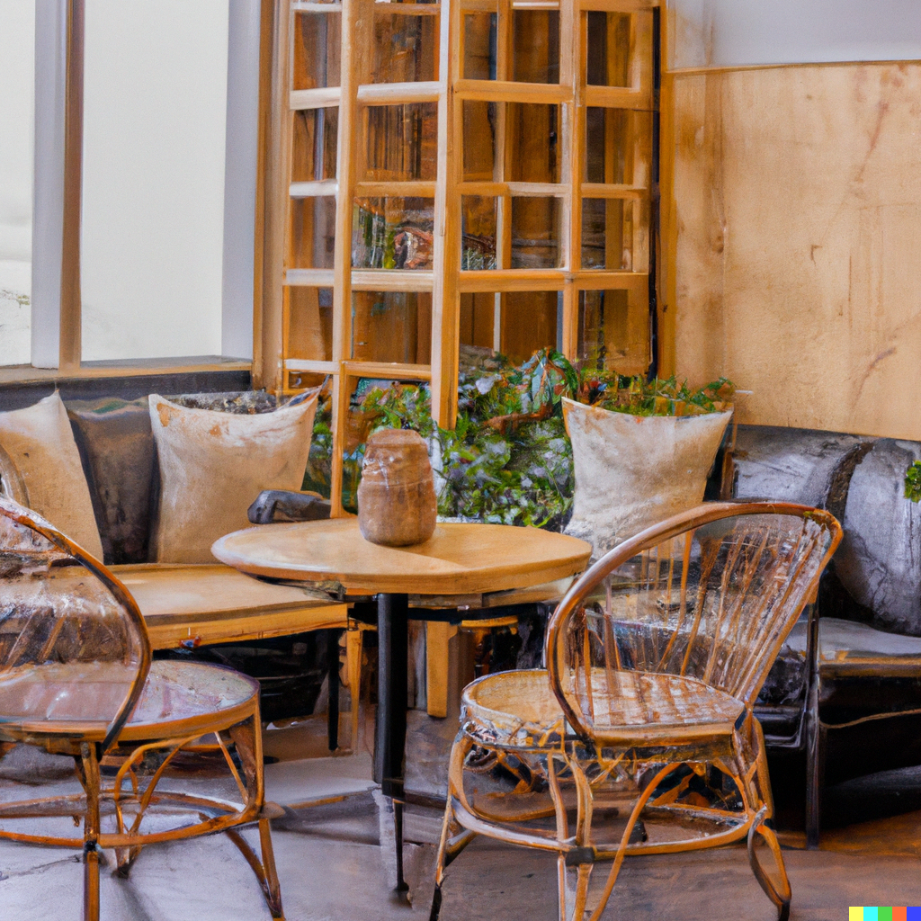

As they worked together, Emma and Max shared ideas and inspiration. They supported each other's creativity, combining their talents to make the community center truly special. Emma's colorful paintings and Max's thoughtful design choices complemented each other, creating a harmonious space.

When they finally finished, the community center was a masterpiece. The walls were filled with Emma's stunning paintings, showcasing the beauty of the world. Max's carefully curated furniture and decorations provided a welcoming environment for everyone to enjoy.

The people of Artville were amazed when they entered the transformed community center. They felt inspired by the colors, touched by the art, and at home in the cozy atmosphere. Emma and Max's collaboration had created a place where people could come together, express themselves, and experience the power of art and design.

Question | Answer
- What emotions or feelings do you experience when you see Emma's colorful painting? Why?
- In your own words, explain what interior design means. Use examples from the story to support your answer.

- Describe the scene in the picture where Max has arranged furniture. How does his careful arrangement of furniture impact the people who visit the community center?
- Choose two vocabulary words from this list - vibrant, harmonious, collaboration, atmosphere, curated and explain their meaning in simple language. How do these words help you understand the story better?

Reading and Vocabulary
Name: ______________________ Date: _________________

Directions:
- Read this story and observe the images
- Answer the questions given below

Once upon a time, in a small town called Artville, there lived two best friends, Emma and Max. Emma was a talented painter, and Max had a passion for interior design. They both loved creating beautiful spaces that brought joy to people's lives.

One sunny day, Emma and Max decided to collaborate on a special project. They were asked to transform an old, abandoned building into a vibrant community center. Excited about the opportunity, they gathered their tools and sketches and got to work.

Emma began by painting colorful murals on the walls of the community center. She used her brush to create scenes of nature, animals, and happy faces. Her vibrant paintings brought life to the once-dull walls, creating a warm and inviting atmosphere.

Meanwhile, Max focused on interior design. He carefully selected furniture and decor that would make the community center cozy and comfortable. With a keen eye for detail, he arranged chairs, tables, and bookshelves in a way that encouraged conversation and creativity.

As they worked together, Emma and Max shared ideas and inspiration. They supported each other's creativity, combining their talents to make the community center truly special. Emma's colorful paintings and Max's thoughtful design choices complemented each other, creating a harmonious space.

The community center was a work of art when they were done. The walls were filled with Emma's stunning paintings, showcasing the beauty of the world. Max's carefully curated furniture and decorations provided a welcoming environment for everyone to enjoy.

The people of Artville were amazed when they entered the transformed community center. The vibrant colors, the artistic expression, and the welcoming atmosphere all served to inspire and move them. Emma and Max's collaboration had created a place where people could come together, express themselves, and experience the power of art and design.

Question | Answer
- What emotions or feelings do you experience when you see Emma's colorful painting? Why? | When I look at the picture of Emma’s painting, her artwork makes me feel...
- In your own words, explain what interior design means. Use examples from the story to support your answer. | I think interior design means …
- Describe the scene in the picture where Max has arranged furniture. How does his careful arrangement of furniture impact the people who visit the community center? | When I look at the picture where Max has arranged furniture in the community center, I notice…
- Choose two vocabulary words from this list - vibrant, harmonious, collaboration, atmosphere, curated and explain their meaning in simple language. How do these words help you understand the story better? | I learned that the word _________________ means  _____________________________________________

Design Elements

Directions:
- Use this table as a reference for ideas while creating the dioramas.

Element of Design | Sample Ideas
Color | - Use different colors to make your diorama look nice. You can choose warm colors like red, orange, and yellow to make it look energetic.  - Pick a special color to make something stand out, like a bright piece of furniture or artwork
Shape | - Use different shapes in your diorama to make it interesting. You can use circles, squares, triangles, or other shapes to represent objects like furniture, windows, or doors
Form | - Use three-dimensional objects in your diorama to create a sense of depth and realism. You can use small objects like miniature furniture or create 3D structures using materials like clay or paper
Texture | - Add texture to your diorama to make it feel more real. You can use materials like fabric, sandpaper, or textured paper to create different textures for objects like walls, floors, or furniture
Space | - Use the space in your diorama wisely to create a balanced and visually pleasing scene. Leave enough space between objects to make them stand out and create a sense of depth in your design
Value | - Use different shades of light and dark to create contrast and depth in your diorama. You can use lighter colors to show areas of brightness and darker colors to show areas of shadow or depth.

Reflection Exit Slip

In one sentence, describe what you learned in this lesson.

Today, I learned _______________________________________________________________.

Is one of the careers discussed today of interest to you? Why or why not?

I liked / did not like ____________________________________ career because___________

______________________________________________________________________________.

Is there anything you still need help understanding?

What’s one question you have?

Circle the emoji that shows how you feel about your mastery of content in this lesson.

😁 🤩 🥴 😭 😠
Happy Smart Confused Sad Angry

