23. Business, Management and Administration Cluster - Human Resources Careers (4 hours)
Purpose/Abstract: To introduce students to common Human Resources Careers.
NCCCS Adult Education Standards: R.3.2.4, S.1.2.6, M.5.2.1
Learning Objective:
By the end of the session, students will be able to:
- Ask and answer questions about human resources careers
- Describe the duties of introductory human resources careers
- Apply basic operations to solve problems
Soft Skills | Communication and Professionalism | Resources | Skills to Pay the Bills (STPTB) (for instructor reference to define each soft skill category)  43-4161.00 - Human Resources Assistants, Except Payroll and Timekeeping  13-1071.00 - Human Resources Specialists  Math:  Three-Digit Addition and Two-Step Word Problems | Exercise | Education.com  Three-Digit Subtraction and Regrouping Numbers  Two-Step Addition & Subtraction Word Problems Check-In | Interactive Worksheet | Education.com  Videos:  Occupation Profile for Human Resources Assistants, Except Payroll and Timekeeping | CareerOneStop  Human Resources Specialist Career Video  NC Career Clusters Guide (for instructor reference)  Handouts:  Human Resources Roles - one for each pair  Vocabulary Crossword - one for each student
Additional Materials
- Vocabulary Crossword, 1 for each student
- Human Resources Roles, 1 for each student
- Art supplies (glue, glitter, markers, paint, etc.)
- Pencils, paper, scissors
- Computers for student use
Icons | 💭 Activity ✔Check-In ⟲ Review

PREPARATION
- Confirm the appointment with the HR professional and ensure you keep extra time for the interaction in case there are more questions from the students.
- Invite the HR professional to come to class during the Group Work section. Brief them on what they can share with the students about the various HR roles and ask them to be prepared for a few questions the students will ask.
- Review the exercises on education.com and print out the following worksheet:
  - Two-Step Addition & Subtraction Word Problems Check-In | Interactive Worksheet | Education.com
  - Exercises:
    - Three-Digit Addition and Two-Step Word Problems | Exercise | Education.com
    - Three-Digit Subtraction and Regrouping Numbers
- Review the Instructional Support Guide and print/prepare referenced scaffolds.
- Print handouts.
- Familiarize yourself with O*NET
- Familiarize yourself with Skills to Pay the Bills, though it won’t be used directly in this lesson.

INTRODUCTION (30 min)
Welcome students to the class!
Begin the class with a short ice-breaker activity. For example, have students pair up and take turns introducing themselves with an adjective before their name and sharing one thing they already know about human resources.

Introduce the concept of human resources careers using one or both of the videos listed below:
- Occupation Profile for Human Resources Assistants, Except Payroll and Timekeeping | CareerOneStop
- Human Resources Specialist Career Video

Explain the importance of human resources in organizations and provide an overview of different introductory human resources roles and responsibilities.
Ask students questions to ensure comprehension and engagement. For example:
"Can anyone name a specific human resources role?"
"What do you think might be the responsibilities of a human resources assistant?"

Introduce the objectives of the lesson and remind students that there will be a guest speaker visiting them to help them understand more about the different roles in Human Resources.

VOCABULARY, READING & WRITING (45 min)
Vocabulary
Distribute the crossword puzzle handout containing ten key vocabulary terms related to human resources careers. This will reinforce their understanding of the terms, their definitions and their spelling.

Allow 20 minutes for students to solve the crossword. Consider pairing students up if required.

Pair students up for the reading comprehension activity and ask students to read the passage out loud to each other to practice their reading skills. Distribute the Human Resources Roles handout to each pair. After they’ve read the passage, tell them to answer the comprehension questions. Allow 20 minutes for this activity.

💭 REFLECTION (5 minutes)
✔Have 2-3 students share the answers to their comprehension questions. Review the vocabulary words with the definitions.

Lower Level | Higher Level
Pair students up for the crossword puzzle. | Challenge students to add an additional paragraph to the passage with their opinion of Human Resource roles so far.

MATHEMATICS (60 min)

Let students know that they will be practicing addition and subtraction operations today.

Demonstrate solving the following word problems step by step related to human resources scenarios.
- A company had 250 employees, and they hired 50 new employees. How many employees does the company have now?
- In the past week, 120 employees attended a training session, and 80 employees attended a different session. How many employees attended the training sessions in total?
- A company has 500 employees, and they recently hired 75 new employees. However, 40 employees decided to leave the company. How many employees does the company have now?

Assign the following two exercises to students to provide practice on Three-Digit Addition and Two-Step Word Problems and Three-Digit Subtraction and Regrouping Numbers

Distribute the Math worksheet and allow students 15 minutes to work on them. Consider solving problems that most students need support with, on the board.

💭 REFLECTION (10 minutes)
✔Discuss the answers and clarify any doubts students have.

Lower Level | Higher Level
Pair students up and offer individual assistance when required. | Challenge students to come up with their own two-step addition/ subtraction problems.

GROUP WORK (75 min)

Divide students into groups of six and let them know that they will need to brainstorm and write down a list of questions they can ask the HR professional who will visit them shortly.

Tell students to think about what they’d like to know about job requirements, daily tasks, skills needed, career growth, and industry insight while framing questions. Inform them that each group should have at least 4 questions. Tell students that it is okay if more than one group has the same question for the guest and that a question will only be asked once to avoid repetition.

Inform students that they will have the opportunity to actively listen and take notes as the HR professional shares insights and experiences. Encourage them to be attentive and jot down key points during the interaction. Once the HR professional has finished speaking, there will be dedicated time for students to ask questions. Each group can select one or two students to represent them and ask their prepared questions.

Allocate 45 minutes for guest interaction. Introduce the HR professional to the class.

Remind students to take notes as they listen. Encourage students to ask their questions and clarify any that are ambiguous.
💭 REFLECTION (20 minutes)
✔ Have a few students share key points from their notes and guide a short discussion to summarize what they learned during the interaction. Emphasize the importance of asking the right questions and taking clear notes and how it will help them in Human Resources careers and many other jobs.
INDEPENDENT WORK TIME (20 min)
Give students 15 minutes to skim through these two links 43-4161.00 - Human Resources Assistants, Except Payroll and Timekeeping , 13-1071.00 - Human Resources Specialists, and write down a list of common tasks/ activities they notice across the roles mentioned in these links.

Encourage students to share their lists with a partner and discuss some of the common tasks they might do in HR careers.

Walk around and clarify any questions that come up.

Lower Level | Higher Level
Provide easy-to-read links for the roles:  Human Resources Assistants at My Next Move  Human Resources Specialists at My Next Move | Challenge students to do research on the career growth of the various roles mentioned on these pages.

WRAP-UP & REFLECTION (10 min)

Ask the following questions and have students turn to a partner and share their thoughts.
- What was one new thing you learned about Human Resource Careers?
- What are you most curious about from today’s lesson?
- Where can you get more information on HR careers?

Ask 2-3 volunteer pairs to share their thoughts with the rest of the class.

Distribute exit slips to students.
Ask for a few volunteers to share their reflections.
Collect and review the answers.

Vocabulary Crossword

Directions:
- Match the following words to the clues below and fill in the crossword puzzle:
  - Recruiting
  - Resume
  - Interview
  - Training
  - Benefits
  - Diversity
  - Conflict-Resolution
  - Performance-evaluation
  - Workplace-ethics
  - Career-development

Clues
  Across
  3. | The principles and standards of conduct that guide professional behavior in the workplace.
  5. | A formal meeting where a potential employer asks questions to assess a candidate's suitability for a job.
  7. | The process of finding and attracting qualified candidates for job positions within an organization.
  8. | The inclusion and representation of people from different backgrounds, cultures, and identities within the workplace.
  10. | The ongoing process of improving skills, gaining experience, and advancing in one's chosen career.
  Down
  1 | An assessment of an employee's job performance; is usually conducted annually or periodically.
  2 | The process of teaching employees the necessary skills and knowledge to perform their job effectively.
  4 | The process of addressing and resolving disagreements or issues that may arise between employees.
  6 | Additional perks or rewards provided to employees, such as health insurance, paid vacation, or retirement plans.
  9 | A document that summarizes a person's education, work experience, skills, and qualifications when applying for a job.
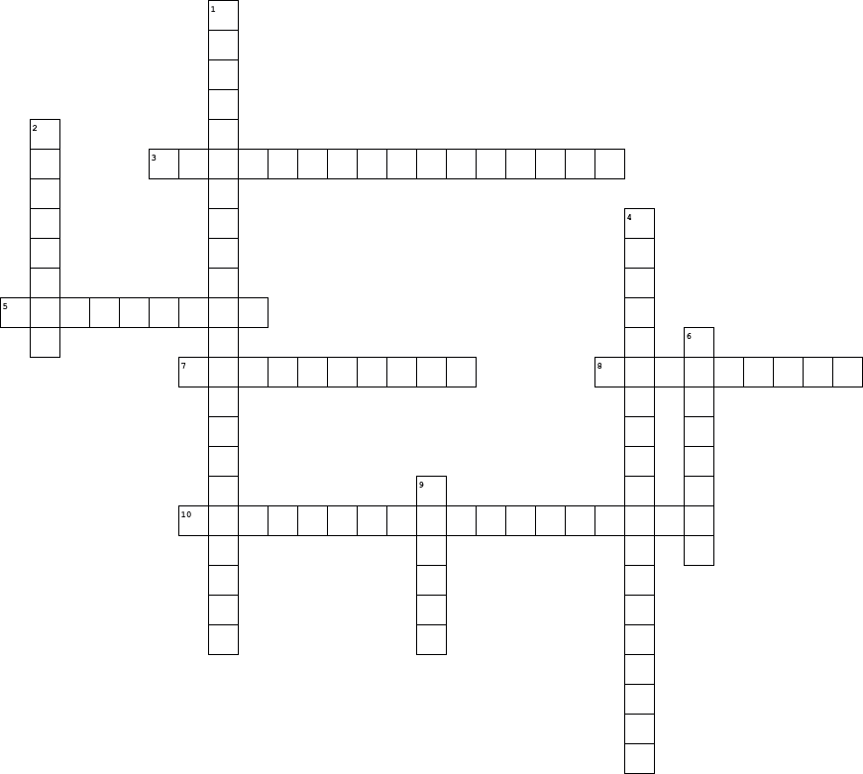

Human Resources Roles

Directions:
- Read the passage with your partner
- Answer the questions given below.

Human resources (HR) careers are all about helping people in the workplace. People who work in HR have important responsibilities that help organizations run smoothly.

One common HR job is a recruiter. Recruiters are like detectives! They search for talented people to join a company. They read resumes, interview candidates, and choose the best fit for the job.

Another introductory HR role is an HR assistant. HR assistants help with many tasks. They organize employee records, answer questions about benefits, and assist in training programs. HR assistants are friendly and helpful.

HR careers also involve conflict resolution. When problems or disagreements arise, HR professionals step in to find solutions. They listen to both sides and help everyone find common ground.

One important thing to remember about HR careers is that they require good communication skills. HR professionals need to talk and listen carefully to understand employees' needs and concerns.

Understanding human resources careers can help us see how important it is to work together and support each other in the workplace.

Comprehension Questions:

Question | Answer
What are some responsibilities of an HR recruiter?
What tasks does an HR assistant typically handle?

What is the role of HR professionals in conflict resolution?

Why is good communication important for HR professionals?

Reflection Exit Slip

In one sentence, describe what you learned in this lesson.

Today, I learned _______________________________________________________________.

Is one of the careers discussed today of interest to you? Why or why not?

I liked / did not like ____________________________________ career because___________

______________________________________________________________________________.

Is there anything you still need help understanding?

What’s one question you have?

Circle the emoji that shows how you feel about your mastery of the content in this lesson.

😁 🤩 🥴 😭 😠
Happy Smart Confused Sad Angry

