36. Finance Cluster - Banking Careers (4 hours)
Purpose/Abstract: To introduce students to different banking careers.
NCCCS Adult Education Standards: R.4.2.1, S.1.1.3, M.4.1.1
Learning Objective:
By the end of the session, students will be able to:
- Describe a day-in-the-life of a bank teller
- Demonstrate professionalism when speaking with "customers"
- Role play check-cashing scenarios as a bank teller
Soft Skills | professionalism | Resources | Skills to Pay the Bills (STPTB) (for instructor reference to define each soft skill category)  Free Blank Check Templates for Kids (Activities for Kids Included) - Go Science Girls (Use this resource for the check cashing activity)  Printable Play Money  NC Career Clusters Guide (for instructor reference)  Handouts:  Crossword - 1 for each student.
Additional Materials
- Crossword handout, one per student
- Index cards with visual representation of graphs and the corresponding descriptions.
- Blank check templates (Please refer to the website attached)
- Printable money from Printable Play Money
- Art supplies (glue, glitter, markers, paint, etc.)
- Pencils, paper, and scissors
- Computers for student use
Icons | 💭 Activity ✔Check-In ⟲ Review

PREPARATION
- Review Free Blank Check Templates for Kids (Activities for Kids Included) - Go Science Girls and print out sample blank checks for students.
- Create index cards for the graph matching activity using information specified in the lesson. Make copies for each group.
- Print the play money.
- Prepare to project the reading passage, types of graphs and the role play scenarios.
- Review the Instructional Support Guide and print/prepare referenced scaffolds.
- Print handouts.
- Familiarize yourself with O*NET
- Familiarize yourself with Skills to Pay the Bills, though it won’t be used directly in this lesson.

INTRODUCTION (30 min)
Welcome students to the class!
Start the lesson with an icebreaker ‘Two Truths and a Lie’. Consider dividing students into smaller groups to save time.
Explain that today's lesson is the first lesson in the Finance Cluster and more specifically, about Banking Careers. Banking careers are a part of the Finance Cluster, which is all about managing money, making financial decisions, and helping people with their finances. Share that the Finance Cluster includes various jobs related to money, such as banking, finance management, and financial planning. Bank tellers are an important part of the Finance Cluster because they work directly with customers and their money.

Explain that bank tellers play a vital role in the world of finance. They are like the friendly faces you see when you visit a bank. They help people with their money needs, whether it's depositing money, withdrawing cash, or cashing checks. Mention that bank tellers are like the "frontline" of a bank. They are the first people you meet when you go to the bank, and they make sure your transactions are handled accurately and smoothly.

Briefly mention that in addition to technical skills related to handling money, bank tellers also need soft skills. These are skills like being polite, listening well, and being helpful, which are important in any job in the Finance Cluster.

Share the objectives of the lesson.
VOCABULARY, READING & WRITING (45 min)

Distribute the Crossword handout to students. Let them know that the words are all related to banking.

Allow 15 minutes for this activity.

Read aloud the passage on Bank Tellers as a class. Pause to clarify words that may be new for students.

💭 REFLECTION (20 minutes)
✔ Discuss the passage to provide practice on the standard S.1.1.3, encouraging students to build on each other's comments. Insert students’ names as you ask consecutive questions.

Here are some questions you can use to guide the discussion:
What was the main point of the paragraph about bank tellers? Can you tell it in your own words?
<Student 1> mentioned that bank tellers handle different types of transactions. Can you give an example of a transaction a bank teller might help with?
<Student 2> mentioned that bank tellers need to be professional when they talk to customers. Why do you think professionalism is important in a job like being a bank teller?
<Student 3> talked about how bank tellers help people with deposits and withdrawals. Can you think of a time when you might need to visit a bank for a deposit or withdrawal?
<Student 4> brought up the term "customer service." What do you think good customer service means in the context of a bank teller's job?

Lower Level | Higher Level
Consider pairing students up to solve the crossword. | Encourage students to share about how

MATHEMATICS (45 min)

Introduce students to different types of charts and graphs by projecting this image. Explain that graphs help professionals present, analyze, and interpret financial data to make informed decisions, manage risks, and enhance customer experiences. By visualizing complex information, these professionals can communicate more effectively with colleagues, clients, and stakeholders.
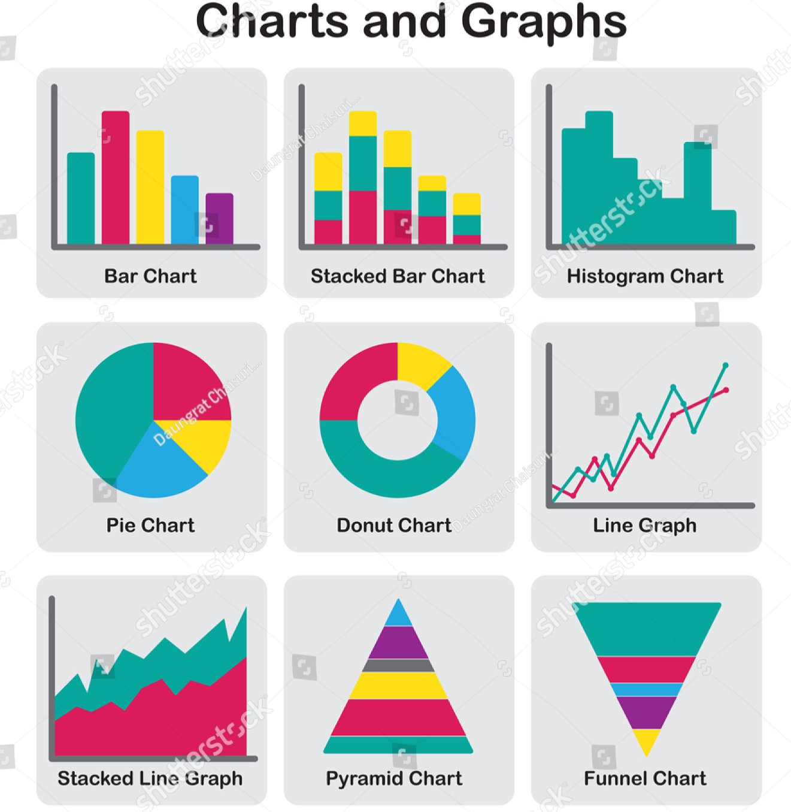

Share the following examples to explain how graphs are used in banking careers:
- In banking, graphs and charts can be used to analyze trends in customer transactions over time. A line graph could show the fluctuations in deposits and withdrawals throughout the year, helping bank managers understand peak activity periods and plan staffing accordingly.
- Banking professionals use pie charts to display the distribution of customers' preferred banking services.
- Risk analysts in banks create scatter plots to assess the relationship between credit scores and default rates among borrowers. This helps them identify patterns and make informed lending decisions to minimize risks.
- Financial advisors use line graphs to illustrate the performance of different investment portfolios over time. This helps clients understand the growth potential and risks associated with their investments.

Prepare a set of cards, each with a visual data representation. Feel free to use the images from the illustration above.
- Bar Chart
- Pie Chart
- Line Graph
- Table
- Histogram
- Pictograph

Prepare another set of cards, each with a description of the type of visual data and its purpose as follows. Please print this out on Index cards before the lesson and make several copies. .
- Description: A _______ uses rectangular bars of varying lengths to represent data. Each bar corresponds to a category or group, and the height of the bar indicates the value it represents.
Purpose: ________are used to compare quantities or values across different categories. They help visualize variations and trends in data, making it easy to understand comparisons.

- Description: A ______________ is a circular graph divided into slices, where each slice represents a portion or percentage of a whole.
Purpose:___________ show how a whole is divided into parts. They help convey the proportion and distribution of different components within a dataset.

- Description: A _____________ displays data points connected by lines, showing changes over time or another continuous interval.
Purpose: ___________ are used to illustrate trends, patterns, or relationships between variables. They help visualize how data changes over a specific period.
- Description: A ________presents data in rows and columns, providing a structured format to display information.
Purpose: ________are used to organize and compare data, especially when precise values or detailed information need to be conveyed.
- Description: A __________is similar to a bar chart, but it displays continuous data by grouping values into intervals (bins) along the x-axis.
Purpose: __________ illustrate the distribution of data within different intervals, allowing us to understand how data is spread across ranges.
- Description: A __________ uses pictures or symbols to represent data, where each picture/symbol corresponds to a certain quantity.
Purpose: ___________make data more engaging and visually appealing. They help convey information quickly, especially to audiences who may find text-heavy representations challenging.

Divide the class into groups of 4 and give each group a set of cards. Tell them to match the visual representation to the description and purpose. Ask them to fill in the blanks with the right type of graph.

Allow 20 minutes for this activity.

💭 REFLECTION (15 minutes)
✔ Discuss the results of the activity. Clarify any doubts that come up.

Lower Level | Higher Level
Ensure that the groups have a balance of lower and higher level students. | Challenge students to find graphs online about banking data and ask them to identify what kind of graphs they are and what information is being represented.

GROUP WORK (60 min)

Inform students that they will practice demonstrating professionalism through role plays.
Have a few students share what they know about professionalism.

Recap what professionalism is and why it’s an important skill in banking careers. Feel free to use the excerpt below to help you with the explanation.
Professionalism means acting and presenting oneself in a respectful, courteous, and responsible manner while performing a job. For bank tellers and other banking professionals, professionalism is crucial because they are the face of the bank and the first point of contact for customers. By being professional, bank tellers create a positive and trustworthy impression on customers, making them feel valued and respected. Good professionalism also ensures accurate and efficient service, which is essential in handling financial transactions. Moreover, it helps in building strong relationships with clients and colleagues, contributing to a harmonious work environment and a successful career in the banking sector.

Divide students into groups of 4 and assign one of the following scenarios to each group.

Title | Role Play Participants | Scenario
Deposits and Withdrawals | Bank Teller 1 (BT1)  Bank Teller 2 (BT2)  Customer 1 (C1)  Customer 2 (C2) | Customer 1 (C1) approaches the bank counter to make a deposit, and Customer 2 (C2) comes to withdraw cash. Bank Teller 1 (BT1) assists C1 with the deposit while Bank Teller 2 (BT2) helps C2 with the withdrawal. Students should focus on using polite language, maintaining a friendly tone, and accurately processing the transactions while addressing any customer questions or concerns.
Customer Inquiry and Assistance | Bank Teller 1 (BT1)  Bank Teller 2 (BT2)  Customer (C)  Observer (O) | Customer (C) approaches the bank counter with questions about different types of accounts and services offered by the bank. Bank Teller 1 (BT1) engages in a conversation with the customer, answering inquiries, explaining account options, and providing relevant information. Bank Teller 2 (BT2) serves as an observer, paying attention to BT1's professionalism and communication skills. After the interaction, BT2 provides feedback on BT1's approach, highlighting areas of strength and areas for improvement.

Encourage students to switch roles so each student in the group gets a chance to play one of the teller roles.

Allow 30 minutes for this activity.

💭 REFLECTION (20 minutes)
✔ Have a few groups present their role plays. Provide constructive feedback and ask students to share their experiences with banks.

PARTNER WORK TIME (45 min)

Tell students that they will practice cashing checks in this activity.
Briefly explain the concept of check cashing to the students, describing it as a service provided by banks where individuals can exchange a check for its equivalent amount in cash.

Distribute check templates and play money to each student.
Explain that the checks are like the ones people receive for payments, and the play money represents the cash they'll receive after cashing the checks.

Divide students into pairs.

Reinforce key points such as verifying the details and counting the money accurately.

💭 REFLECTION (10 minutes)
✔Ask students about their experiences during the simulation. Discuss the importance of accuracy when filling out checks and counting money. Highlight how bank tellers need to be attentive to details during real check-cashing transactions. Emphasize the role of professionalism in handling financial transactions, especially for bank tellers.

Lower Level | Higher Level
Lead students through a step-by-step check cashing scenario:  Explain the information on the check template (e.g., payer's name, date, amount in numbers and words).  Guide them to fill out the payee's name (their own name) and other required details on the check.  Show them how to count the play money equivalent to the check amount.  Walk them through the process of exchanging the check for play money. | Allow them to create their own check-cashing scenarios:  Instruct them to choose a check template and fill in different scenarios (e.g., a paycheck, a gift from a family member, etc.).  Have them calculate the play money amount corresponding to the check.  Encourage them to solve their own scenarios independently, ensuring they complete all steps accurately.  Students can take turns role-playing both the customer and the bank teller, exchanging checks for play money.

WRAP-UP & REFLECTION (15 min)

Recap the lesson's key points: Bank teller's role, professionalism, and check-cashing scenarios.
Discuss the importance of these skills in the workplace.
Ask students to share one thing they learned from the lesson.

Distribute exit slips to students.
Ask for a few volunteers to share their reflections.
Collect and review the answers.

Crossword: Banking Careers
Directions:
- Read the clues below and fill in the correct words from this list:
  - Deposit, Withdrawal, Interest, Loan, ATM, Balance, Check, Overdraft
- Please note that there will be a blank square at the end of each word.
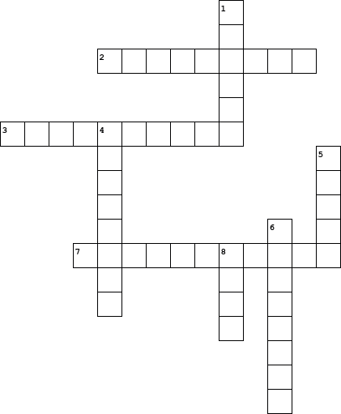

  Across
  2. | An extra amount of money that the bank pays you when you keep your money in a savings account.
  3. | When you spend more money than you have in your account, the bank might charge you a fee for this.
  7. | Taking money out of your bank account, either by using an ATM or visiting the bank.
  Down
  1. | A piece of paper that you write an amount on, and the bank pays that amount to the person or business you wrote it to.
  4. | Money you put into your bank account. This can include cash, checks, or electronic transfers.
  5. | Money that the bank lends you, and you have to pay it back with interest over time.
  6. | The amount of money in your bank account after all transactions have been taken into account.
  8. | Automated Teller Machine - A machine that allows you to perform banking transactions such as withdrawals and deposits without visiting the bank.

Bank Tellers: Helping People with Their Money

Bank tellers are important people who work at banks. They help customers with their money every day. When you go to a bank, you might see a bank teller behind a counter. They are there to assist you with your transactions.

One of the main things bank tellers do is help you put money into your bank account. When you get money, like a paycheck, you can give it to the bank teller. They will count it and put it into your account. This way, your money stays safe and you can use it later.

Bank tellers also give you money when you need it. If you want to take money out of your account, they can give you cash. They count the money carefully to make sure you get the right amount. They might also help you with coins if you have some.

Another job that bank tellers have is to cash checks. When you receive a check, you can bring it to the bank. The teller will look at the check, check your ID, and give you the money. This helps you get the money that someone else wants to give you.

Being a bank teller is not just about handling money. It's also about being professional. Being professional means being polite, helpful, and respectful to everyone. When bank tellers talk to customers, they use their good manners and make them feel welcome. This is very important because people like to be treated nicely.

Bank tellers also need to pay attention to details. They have to make sure that all the numbers are correct when they count money or process transactions. This is important to keep everything accurate and avoid mistakes.

Next time you visit a bank, say hello to the bank tellers. They play an important role in helping people manage their money, and they do it with professionalism and care.

In this passage, we learn about the various tasks bank tellers do, from handling deposits and withdrawals to cashing checks. We also see how being professional is a key part of their job, as they use good manners, pay attention to details, and make customers feel valued. Being professional helps bank tellers create a positive experience for everyone they assist.

Reflection Exit Slip

In one sentence, describe what you learned in this lesson.

Today, I learned _______________________________________________________________.

Is one of the careers discussed today of interest to you? Why or why not?

I liked / did not like ____________________________________ career because___________

______________________________________________________________________________.

Is there anything you still need help understanding?

What’s one question you have?

Circle the emoji that shows how you feel about your mastery of content in this lesson.

😁 🤩 🥴 😭 😠
Happy Smart Confused Sad Angry

