37. Finance Cluster - Tax and Accounting Careers (4 hours)
Purpose/Abstract: To introduce students to tax and accounting careers.
NCCCS Adult Education Standards: R.3.2.3, W.5.2.7, M.4.1.1
Learning Objective:
By the end of the session, students will be able to:
- Work as a team to create a balance sheet for a chosen small business
- Describe skills required for effective accounting practices
Soft Skills | problem solving & critical thinking, professionalism | Resources | Skills to Pay the Bills (STPTB) (for instructor reference to define each soft skill category)  13-2082.00 - Tax Preparers  NC Career Clusters Guide (for instructor reference)  Handouts:  Vocabulary Match - one for each student  Introduction to Balance Sheets - one for each pair  Balance Sheet Template - one for each group
Additional Materials
- Vocabulary Match handout, one for each student
- Introduction to Balance Sheets handout, one for each pair
- Balance Sheet Template - one for each group
- Art supplies (glue, glitter, markers, paint, etc.)
- Pencils, paper, and scissors
- Computers for student use
Icons | 💭 Activity ✔Check-In ⟲ Review

PREPARATION
- Review the graphs in this lesson and prepare to explain them in simple terms to students
- Review the balance sheet template for the group activity
- Review the Instructional Support Guide and print/prepare referenced scaffolds.
- Print handouts.
- Familiarize yourself with O*NET
- Familiarize yourself with Skills to Pay the Bills, though it won’t be used directly in this lesson.

INTRODUCTION (30 min)
Welcome students to the class!

Distribute index cards to each student. Ask them to write down one thing they find financially challenging or confusing. Collect the cards and read a few responses aloud, creating a shared experience.

Present the lesson's objective: to understand basic concepts of tax and accounting careers and create a balance sheet for a small business. Share a brief overview of the Finance Cluster, emphasizing the significance of tax and accounting careers in different industries. Feel free to use the following excerpt to add to your explanation.
Tax and accounting careers are like the financial "detectives" of the business world. They track and manage money, making sure that financial records are accurate and that taxes are calculated correctly. Tax and accounting professionals ensure that businesses comply with financial regulations, keep track of income and expenses, and provide crucial insights for decision-making.
In every industry, from healthcare to entertainment, manufacturing to technology, tax and accounting professionals help organizations maintain their financial health. Their work is like a backbone that supports businesses in achieving their goals and growth

Share the objectives of the lesson.
VOCABULARY, READING & WRITING (45 min)

Distribute the Vocabulary Match handout to each student.
Engage students in a "Match the Following" activity using the provided vocabulary words and their definitions.

Explain the words in simple terms for students to understand.

Distribute the Introduction to Balance Sheets handout and pair students up.
Allow 20 minutes for reading and walk around to clarify any doubts students have.

💭 REFLECTION (10 minutes)
✔ Guide a discussion around the passage using the following questions:
- Do you remember the three parts of a balance sheet?
- What's the difference between assets and liabilities?
- How do balance sheets help companies make decisions?

Encourage students to share examples from their lives, like saving money for a toy or borrowing a book from a friend, to make the concept of balance sheets more relatable. Highlight that, just like keeping track of your pocket money helps students plan, balance sheets help companies plan and keep their money safe and organized.

Wrap up this section by telling students that they’ll use this information to create our own balance sheets later and see how it all works!

Lower Level | Higher Level
Pair students up for the reading activity. | Encourage students to go on the internet and look for sample balance sheets and see if they can identify the sections mentioned in the passage. Have them share their findings with the rest of the class.

MATHEMATICS (45 min)

Tell students that in today’s lesson they will continue to explore how graphs are used in careers in the Finance Cluster. Project each of the following graphs and explain them briefly and have students share what they understand. You do not need to get into too much detail, this is more to introduce students to the various ways in which graphs help present financial data for easy understanding. Before projecting these graphs increase the size for better visibility.

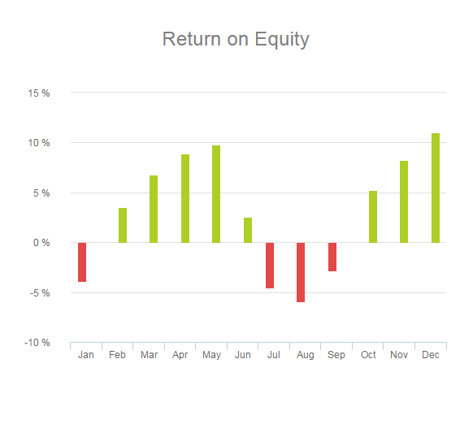
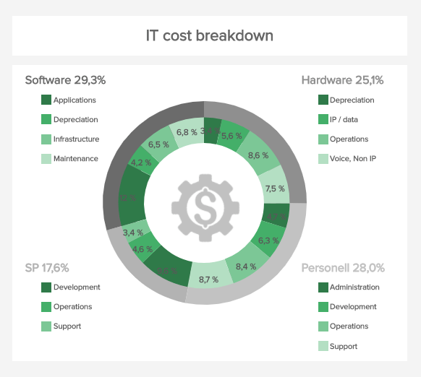

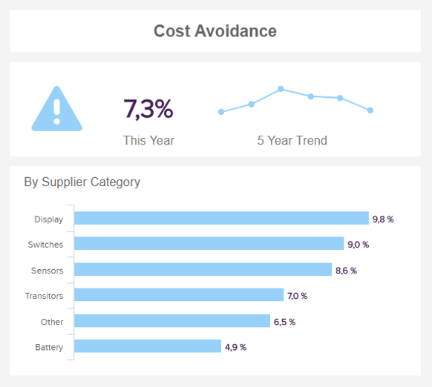

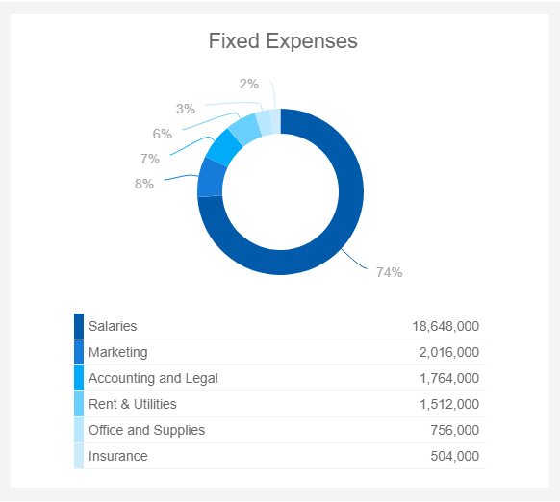

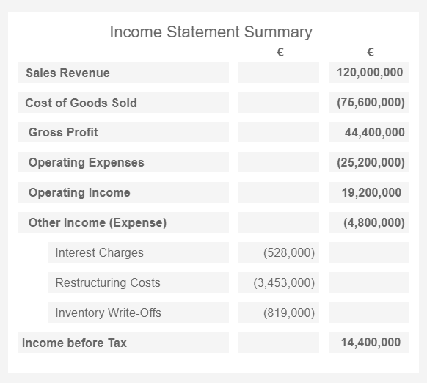
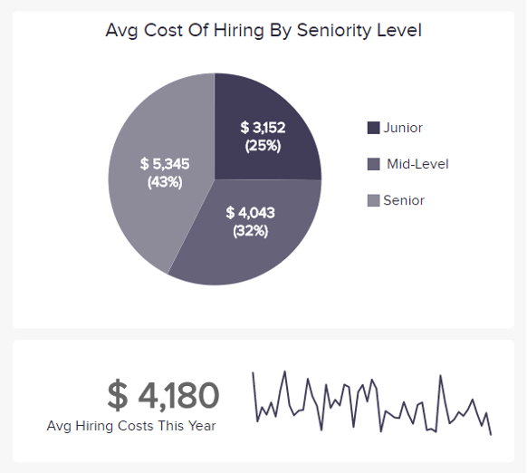
💭 REFLECTION (15 minutes)
✔ Have 2-3 students share their reflections about what they learned through this exercise.

Ask them to think about how they might use graphs in their personal lives and discuss with a partner. Have a few students share their ideas.
GROUP WORK (60 min)

Tell students that they will work together to create simple balance sheets for different types of small businesses. This will help them understand how businesses manage their money and keep track of what they own and owe.

Review what balance sheets are and have students share what they understand from the reading comprehension passage on balance sheets.

Project this template and explain the different sections. Explain briefly about updating the balance sheet either monthly or quarterly and answer questions students have on the template.

Tell students that they will work in groups on businesses assigned to them.

Divide the class into groups of 4. Assign each group a business type like a bakery, bookstore, or coffee shop. This helps students focus on one kind of business.

Provide basic details about what each business might own (assets) and what they might owe (liabilities). Use the following list as a guide.
- Bakery
  - Assets: Oven, baking equipment, mixers, flour and ingredients, electrical appliances
  - Liabilities: Bills to pay for raw materials, loans, employee wages, insurance
- Bookstore
  - Assets: Books Inventory, Shelves and Furniture
  - Liabilities: Bills to Pay, insurance
- Coffee Shop
  - Assets: Coffee Machines, Coffee Beans Inventory, Furniture, Music System
  - Liabilities: Bills to Pay, rent, employee wages, insurance

Inform students that working together they will create a simple balance sheet for all four quarters and find the total assets, liabilities and equity.

Hand out the Balance Sheet Template to each group.

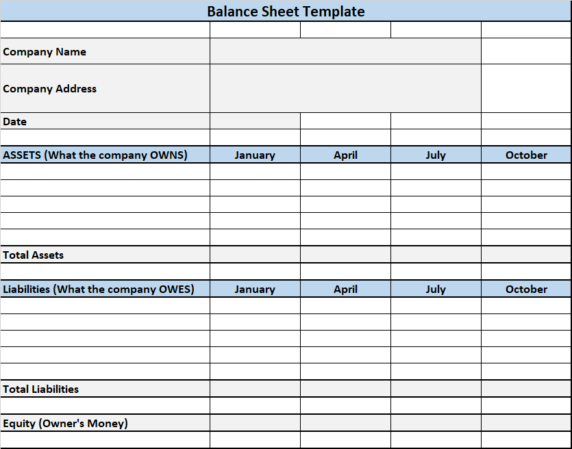

Walk around and support students with their balance sheets.
💭 REFLECTION (20 minutes)
✔ Each group can briefly share what they put on their balance sheet. Ask questions like:

What things does this business own? (Assets)
What things does this business need to pay for? (Liabilities)
How much is left for the owner after paying all the bills? (Equity)

INDEPENDENT WORK TIME (45 min)

Tell students that they will spend this time reviewing what they learned in this lesson and read about tax preparers.

Share 13-2082.00 - Tax Preparers and allow students time to read through and ask any questions that come up.

💭 REFLECTION (15 minutes)
✔Have a few volunteers share what they read about. Guide a short discussion about the career and ask questions to understand what students connected with about the career.

Lower Level | Higher Level
Share the easy-read link with students. Tax Preparers at My Next Move | Encourage students to research other tax and accounting careers and make a list.

WRAP-UP & REFLECTION (15 min)

Distribute exit slips to students.
Ask for a few volunteers to share their reflections.
Collect and review the answers.

Vocabulary Match
Directions:
- Match the words in the first column to the correct definitions in the second column.

Word | Definition
Assets | The remaining interest in company assets after deducting liabilities
Liabilities | Financial obligations and debts owed by a company
Revenue | Items of value that a company owns, contributing to its overall worth
Equity | Costs incurred by a company in its day-to-day operations
Expenses | Financial obligations and debts owed by a company

Introduction to Balance Sheets

Directions:
- Read the passage given below, use the subheadings to help you understand the information.

A balance sheet is like a snapshot of a company's money. It helps us see how much money a company has and how much it owes. Imagine you have a piggy bank. Inside, you keep your money and sometimes you also borrow money from friends. That's kind of like what a balance sheet shows for a company!

What's Inside a Balance Sheet:
A balance sheet has three important parts: assets, liabilities, and equity.

Assets: These are things that a company owns, like money in the bank, computers, and even the building where the company works. Just like you have toys and books, a company has things too, and they are all valuable.

Liabilities: These are promises a company made to give money or things back to other people or companies. It's a bit like when you borrow a toy from a friend and promise to give it back.

Equity: Think of equity as the leftover money after the company pays back all the promises (liabilities). It's like the money that's truly owned by the company.

Why Balance Sheets Are Important:
Balance sheets help companies keep track of their money. They show if a company is doing well or if it needs to be careful with its spending. It's like how you keep track of your pocket money – if you know how much you have, you can decide what to buy.

Companies use balance sheets to make smart decisions. They can see which things are helping them make money (assets) and which things they need to pay (liabilities). Balance sheets also help people understand if a company is in good financial health.

Sample Balance Sheet

Reflection Exit Slip

In one sentence, describe what you learned in this lesson.

Today, I learned _______________________________________________________________.

Is one of the careers discussed today of interest to you? Why or why not?

I liked / did not like ____________________________________ career because___________

______________________________________________________________________________.

Is there anything you still need help understanding?

What’s one question you have?

Circle the emoji that shows how you feel about your mastery of content in this lesson.

😁 🤩 🥴 😭 😠
Happy Smart Confused Sad Angry

