43. Health Science Cluster - Mental Health Careers (4 hours)
Purpose/Abstract: To introduce students to mental health careers and their importance in the healthcare industry.
NCCCS Adult Education Standards: R.5.2.9, W.5.2.1, M.4.2.3
Learning Objective:
By the end of the session, students will be able to:
- Evaluate the importance of mental health professionals
- Analyze informational texts on mental health careers
- Compose informative texts that introduce mental health career subjects, utilizing facts and linking phrases to effectively communicate key points.
Soft Skills | communication, professionalism | Resources | Skills to Pay the Bills (STPTB) (for instructor reference to define each soft skill category)  Mental Health, Substance Abuse, and Behavioral Disorder Counselors Career Video  NC Career Clusters Guide (for instructor reference)  Handouts:  Vocabulary Practice - one for each student  Reading Comprehension - one for each student
Additional Materials
- Vocabulary Practice handout, one for each student
- Reading Comprehension, one for each student
- Art supplies (glue, glitter, markers, paint, etc.)
- Pencils, paper, and scissors
- Computers for student use
Icons | 💭 Activity ✔Check-In ⟲ Review

PREPARATION
- Watch the video below and prepare to guide discussions around them.
  - Mental Health, Substance Abuse, and Behavioral Disorder Counselors Career Video
- Familiarize yourself with WIOA Partners | AEFLA and be prepared to locate applicable mental health services for students.
- Review the Instructional Support Guide and print/prepare referenced scaffolds.
- Print handouts.
- Familiarize yourself with the NC Career Clusters Guide.
- Familiarize yourself with O*NET
- Familiarize yourself with Skills to Pay the Bills, though it won’t be used directly in this lesson.

INTRODUCTION (30 min)
Welcome students to the class!
Have each student share two true statements and one false statement about themselves related to mental health or healthcare. This activity introduces the topic of mental health and encourages communication.
Display the term "Mental Health Careers" and ask students if they know what it means.
Play the video Mental Health, Substance Abuse, and Behavioral Disorder Counselors Career Video
Explain the importance of mental health professionals in society and how they help individuals with mental health challenges.
Relate the topic to the students' own experiences and emphasize the role of communication and professionalism in mental health careers.
Share the objectives of the lesson.
VOCABULARY, READING & WRITING (45 min)

Distribute the vocabulary practice handout to students and allow 15 minutes for completion.

Take a few minutes to review the definitions and encourage students to use the words in sentences.

Distribute the reading comprehension handout and give students 15 minutes to read through.

Bring the class back together.

💭 REFLECTION (15 minutes)
✔ Ask the following comprehension questions to check if students understand the importance of communiciaton and professionalism in mental health careers.

- What is the main job of mental health professionals like counselors and psychologists?
- Why do you think it's important for these professionals to listen carefully to what people say?
- How do mental health professionals use good communication to help people?
- Can you think of a time when good communication helped you feel better? How did it make you feel?
- How might acting professionally help build trust between the mental health helper and the person they're helping?
- Imagine you're a social worker. What kind of things would you do to help someone who is going through a tough time?
Lower Level | Higher Level
Pair students up for the reading activity and encourage them to read aloud to their partner. | Encourage students to think about the following two questions and write their thoughts down:  - Why do you think it's important for people to know that what they share with a mental health professional will be kept private? How might this help people feel more comfortable seeking help?  - How do mental health professionals make sure that what you talk about with them stays private?

MATHEMATICS (45 min)

Briefly review bar graphs and scaled bar graphs and have students share what they remember from previous lessons.

Project the first scaled bar graph and spend a few minutes explaining what the graph the graph is about the different parts of the graph. Explain how the data must have been gathered using a survey.
Demonstrate how to answer questions on this graph using the first question listed below the graph. Ask the remaining questions to students and provide ample time for them to work out the answer. Guide them as required.

Repeat these same steps for the second graph listed below that shows the personal source of stress among students.
Bar graph showing measures taken by participants to maintain mental health during lockdown
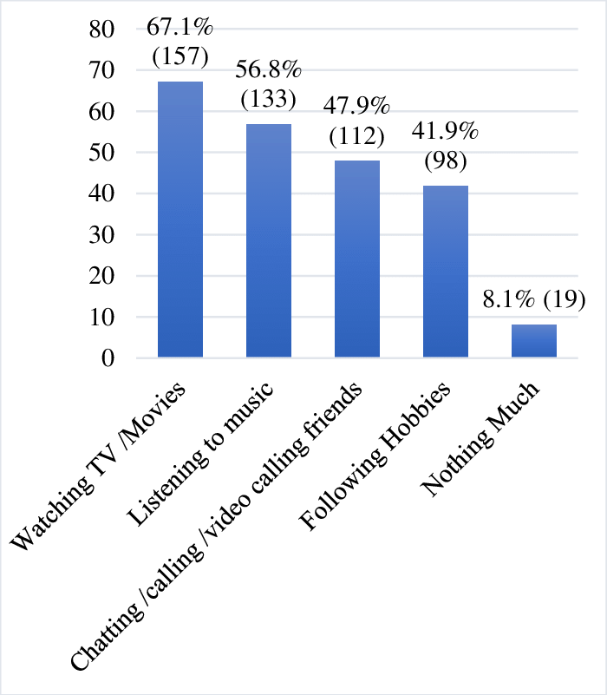
(Source: Bar graph showing measures taken by participants to maintain mental health during lockdown )

- How many more people watched TV/movies compared to those who said they did nothing much to maintain their mental health during lockdown?

- How many less people followed hobbies as compared to those who listened to music to maintain their mental health during lockdown?

- How many more participants chose to video call their friends compared to those who said they followed their hobbies for maintaining mental health during lockdown?

- How many less people said they did nothing much for their mental health compared to those who chose to listen to music during lockdown?

- How many more participants watched TV/movies than those who said they followed hobbies to maintain their mental health during lockdown?

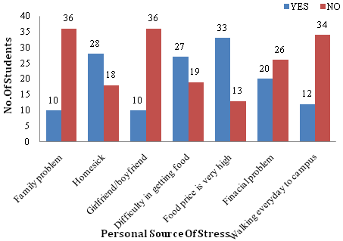
(Source: Bar Graph Based on Personal Related Source of Stress. | Download Scientific Diagram)

- How many more participants experienced homesickness compared to those who had difficulty getting food?

- How many less participants reported financial problems compared to those who said they had high food prices as a source of stress?

- How many more participants did not experience walking to campus as a source of stress compared to those who reported having family problems?

- How many less participants did not face financial problems compared to those who said they had difficulty getting food as a source of stress?
- How many more participants did not have a girlfriend or boyfriend as a source of stress compared to those who experienced homesickness?

💭 REFLECTION (10 minutes)
✔ Have 1-2 students share what was easy and what was difficult in this activity.

GROUP WORK (60 min)

Explain what a group discussion is before you begin the activity for this section.
Inform students that they will explore mental health challenges and career interventions in small groups.

Divide the class into small groups of about 3-5 students each.

Provide each group with a set of scenarios that depict various mental health challenges individuals might face. These scenarios could include situations like coping with anxiety before a big presentation, helping a friend who is feeling isolated, or supporting someone struggling with low self-esteem. The scenarios should be realistic and relatable, encouraging students to think critically about the potential issues people might encounter.

Along with each scenario, provide information about different mental health professionals (counselors, psychologists, social workers) and their roles. Explain how each type of professional can offer support and interventions to address the specific challenges presented in the scenarios. For instance, a counselor might use talk therapy to help someone manage anxiety, while a psychologist might employ techniques to boost self-esteem. Encourage students to refer to the reading comprehension passage or look up more information on the internet, if required.

In their small groups, students will read and discuss the scenarios provided. They should consider how mental health professionals could offer assistance in each situation. Encourage students to brainstorm ideas and discuss potential approaches that professionals might take. For instance, if the scenario involves a person feeling isolated, students might discuss how a social worker could help connect the individual with social groups or resources.
During their discussions, students should focus not only on the types of interventions mental health professionals might use but also on how these professionals would communicate and behave. Stress the importance of effective communication skills, such as active listening, using empathetic language, and creating a supportive environment.
Hiighlight the significance of professionalism in these interactions, which includes maintaining confidentiality, showing respect, and adhering to ethical standards.

💭 REFLECTION (20 minutes)
✔Have each group present their findings to the class. Guide a discussion around what students share while highlighting instances of teamwork, effective communication you noticed within the groups.

INDEPENDENT WORK TIME (45 min)

Have students write a short reflection on the importance of mental health professionals. Give them the following topic: magine you are writing to a friend about mental health professionals. Write a short paragraph about why you think mental health professionals are helpful.

Allow 30 minutes for this activity.

Using the information you’ve gathered from WIOA partners, share a few resources and contacts of mental health professionals with students and emphasize the importance of reaching out for help when needed.

Lower Level | Higher Level
Provide sentence starters. Here are a few examples:  "Mental health professionals are important because…”  “ From what I learned, mental health professionals are crucial because..”  "They use their skills to make people feel better by..."  "They work in different places like hospitals and schools to help..." | Challenge students to think about the following and add to their paragraphs:  Share your thoughts on the challenges mental health professionals might face in their work.  How do you think they navigate difficult situations to provide the best care possible?

WRAP-UP & REFLECTION (15 min)
Review the main concepts covered in the lesson: mental health careers, communication, and professionalism.
Ask students to share one new thing they learned during the lesson.

Distribute exit slips to students.
Ask for a few volunteers to share their reflections.
Collect and review the answers.

Vocabulary Practice
Directions:
- Match the words in column 1 with the correct definitions in column 2

Word | Definition
Therapist | Negative beliefs or attitudes that people may have about mental health issues, which can create barriers for seeking help or treatment
Psychologist | A trained professional who uses different methods, like talking or activities, to help individuals improve their mental and emotional well-being
Social Worker | An expert in the study of the mind and behavior who helps people understand their thoughts and feelings and provides strategies to manage them
Diagnosis | The ability to bounce back and cope with challenges, setbacks, and stressors in a healthy and positive way
Stigma | A person who supports individuals and families by connecting them with resources and services to improve their overall well-being
Resilience | Identifying and understanding a person's mental health condition based on their symptoms and experiences

Reading Comprehension
Discovering Mental Health Careers: How Communication and Professionalism Make a Difference
Did you know that some special people have jobs that help others with their feelings and thoughts? These special people are called mental health professionals. They work in places like hospitals, schools, and clinics to help people who might be feeling sad, worried, or scared. Let's learn more about how they use good communication and act professionally to make a big impact.
Meet the Helpers
Counselors: These are like friendly listeners who talk to people about their worries. They help people find ways to feel better and handle tough times. They use kind words and make sure to understand how others feel.
Psychologists: These smart folks study how our minds work. They chat with people to understand why they feel certain ways. Then, they share ideas on how to think happier thoughts.
Social Workers: These helpers care about every part of a person's life. They talk with people to see what they need. Then, they find ways to get them help and support.
How They Help
When you talk to these helpers, they use their words to make you feel safe and understood. This is called good communication. They listen carefully to your words and feelings. They ask questions and show that they care. This helps you feel better because you know someone understands.
These helpers also act professionally. This means they act in a serious and respectful way. They keep things private, which means they don't tell anyone else what you talk about. They follow rules to make sure you stay safe and get the best care.
Why It Matters
When you're feeling down, these helpers can make you feel better. They help you find ways to cope with tough times and make happy changes. The way they talk and act makes a big difference. It helps you trust them and share your feelings. That's why communication and professionalism are super important in their jobs.
In the end, mental health professionals use their special skills to help people feel happier and stronger. They show that good communication and acting professionally can create a safe and caring place for everyone. So, if you ever need someone to talk to, remember these helpful friends are there to listen and make you feel better.

Reflection Exit Slip

In one sentence, describe what you learned in this lesson.

Today, I learned _______________________________________________________________.

Is one of the careers discussed today of interest to you? Why or why not?

I liked / did not like ____________________________________ career because___________

______________________________________________________________________________.

Is there anything you still need help understanding?

What’s one question you have?

Circle the emoji that shows how you feel about your mastery of content in this lesson.

😁 🤩 🥴 😭 😠
Happy Smart Confused Sad Angry

