44. Health Science Cluster - Dental Health Careers (4 hours)
Purpose/Abstract: To introduce students to dental hygienist and dental assistant roles.
NCCCS Adult Education Standards: R.3.2.3, W.5.1.3, M.2.2.4
Learning Objective:
By the end of the session, students will be able to:
- Analyze simple charts, graphs, and labels to extract information and answer questions
- Participate in dialogues with peers concerning dental health careers
- Apply measurement and estimation skills to solve problems
Soft Skills | communication, professionalism,  enthusiasm & attitude | Resources | Skills to Pay the Bills (STPTB) (for instructor reference to define each soft skill category)  Math:  Choose the Unit: Liquid Volume | Worksheet | Education.com  Liquid Volume Equivalents #1 | Worksheet | Education.com  Dental Assistants : Occupational Outlook Handbook  Dental Hygienists : Occupational Outlook Handbook  NC Career Clusters Guide (for instructor reference)  Handouts:  Vocabulary Practice - one for each student
Additional Materials
- Vocabulary Practice handout, one for each student
- Art supplies (glue, glitter, markers, paint, etc.)
- Pencils, paper, and scissors
- Computers for student use
Icons | 💭 Activity ✔Check-In ⟲ Review

PREPARATION
- Review the worksheets and games on education.com and print out the following worksheets:
  - Choose the Unit: Liquid Volume | Worksheet | Education.com
  - Liquid Volume Equivalents #1 | Worksheet | Education.com
- Review the following links and be prepared to answer questions:
  - Dental Assistants : Occupational Outlook Handbook
  - Dental Hygienists : Occupational Outlook Handbook
- Review the Instructional Support Guide and print/prepare referenced scaffolds.
- Print handouts.
- Familiarize yourself with the NC Career Clusters Guide.
- Familiarize yourself with O*NET
- Familiarize yourself with Skills to Pay the Bills, though it won’t be used directly in this lesson.

INTRODUCTION (30 min)
Welcome students to the class!
Ask students to share a memory from their past that is related to dental health. It could be a visit to the dentist, a memorable experience with oral hygiene, or even a funny tooth-related story.
Encourage each student to take turns sharing their memory with the class.
After students share, the class can engage in a brief discussion or ask questions related to the shared memory. Here are some ideas for you, feel free to select questions from here got guide the discussion.
How did that experience make you feel?
What did you learn from that experience?
How does that memory relate to what we're learning today about dental health careers?
Do you think that memory might have influenced your perspective on oral health or dental professionals?

Briefly review the Health Science Cluster and how dental careers fit in. Highlight that this lesson will focus on dental assistants and dental hygienists.

Share the objectives of the lesson.
VOCABULARY, READING & WRITING (60 min)

Distribute the vocabulary practice handout to students and allow 15 minutes for completion. Demonstrate how they they should search for words in the provided grid with one word.

Review the solution with the class and ask students to define the words.

Pair students up and share Dental Assistants : Occupational Outlook Handbook and Dental Hygienists : Occupational Outlook Handbook. Alternatively you can project these links one after the other for this activity.

Instruct students to go to the Job Outlook tab. Explain that the information presented here is an example of text supplemented with charts and graphs. Ask students to read the text and to identify and analyze the charts and graphs both dental assistants and dental hygienists.

Encourage students to discuss the projected employment growth and other career-related data presented.

Ask students to consider the importance of these insights in making informed decisions about career paths.

Allow 30 minutes for students to read, analyze and discuss both the links.

Bring the class back together.

💭 REFLECTION (15 minutes)
✔ Ask the following comprehension questions to check for understanding
- What is the projected employment growth for dental assistants and dental hygienists?
- How might this data influence your perceptions of these dental health careers?
- What other information do the charts and graphs provide about the job outlook for these professions?
- (Optional) What can you infer from the Quick Facts Chart on the Summary tab?

Lower Level | Higher Level
Provide individual support for students to interpret the graph in relation to the text. | Encourage students to explore the Summary tab and interpret the chart presented.

MATHEMATICS (45 min)

Begin by explaining the relevance of measurement and estimation skills in dental health careers. Mention that professionals often need to accurately measure and estimate liquid volumes for various tasks, such as preparing solutions, medications, and mouthwashes.

Provide the students with a scenario:
"As a dental assistant, you are tasked with preparing a mouthwash solution for a patient. The dentist prescribes a specific volume of mouthwash. Your job is to accurately measure the required amount."

Distribute the Choose the Unit: Liquid Volume worksheet to each student.
Instruct students to work individually to complete the worksheet, choosing the appropriate unit of measurement for the given volumes.
Emphasize the importance of precision in measurements.
Provide the students with the following scenario:
"As a dental hygienist, you are responsible for preparing dental solutions for patients. Your task is to estimate the appropriate volume of a dental solution based on different liquid measurement units."

Distribute the Liquid Volume Equivalents 1 worksheet to each student.
Instruct students to work individually or in pairs to complete the worksheet, focusing on matching the equivalent volumes between different liquid measurement units, such as ounces, pints, cups, quarts, and gallons.

Walk around and provide support.
💭 REFLECTION (10 minutes)
After completing the worksheets, lead a class discussion on the importance of accurate liquid volume measurements in dental health practices.

✔ Ask students to reflect on the dental solution scenario and their approach to estimating liquid volume conversions. How did they use the conversion table to match equivalent volumes?
Summarize the activity by highlighting the significance of accurate liquid volume conversions in dental health careers. Emphasize that these skills directly impact patient care and the quality of dental solutions.

Lower Level | Higher Level
Offer support by discussing the units of measurement and helping them understand how to convert between units if necessary. | Encourage them to think about the practical implications of accurate liquid volume measurements in preparing dental solutions. Discuss the potential consequences of using incorrect volumes.

GROUP WORK (60 min)

Divide the class into groups of 3 students each. Provide each group with one of the following links:
31-9091.00 - Dental Assistants
29-1292.00 - Dental Hygienists
Explain that each group will research and present information about either dental assistants or dental hygienists.

Provide a set of common research questions for each group to guide their exploration:

- What are the primary clinical duties and responsibilities of dental assistants/dental hygienists?
- How do dental assistants/dental hygienists contribute to patient care and treatment procedures?
- What essential skills are required for success in the role?
- What education and training pathways are typically pursued to become a dental assistant or dental hygienist?
- How do dental assistants/dental hygienists utilize technology and tools in their daily tasks?
Instruct each group to:
- Assign roles within the group, such as a researcher, note-taker, and presenter.
- Explore the provided links and gather information based on the common research questions.
- Take notes on key findings, statistics, and any relevant details.
Allow time for group research. Circulate among the groups to provide guidance and answer questions as needed.

Once the research is complete, instruct each group to prepare a presentation summarizing their findings. They should address the common research questions and highlight key insights about the selected dental health career.

💭 REFLECTION (20 minutes)
✔Have all groups or a few present their findings depending on the time available.
Compare and contrast the roles of dental assistants and dental hygienists based on the shared research questions. Guide students in reflecting on how the presented information aligns with the soft skills discussed earlier in the lesson, such as communication and professionalism.

INDEPENDENT WORK TIME (30 min)

Tell students they can work on a short writing activity and once it’s completed, they can research on these roles using the links from the reading comprehension section.

Provide the following prompt: "Imagine you are a dental assistant or dental hygienist. Write a short paragraph about a typical day in your job."

Consider using this time to provide individual support for reading comprehension or writing for students.

Lower Level | Higher Level
Provide sentence starters and work with students individually. | Challenge students to write a detailed paragraph with multiple examples.

WRAP-UP & REFLECTION (15 min)
Review key concepts from the lesson and discuss how communication, professionalism, and attitude are essential soft skills in dental health careers.

Ask students to share one new thing they found interesting in this lesson.

Distribute exit slips to students.
Ask for a few volunteers to share their reflections.
Collect and review the answers.

Vocabulary Practice
Directions:
- Find the words listed below.

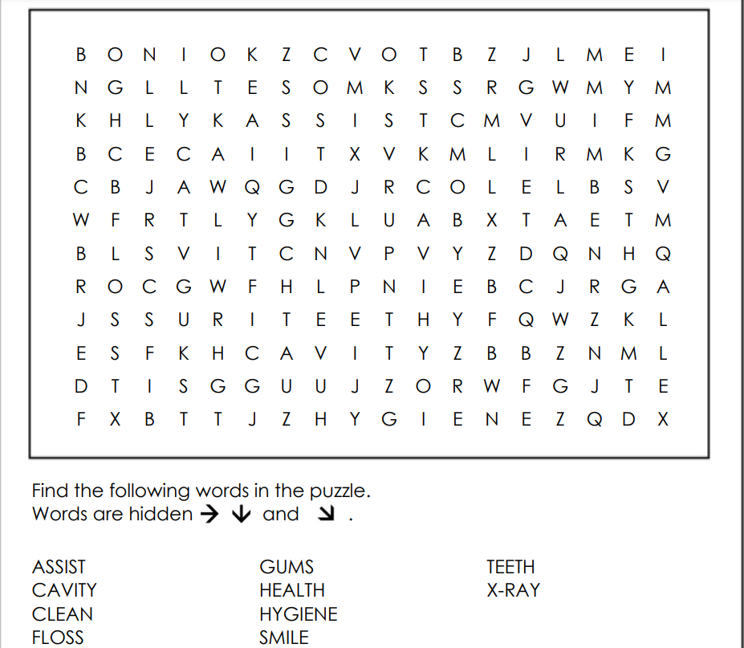

Reflection Exit Slip

In one sentence, describe what you learned in this lesson.

Today, I learned _______________________________________________________________.

Is one of the careers discussed today of interest to you? Why or why not?

I liked / did not like ____________________________________ career because___________

______________________________________________________________________________.

Is there anything you still need help understanding?

What’s one question you have?

Circle the emoji that shows how you feel about your mastery of content in this lesson.

😁 🤩 🥴 😭 😠
Happy Smart Confused Sad Angry

