48. Hospitality and Tourism Cluster - Housekeeping Careers (4 hours)
Purpose/Abstract: To introduce students to housekeeping careers and the importance of following Safety Data Sheets in these careers..
NCCCS Adult Education Standards: R.3.2.3, W.5.1.3, M.2.2.4
Learning Objective:
By the end of the session, students will be able to:
- Identify common cleaning tools and products used by maids, housekeeping cleaners, janitors, and other cleaning professionals.
- Recognize the importance of following Safety Data Sheets (SDS) guidelines to ensure personal safety and the safety of others while cleaning.
- Describe the steps involved in cleaning tasks, using simple and clear language.
- Identify the roles and responsibilities of maids, housekeeping cleaners, janitors, and other cleaning professionals in the hospitality and tourism industry.
Soft Skills | enthusiasm & attitude  teamwork  professionalism | Resources | Skills to Pay the Bills (STPTB) (for instructor reference to define each soft skill category)  37-2011.00 - Janitors and Cleaners, Except Maids and Housekeeping Cleaners  37-2012.00 - Maids and Housekeeping Cleaners  Math:  Word Problems: Perimeter | Worksheet | Education.com  Pentagon Perimeters | Worksheet | Education.com  Longest Route: Calculating Perimeter | Worksheet | Education.com  Clorox SDS  Dawn SDS  Lysol SDS  Housekeeping tips: How to make the perfect hotel bed  Hospitality Techniques Masterclass | Episode 4: Carpet Stain Removal  Handouts:  Housekeeping word search - one for each student  Housekeeping Helpers - one for each student
Additional Materials
- Housekeeping word search handout, one for each student
- Housekeeping Helpers handout, one for each student
- Art supplies (glue, glitter, markers, paint, etc.)
- Pencils, paper, and scissors
- Computers for student use
Icons | 💭 Activity ✔Check-In ⟲ Review

PREPARATION
- Review and print out these worksheets on education.com and be prepared to support students with the problems:
  - Word Problems: Perimeter | Worksheet | Education.com
  - Pentagon Perimeters | Worksheet | Education.com
  - Longest Route: Calculating Perimeter | Worksheet | Education.com
- Review the Safety Data Sheets linked and familiarize yourself with the GHS pictograms.
- Bookmark or download a few images of messy and clean hotel rooms to show in the introduction.
- Watch the housekeeping videos and be prepared to answer questions:
  - Housekeeping tips: How to make the perfect hotel bed
  - Hospitality Techniques Masterclass | Episode 4: Carpet Stain Removal
- Review the Instructional Support Guide and print/prepare referenced scaffolds.
- Print handouts.
- Familiarize yourself with O*NET
- Familiarize yourself with Skills to Pay the Bills, though it won’t be used directly in this lesson.

INTRODUCTION (30 min)
Welcome students to the class!
Start with an ice-breaker. Divide students into small groups. Provide them with a "mess" (scattered papers, small items) and cleaning supplies (wipes, broom, etc.). Instruct them to work together to clean the mess. This introduces teamwork and emphasizes the importance of cleaning.
Discuss the importance of housekeeping careers in the hospitality and tourism industry. Show images of clean and messy rooms to highlight the impact of housekeeping. Explain that they will explore different aspects of housekeeping careers today.
Share the objectives of the lesson.
VOCABULARY, READING & WRITING (45 min)

Distribute the Word Search handout containing the key vocabulary words related to housekeeping and cleaning tools/products. If students choose to solve the word search online, please ask them to use the link given in the handout. Let students know that the words can be found horizontally, vertically or diagonally. Allow 15-20 minutes for completion.

Review the solution with the whole class.

Hand out the Housekeeping Helpers handout to students. Let them know that after reading they should be prepared to answer a few questions to discuss the passage.

💭 REFLECTION (15 minutes)
✔ Guide a discussion to check students’ comprehension using the following questions.
- Summarize the passage content using the words in bold?
- How can you make use of text features like bold print, subheadings, captions to help you understand the main points in a passage or website?
- Why is enthusiasm important for maids and cleaners?
- What does it mean to be professional as a maid or cleaner?

Lower Level | Higher Level
Pair students up if required for the reading comprehension. | Encourage students to think about what other attributes are important in housekeeping careers.

MATHEMATICS (60 min)

Review perimeter concepts with the class.
Use the following example to demonstrate how knowledge of perimeter can help with housekeeping careers.
Imagine a housekeeper who needs to clean several hotel rooms. They need to find the quickest route to move from one room to another. Similarly, when they change bedding, clean bathrooms, or vacuum carpets, they want to find the shortest path to get the job done well and save time. Perimeter is the distance around the edge of a shape or area. In the real world, we use perimeter to measure the distance around objects or spaces, just like housekeepers need to find the shortest route to efficiently clean rooms.
Tell students that as they work on the math worksheet that involves calculating perimeter, to think about how this math concept can relate to the tasks housekeeping professionals do. Remind students that finding the shortest route can help them complete their work effectively and ensure that guests have clean and tidy spaces to enjoy.

Assign Longest Route: Calculating Perimeter | Worksheet | Education.com to students. Let them know that this is not directly related to housekeeping careers but will provide them with practice for calculating the shortest route possible.

After 15 minutes, review the answers with the class. Let students know that they will continue practicing problems on solving for the perimeter through word problems and also for pentagons. Demonstrate how to find the perimeter of a pentagon on the board and clarify doubts before assigning the next set of worksheets.

Assign Word Problems: Perimeter | Worksheet | Education.com and Pentagon Perimeters | Worksheet | Education.com. Walk around and provide individual support as required.

💭 REFLECTION (10 minutes)
✔ Have a few students share their answers and review the worksheets with the whole class. Reiterate how basic operations and knowledge of area and perimeter can be useful in many professions including housekeeping careers.

Lower Level | Higher Level
Consider working with students individually. Write the perimeter formula on the board for the shapes referenced in the worksheet. | Encourage students to support their classmates if they finish work early.

GROUP WORK (45 min)
Begin by explaining what Safety Data Sheets (SDS) are and their importance in ensuring safe use of cleaning products. Emphasize that SDS provide detailed information about the hazards, precautions, and handling procedures for various products. Mention that students will work in groups to read SDS for specific products and prepare presentations to share what they've learned.

Divide the class into groups of 4. Assign each group one of the following products: Clorox, Dawn, or Lysol. Provide each group with the link to the SDS for their assigned product. Instruct them to carefully read through the sheet to understand the information it contains. Highlight that they should pay attention to hazard statements, precautions, and hazard categories.
- Clorox SDS
- Dawn SDS
- Lysol SDS

Within their groups, have students discuss and extract the following information from the SDS:

- Hazard statements
- Precautions
- Storage recommendations
- Hazard category
- Any additional relevant information - Encourage students to use prior knowledge of the product or use the internet to find out how the product is commonly used.

Project this image with GHS pictograms and introduce students to the common signs.
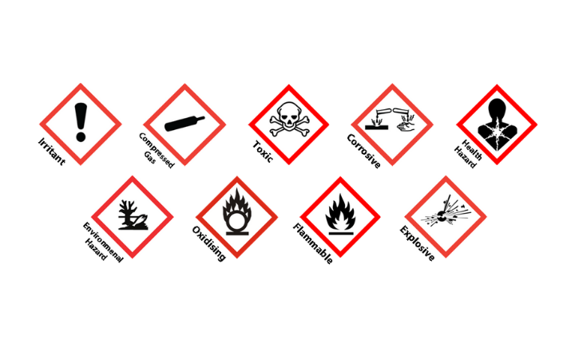

Each group will create a short presentation about the product assigned to them.

💭 REFLECTION (15 minutes)
To save time, have 1-2 groups for each product present their findings while the rest of the class can ask questions or add further information.
Once the presentations are over, talk briefly about workplace safety and hazards highlighting the common accidents that might occur in housekeeping careers. Reiterate the importance of being aware of the SDS for a particular chemical/ product used.
INDEPENDENT WORK TIME (45 min)

Inform students that they will watch videos on two basic housekeeping tasks in hotels and write the steps followed in their own words in the correct sequence.

Play Housekeeping tips: How to make the perfect hotel bed and Hospitality Techniques Masterclass | Episode 4: Carpet Stain Removal one after the other with a pause between the videos to answer questions.

Consider switching on the closed captions on the videos for easier understanding. Encourage students to take notes as they watch the videos. Play them a second time if required.

Allow 25 minutes for students to recall and write down the steps for making a bed and removing a stain from the carpet. Emphasize clear language and use of text features such as subheadings and underlining or using a different colored pen if required to highlight key points.

💭 REFLECTION (10 minutes)
Ask a few volunteers to read what they’ve written.

Instructor Note: If students want to review the videos as they write, do share the link with them.

WRAP-UP & REFLECTION (15 min)

Share the following links for additional reading in their own time:
37-2011.00 - Janitors and Cleaners, Except Maids and Housekeeping Cleaners
37-2012.00 - Maids and Housekeeping Cleaners
Ask students to share one new thing they found interesting in this lesson.

Distribute exit slips to students.
Ask for a few volunteers to share their reflections.
Collect and review the answers.

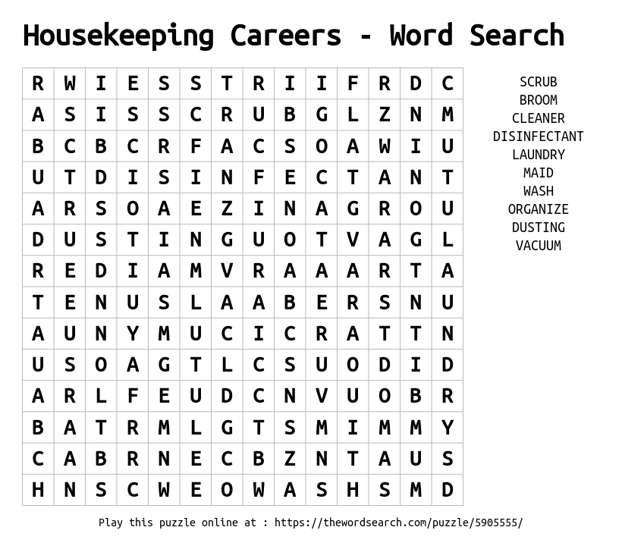

Housekeeping Helpers
Directions:
- Read the passage and be prepared to answer comprehension questions with the rest of the class.

In hospitality and tourism, there are special people who work behind the scenes to make sure everything is clean and welcoming for guests. These people are called maids, housekeeping cleaners, and janitors. They use different tools and products to keep hotels, resorts, and other places nice and tidy.
Maids and cleaners use various tools to make rooms sparkle. They use brooms and mops to sweep and mop the floors. Vacuums help them suck up dust and dirt from carpets. They also use dusters to wipe away cobwebs and dust from high places. Clean, fresh-smelling rooms make guests happy. To make everything clean and shiny, cleaning professionals use special products. They use soapy solutions to wash windows and mirrors, making them clear and gleaming. Disinfectants help kill germs on surfaces, like doorknobs and light switches. Room fresheners make spaces smell nice and inviting.
Enthusiasm means being excited and positive about your work. When maids and cleaners have enthusiasm, they work with a smile. They know that their cleaning makes a big difference in how guests feel. An enthusiastic attitude can make the cleaning process enjoyable and motivate others to keep things neat too. Cleaning professionals often work together in teams. They help each other clean rooms faster and better. Teamwork means sharing tasks and helping one another. When people work together, they can finish more work and have time for fun too. Being professional means doing your job well, no matter what. Maids and cleaners are professionals because they take their work seriously. They follow rules, wear uniforms, and show respect to guests. Their professionalism creates a good impression and makes guests want to return.

Remember, a clean place is a happy place!

Reflection Exit Slip

In one sentence, describe what you learned in this lesson.

Today, I learned _______________________________________________________________.

Is one of the careers discussed today of interest to you? Why or why not?

I liked / did not like ____________________________________ career because___________

______________________________________________________________________________.

Is there anything you still need help understanding?

What’s one question you have?

Circle the emoji that shows how you feel about your mastery of content in this lesson.

😁 🤩 🥴 😭 😠
Happy Smart Confused Sad Angry

