55. Information Technology Cluster - Video Game and Graphic Design Careers (4 hours)
Purpose/Abstract: To introduce students to video game and graphic design careers in the IT cluster.
NCCCS Adult Education Standards: R.3.3.2, W.5.2.5, M.5.2.7
Learning Objective:
By the end of the session, students will be able to:
- Compare and contrast the roles of graphic designers and video game designers, identifying at least three key differences and similarities between the two careers.
- Explore basic functions and tools within the Scratch environment, including selecting characters, creating basic animations, and altering backgrounds.
- Solve two-step word problems using the four arithmetic operations.
Soft Skills | problem-solving and critical thinking | Resources | Scratch  15-1255.01 - Video Game Designers  27-1024.00 - Graphic Designers  Video Game Designers Career Video  Graphic Designer Career Video  Handouts:  Vocabulary Practice  Soft Skills for Video Game and Graphic Design Careers  Math Practice
Additional Materials
- Vocabulary Practice handout, one for each student
- Soft Skills for Video Game and Graphic Design Careers, one for each student
- Math Practice, one for each student
- Art supplies (glue, glitter, markers, paint, etc.)
- Pencils, paper, and scissors
- Computers for student use
Icons | 💭 Activity ✔Check-In ⟲ Review

PREPARATION
- Watch the following videos and use them to introduce students to the two careers in focus.
  - Video Game Designers Career Video
  - Graphic Designer Career Video
- Familiarize yourself with Scratch to help students navigate the site and understand the basics.
- Review the Instructional Support Guide and print/prepare referenced scaffolds.
- Print handouts.
- Familiarize yourself with O*NET
- Familiarize yourself with Skills to Pay the Bills, though it won’t be used directly in this lesson.

INTRODUCTION (30 min)
Welcome students to the class!
Start the lesson by asking students to share any video games they know of and their favorites. Ask probing questions to understand why they prefer a video game over another. Share your favorite video games with the class.

Inform students that this is the first lesson in the Information Technology Cluster and the focus will be on video game and graphic design careers.

Play the following two videos and introduce the two careers. Pause the video as required and allow students to ask any questions they have.
- Video Game Designers Career Video
- Graphic Designer Career Video

Introduce the objectives of the lesson.

VOCABULARY, READING & WRITING (45 min)

Distribute the word search handout and allow 20 minutes for completion. Review the words and solution with the whole class. Provide a simple definition for each word and have students form sentences with each word.

Hand out the Soft Skills for Video Game and Graphic Design Careers worksheet and allocate 20 minutes for reading. Circulate around the room to assess whether students can guess the meanings of unfamiliar words by considering the surrounding context. Take the time to have one-on-one conversations with students to assist them in understanding the passage better.

💭 REFLECTION (20 minutes)
✔ Ask the following questions to check student comprehension of the passage and guide a short discussion around why problem solving and critical thinking are essential soft skills for these roles.
- What do graphic designers and video game designers have in common in terms of the skills they use? How do these skills help them in their respective careers?
- Imagine you're a graphic designer working on a project for a company that sells eco-friendly products. How might you use critical thinking to design visuals that reflect the company's values and message?
- In the passage, it's mentioned that video game designers create challenges that are both exciting and fun to play. Can you think of a game you've played where the challenges felt just right? What made them enjoyable?
- Can you think of a real-life situation where being a good problem solver could help you, just like it helps graphic designers and video game designers?
- What are some differences between video game and graphic design creators? List any 3.

Instructor Note: Ensure that all students get an opportunity to share their thoughts and answers during the Q&A and discussion.
Lower Level | Higher Level
Consider pairing students up for the word search activity. | Encourage students to think about how they apply problem-solving skills while playing video games.

MATHEMATICS (45 min)

Inform students that they will work on word problems to practice applying basic operations to two-step problems.

Demonstrate solving the following two-step problem on the board.
Sarah is designing a poster for an event. She has already used 4 red markers and 3 blue markers. How many markers does she need to complete the poster if she wants to use a total of 12 markers?
Distribute the Math Practice handout and allow ample time for students to solve the problems. Walk around and provide individual support as required.

💭 REFLECTION (10 minutes)
✔Review the answers with the whole class. Ask 2-3 students to share the strategies they used to identify which operations to use to solve the problems.

Lower Level | Higher Level
Work individually with students to support them. | Encourage students to make a list of keywords that will help them identify which operation to apply to solve word problems.

GROUP WORK (75 min)
Introduce students to what Scratch is using Scratch - About.

Divide students into groups of 3 and ensure that each group has access to a laptop, tab or computer.
Share Get Started in Scratch and guide them through basic functions such as selecting characters, creating animations, and altering backgrounds. For low-level learners, provide step-by-step instructions with visual aids or use existing examples in the explore tab.
Assign a basic scratch activity for each group. Encourage students to practice critical thinking as they work on their activity.

Scratch Activity: Direct students to work in their groups to create a simple interactive scene using Scratch, incorporating the tools they've learned about.
💭 REFLECTION (20 minutes)
✔ Each group presents their interactive scene, explaining how they used Scratch's tools.

INDEPENDENT WORK TIME (30 min)

Share the following links with students and encourage them to take notes on the skills and worker characteristics required for each of these professions as they read.

15-1255.01 - Video Game Designers
27-1024.00 - Graphic Designers

Walk around and check that students are taking notes and answer questions that come up.

Lower Level | Higher Level
Show students how to access the easy-read link. | Encourage students to explore the career growth options for both these careers.

WRAP-UP & REFLECTION (15 min)

Ask students to share one new thing they found interesting in this lesson.
Recap the objectives and key points of the lesson.

Distribute exit slips to students.
Ask for a few volunteers to share their reflections.
Collect and review the answers.

Vocabulary Practice

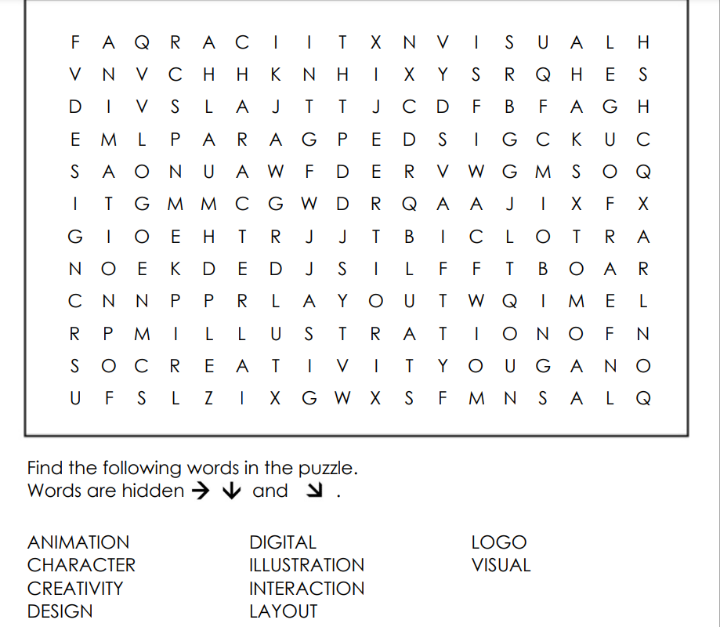

Soft Skills for Video Game and Graphic Design Careers
Directions:
- Read the passage below paying special attention to how the listed soft skills help in these careers.

In the worlds of graphic design and video game design, being a fantastic problem solver and a smart critical thinker can make all the difference. Let's take a closer look at how these skills come into play in various tasks!

Imagine you're a graphic designer. Your job is to make visuals that tell stories and catch people's eyes. Now, picture this: a client wants a logo that represents their company's adventurous spirit. How do you go about it? This is where your problem-solving skills shine. You'll need to think deeply about the company's values and what kind of design matches their message. Critical thinking helps you analyze different colors, shapes, and layouts to create a logo that truly speaks for the company.

In video game design, problem-solving and critical thinking are like secret ingredients that make games exciting. Let's say you're working on a new level of a game. You want players to have fun, but not get frustrated. Here comes the challenge: how do you create puzzles that are challenging yet doable? That's where your critical thinking comes in. You analyze each step, imagining how players will react. Problem-solving helps you design levels with just the right balance of difficulty and reward, making the game engaging and enjoyable.

Moreover, think about the technical side of things. In both careers, you'll face technical glitches from time to time. As a graphic designer, you might encounter issues while turning your design into a printed poster. Here's where your problem-solving skills leap into action. You'll troubleshoot, finding ways to fix the problem and make sure the final product looks perfect. Similarly, as a videogame designer, you might need to figure out why a character in the game isn't moving correctly. Critical thinking guides you as you examine the game's code, seeking solutions to make everything run smoothly.

So, whether you're crafting stunning visuals as a graphic designer or creating adventurous games as a videogame designer, problem-solving and critical thinking are your trusty companions. These skills help you tackle challenges, overcome obstacles, and bring your creative ideas to life in the most amazing ways!

Math Practice
Directions:
- Solve the following problems using simple math operations.

- In a video game, players need to collect coins to win. If Sam collected 8 coins in the first level and 5 coins in the second level, how many more coins does he need to collect to have a total of 25 coins?
- A logo designer is creating 6 different logo sketches. Each sketch takes 10 minutes to complete. How much time will the designer spend creating all 6 logo sketches?
- In a game, players earn points by completing challenges. If Jane earned 15 points in one challenge and 7 points in another, how many points does she have in total?
- Alex is designing a magazine layout with 3 pictures on each page. If he needs to arrange 18 pictures in total, how many pages does he need for the magazine?
- A graphic designer is arranging 15 photos into a grid for a magazine layout. If each row contains 3 photos, how many rows will there be in the layout?
- In a video game, a character can jump 6 spaces at a time. If the character needs to jump 30 spaces to cross a gap, how many jumps will it take?
- Emma created 7 posters for an art event. She sold 3 of them at the event. How many posters does Emma have left?
- In a game, players earned 12 points in the first level and 9 points in the second level. How many points did they earn in total?
- Anna has 14 colors on her digital palette. She used 6 colors to create backgrounds and 3 for characters. How many colors does Anna have left for future designs?
- A graphic designer has 24 stickers and wants to put an equal number of stickers on each of the 4 posters they are creating. How many stickers will be on each poster?

Reflection Exit Slip

In one sentence, describe what you learned in this lesson.

Today, I learned _______________________________________________________________.

Is one of the careers discussed today of interest to you? Why or why not?

I liked / did not like ____________________________________ career because___________

______________________________________________________________________________.

Is there anything you still need help understanding?

What’s one question you have?

Circle the emoji that shows how you feel about your mastery of content in this lesson.

😁 🤩 🥴 😭 😠
Happy Smart Confused Sad Angry

