56. Information Technology Cluster - Computer Technology Careers (4 hours)
Purpose/Abstract: To introduce students to various careers related to Computer Technology.
NCCCS Adult Education Standards: R.4.2.1, W.5.2.1, M.4.2.2
Learning Objective:
By the end of the session, students will be able to:
- Explore a careers website and identify different job titles in computer technology.
- Compare two or three different computer technology roles using informational texts.
- Reflect on personal interests and skills, comparing them to skills and technologies required for roles that are interesting.
Soft Skills | professionalism, critical thinking & problem-solving | Resources | Our commitment to hiring people with disabilities - Google Careers  Information Technology In 4 Minutes  Information Technology Careers | Career Cluster / Industry Video Series  North Carolina Wages: 15-1252.00 - Software Developers  North Carolina Wages: 15- 1232.00 - Computer User Support Specialists  North Carolina Wages: 15-1231.00 - Computer Network Support Specialists  Handouts:  Vocabulary Practice - one for each pair.  Success in Computer Technology - one for each student
Additional Materials
- Vocabulary Practice handout, one for each pair
- Success in Computer Technology handout, one for each student
- Art supplies (glue, glitter, markers, paint, etc.)
- Pencils, paper, and scissors
- Computers for student use
Icons | 💭 Activity ✔Check-In ⟲ Review

PREPARATION
- Review Our commitment to hiring people with disabilities - Google Careers and prepare to explain Accommodations at Google for employees / candidates with disabilities.
- Review the Instructional Support Guide and print/prepare referenced scaffolds.
- Print handouts.
- Familiarize yourself with O*NET
- Familiarize yourself with Skills to Pay the Bills, though it won’t be used directly in this lesson.

INTRODUCTION (45 min)
Welcome students to the class!
Start the lesson by sharing your favorite tech devices / apps and asking students to share their favorite tech devices or apps and explain why they like them.

Play the following videos to introduce students to what Information Technology is and introduce the Information Technology Cluster and the various careers within the cluster.
- Information Technology In 4 Minutes
- Information Technology Careers | Career Cluster / Industry Video Series

Encourage students to ask questions on what they watched and discuss the key takeaways from both the videos.

Explain that today's lesson will explore computer technology careers, including roles at Google for people with disabilities.

VOCABULARY, READING & WRITING (45 min)
Introduce students to a list of computer technology words using the Vocabulary handout.
Distribute the handout and discuss each term with students. After discussions, allow time for students to complete the word search activity to find the listed words.

Distribute the Success in Computer Technology handout and allow time for reading. Emphasize students should pay specific attention to how the soft skills help in these professions.

💭 REFLECTION (15 minutes)
✔ Guide a discussion around the importance of professionalism, problem solving and critical thinking in computer technology careers.

Lower Level | Higher Level
Pair students up for the word search activity | Encourage students to relate to how they can develop these soft skills for careers in Computer Technology.

MATHEMATICS (45 min)

Inform students that they will practice reading data from graphs and tables to understand how wages differ across three different computer technology careers.

Pair students up and share the following links:

Draw this table format on the board:

Role | Computer User Support Specialists | Computer Network Support Specialists | Software Developers
Minimum Wage - NC
Average Wage- NC
Maximum Wage - NC
Minimum Wage - US
Average Wage- US
Maximum Wage - US

Encourage students to interpret the graphs for annual wages on each page and note down the amounts for each as follows in a table.
- What is the minimum annual wage for the role in NC ?
- What is the average annual wage for the role in NC?
- What is the maximum annual wage for the role in NC?
- How does it compare with the graph for wages in the country for this role? I.e. is it less or more by how much is it less or more. Use simple operations to find the difference in wage amounts.

Consider giving one or two examples to explain how students can compare the wages across the two graphs if it is unclear.

Give students the time to explore the wages for these three careers in cities across the state. Show them how to sort the data in the table to understand where wages are higher/ lower.
Move around the room and engage with pairs, posing questions about the information they are inputting into the table to assess their comprehension.

💭 REFLECTION (10 minutes)
✔ Bring the class back together and have a few students share what they understood from the graphs and the tables for any one role.

Lower Level | Higher Level
Pair students with a higher level learner. | Encourage students to plot the information on their table on scaled bar graphs as an extension activity if there is time.

GROUP WORK (60 min)
Explain the concept of equal opportunity employers and highlight why it is important for employers to provide equal employment opportunities.

Inform students that in this section, they will spend time exploring the various career options for those with disabilities at Google.
Divide students into groups of three and share the following link and show students how to use the filters on the left side to identify jobs.

Our commitment to hiring people with disabilities - Google Careers

Ask students to shortlist up to 4 jobs that interest them as a group and summarize the key requirements for the role. Emphasize that students should focus on the soft skills highlighted for each role. Tell them to make note of these skills to share with the class. Allow each group to decide on how they want to present their learnings.
💭 REFLECTION (15 minutes)
Have each group present their findings with the rest of the class. Review why professionalism, problem-solving and critical thinking are important skills for computer technology professions. Encourage students to share how these skills will help them excel in the job postings they researched.

INDEPENDENT WORK TIME (30 min)

Tell students to take time to reflect on their own skills and interests. Have them write a short summary about how their skills align with specific roles discussed in this section. Allow students to read more about the roles they used for wage comparison or watch the video on careers in the IT cluster to help with their reflections.

Have a few volunteers read what they’ve written but consider using this time to encourage more time for reflection.
Lower Level | Higher Level
Write a short paragraph about how their skills align with a specific role. Provide sentence starters. | Challenge students to write a longer reflection, including a plan for acquiring any missing skills.

WRAP-UP & REFLECTION (15 min)

Ask a few students to summarize the key learnings from this session.

Distribute exit slips to students.
Ask for a few volunteers to share their reflections.
Collect and review the answers.

Vocabulary Practice
Directions:
- Learn the words and the definitions with your instructor.
- Find the listed words in the word search grid.

Interface: A way for users to interact with a computer program, software, or device, often involving visual elements and controls.

Browser: A software application that allows users to access and navigate the internet by displaying web pages and websites.

Firewall: A security system that monitors and controls incoming and outgoing network traffic to protect against unauthorized access and potential threats.

Encryption: The process of converting information into a code to prevent unauthorized access, ensuring data privacy and security.

Debugging: The process of identifying and fixing errors or bugs in computer programs to ensure proper functionality.

Operating System: The software that manages computer hardware and provides a platform for software applications to run and interact with the hardware.

Cloud Computing: A technology that allows users to access and use resources, services, and applications over the internet, often without needing to install or maintain software locally.

Malware: Short for "malicious software," malware is software designed to harm or exploit computer systems, including viruses, spyware, and ransomware.

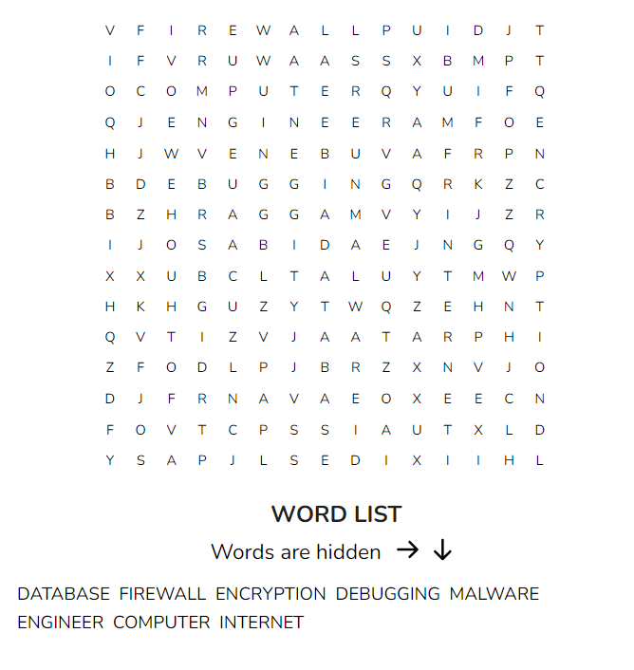

Success in Computer Technology
Directions:
- Read the passage below paying special attention to how the listed soft skills help in these careers.
In the world of Computer Technology, there are skills that are like superpowers. These superpowers help people do amazing things and succeed in their careers. Let's talk about three of these superpowers: professionalism, problem-solving, and critical thinking.

Professionalism: Imagine you're a superhero at work. Just like superheroes follow rules and show respect, professionals in Computer Technology do too. Being professional means being on time, dressing neatly, and communicating politely. It's like having a secret code that tells everyone you're reliable and trustworthy. When you act professionally, you make a good impression on your team and your bosses. This helps you move up in your career and become a leader.

Problem-Solving: Computer Technology is like a puzzle. Sometimes things don't work as planned. That's when problem-solving comes in. It's like being a detective, finding clues and figuring out what's wrong. People who can solve problems quickly become heroes in their jobs. They save time and help their team keep moving forward. When you're good at problem-solving, you become the go-to person for tricky situations.

Critical Thinking: Think of critical thinking as being like a superhero's brain power. It's about looking at things from different angles and making smart decisions. In Computer Technology, you'll face challenges that need creative solutions. Critical thinkers ask questions, gather information, and use their imagination to come up with new ideas. When you can think critically, you stand out in the crowd and get noticed by the big companies.

How These Skills Help: These superpowers aren't just for show. They help you fly high in your career. Being professional shows your team you're serious and ready to take on big projects. Problem-solving helps you fix issues quickly, making you a valuable asset to any company. Critical thinking helps you come up with new ways to do things, making you an innovator. When you have these skills, you become a superhero in the Computer Technology world.

So, remember, if you want to succeed in the exciting world of Computer Technology, be professional, solve problems like a hero, and think critically like a genius. With these superpowers, you'll be ready to conquer any challenge and reach new heights in your career journey.
Reflection Exit Slip

In one sentence, describe what you learned in this lesson.

Today, I learned _______________________________________________________________.

Is one of the careers discussed today of interest to you? Why or why not?

I liked / did not like ____________________________________ career because___________

______________________________________________________________________________.

Is there anything you still need help understanding?

What’s one question you have?

Circle the emoji that shows how you feel about your mastery of content in this lesson.

😁 🤩 🥴 😭 😠
Happy Smart Confused Sad Angry

