70. Marketing, Sales, and Service Cluster- Stock and Merchandising Careers (4 hours)
Purpose/Abstract: To introduce students to stocking and merchandising careers.
NCCCS Adult Education Standards: R.4.2.1, W.5.2.5, M.5.2.1
Learning Objective:
By the end of the session, students will be able to:
- Identify the main tasks involved in stock and merchandising careers, such as receiving, storing, issuing merchandise, and assisting customers.
- Recognize the importance of soft skills in stock and merchandising careers.
- Develop a simple job description for the roles of stockers and order fillers using appropriate vocabulary and language and showcase it on Google Slides.
Soft Skills | communication, teamwork, problem solving & critical thinking | Resources | Stocking and Merchandising- Job Listings  Shipping, Receiving, and Inventory Clerks Career Video  53-7065.00 - Stockers and Order Fillers  Handouts:  Vocabulary Practice - one for each student  Soft Skills in Stock and Merchandising Careers - one for each student  Math Practice - one for each student
Additional Materials
- Vocabulary Practice handout, one for each student
- Soft Skills in Stock and Merchandising Careers handout, one for each student
- Math Practice handout, one for each student
- Art supplies (glue, glitter, markers, paint, etc.)
- Pencils, paper, and scissors
- Computers for student use
Icons | 💭 Activity ✔Check-In ⟲ Review

PREPARATION
- Watch Shipping, Receiving, and Inventory Clerks Career Video and review 53-7065.00 - Stockers and Order Fillers to provide an introduction to the careers.
- Review Stocking and Merchandising- Job Listings and familiarize yourself with the job listings to support students in the group activity.
- Ensure that students have access to a folder on the drive where they can save their Google slides.
- Review the Instructional Support Guide and print/prepare referenced scaffolds.
- Print handouts.
- Familiarize yourself with O*NET
- Familiarize yourself with Skills to Pay the Bills, though it won’t be used directly in this lesson.

INTRODUCTION (30 min)
Welcome students to the class!
Begin with an icebreaker activity: "What's in Your Cart?"
Each student shares an item they would find in their favorite store and briefly explains its use. This introduces the idea of merchandise and shopping.

Discuss the importance of stock and merchandising careers in keeping stores organized and customer-friendly. Explain that today's lesson will explore these careers and the skills needed for success.

Play Shipping, Receiving, and Inventory Clerks Career Video and summarize the key points from the video. Answer any questions that come up.

Share the lesson objectives.

Instructor Note: This lesson will focus on stocking and merchandising careers in non-retail sectors such as stocking shelves in an internal supply room at a factory or stocking shelves at an auto parts store.
VOCABULARY, READING & WRITING (45 min)

Distribute the vocabulary practice handout and allow 20 minutes for students to complete the crossword puzzle.

Quickly review the answers and go over the definitions with the whole class.

Handout the reading passage on Soft Skills in Stock and Merchandising Careers.

💭 REFLECTION (15 minutes)
✔ Have 1-2 students summarize the key points from the passage, ask the following questions to guide a discussion while checking for students’ comprehension.

- What roles do stockers and order fillers play in stores, as mentioned in the passage?
- According to the passage, why is teamwork important in stock and merchandising careers?
- How might disorganization in the stockroom affect the overall shopping experience for customers, and why is this significant for a store?
- What are some of the consequences mentioned in the passage if stockers and order fillers do not communicate or work well as a team?

Lower Level | Higher Level
Pair students up for the crossword and the reading to encourage them to read-aloud to a partner. | Ask students to brainstorm more negative consequences if communication, teamwork, problem solving & critical thinking are not applied in stock and merchandising careers. Encourage them to share it with the rest of the class during the reflection.

MATHEMATICS (45 min)

Inform students that they will continue to practice applying addition and subtraction skills for numbers within 1000. Emphasize that this section aligns with the math standard M.5.2.1, which focuses on representing and solving problems involving addition and subtraction, including multi-step operations.

Explain that the problems presented here will require them to use drawings, equations, or any other strategies to solve real-world scenarios.

Encourage them to think critically and make connections between math and practical situations they might encounter in stock and merchandising careers.

Tell students to show the calculation steps as they work through each problem.

Distribute the math practice handout and walk around to provide individual support to students as required.

💭 REFLECTION (10 minutes)
✔ Review the answers with the whole class and clarify any doubts.

Instructor Note: Though the Math standard mentions addition and subtraction under 100, this exercise is designed for numbers under 1000 because students have had sufficient practice in previous lessons on addition and subtraction.
Lower Level | Higher Level
Work individually with students to model one or two problems. | Challenge students to time themselves to check if they can solve each subsequent problem faster than the previous one.

GROUP WORK (75 min)

Let students know that in this group activity, they will refer to job listings related to stock and merchandising careers and create engaging job advertisements on Google Slides. They will apply their understanding of the job responsibilities, soft skills, and job preferences discussed earlier.

Divide the students into small groups. Each group will be responsible for creating a job ad for a specific job listing related to stock and merchandising careers. Share Stocking and Merchandising- Job Listings and tell each group to select one job listing that interests them the most.

In their respective groups, instruct students to carefully analyze the job listing they have been assigned. Focus on understanding the key details such as job responsibilities, pay, benefits, and requirements. Highlight the relevant soft skills mentioned.

Using Google Slides, instruct each group to create a visually appealing job advertisement. Each ad should include the following elements:

- Job title (e.g., Retail Stocking Associate).
- A brief description of the job responsibilities.
- Highlight the soft skills required for the role (e.g., teamwork, communication).
- Mention the pay rate and any benefits available (e.g., 401(k), health insurance).
- Add images or illustrations to make the ad engaging.
- Group members' names and a group title.
Encourage students to elaborate on the importance of the soft skills mentioned in the job listing. How do these skills contribute to success in the role? Include examples if possible.
💭 REFLECTION (25 minutes)
Once the job ads are completed, each group will present their ad to the class. They should explain why they included specific elements in their ad and how the soft skills are crucial for the job. This presentation should take about 5-7 minutes per group.
✔ After each presentation, facilitate a brief discussion. Ask other students if they would be interested in applying for the job based on the presented ad. Discuss the importance of soft skills in stock and merchandising careers.
INDEPENDENT WORK TIME (30 min)

Share https://www.onetonline.org/link/summary/53-7065.00 and allow time for students to independently read about stockers and order fillers.

During this independent activity, prompt students to not only read about the roles, tasks, and responsibilities of stockers and order fillers but also to actively engage with the content. Encourage them to ask questions and reflect on how the skills required and the tasks and responsibilities involved in these careers align with their own skills and interests.

Inform students that this reflection is an opportunity for them to make personal connections to the content, consider whether a stock and merchandising career might be of interest to them, and potentially identify areas where they excel or areas they would like to further develop. It's a moment for self-discovery and exploration that can inform their future career decisions.

WRAP-UP & REFLECTION (15 min)

Summarize the key points of the lesson, emphasizing the significance of soft skills in stock and merchandising careers and the practical insights gained while analyzing the job descriptions.

Distribute exit slips to students.
Ask for a few volunteers to share their reflections.
Collect and review the answers.

Vocabulary Practice
Directions:
- Match the given words to the clues given below and complete the crossword puzzle:
  - stocking, merchandising, communication, teamwork, customer, organization, responsibility, cooperation
  - Please note that the last square at the end of each word will be blank in this puzzle.

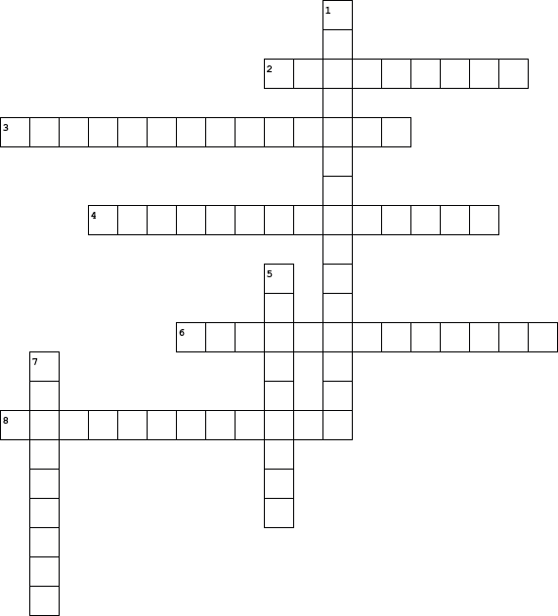

  Across
  2. | A person who buys goods or services from a store or business.
  3. | The act of sharing information or ideas with others through talking, writing, or other means to convey messages and understanding.
  4. | The process of planning and arranging products in a way that makes them attractive to customers, often including displays, pricing, and promotions.
  6. | The arrangement and coordination of activities or items in a systematic and orderly manner to achieve efficiency and effectiveness.
  8. | The act of working together with others in a harmonious and helpful way to achieve a shared goal or task.
  Down
  1. | Being accountable for tasks, duties, or obligations, and making sure they are completed satisfactorily.
  5. | Working together with others to achieve a common goal by combining individual skills and efforts.
  7. | The act of putting items on shelves or racks in a store so that customers can see and buy them.

Soft Skills in Stock and Merchandising Careers

Stockers and order fillers play a crucial role in keeping stores organized and customers satisfied. Good communication helps them answer questions and provide assistance, making shopping a pleasant experience. When stockers and order fillers work well as a team, the store runs smoothly. For example, if they don't communicate, they might place items in the wrong spots, causing confusion for customers. Lack of teamwork can lead to disorganization, making it difficult for everyone.

Stockers and order fillers often interact with customers directly, helping them find products and providing information about sales and promotions. Effective communication is essential in these situations. When they listen carefully to customer needs and respond politely, it creates a positive shopping experience. For example, a friendly stocker who assists a customer in finding a specific item makes the customer feel valued and more likely to return to the store.

Teamwork is not only crucial within the store but also when receiving and organizing merchandise in the stockroom. When stockers and order fillers collaborate efficiently, products are readily available for customers. However, if there's a lack of teamwork in the stockroom, items might be misplaced or take longer to reach the shelves. This can lead to frustrated customers who can't find what they need, impacting the store's reputation. Therefore, having both good communication skills and the ability to work well with colleagues is vital for success in these careers.

Math Practice

- In a stockroom, there were 325 boxes of electronics. If 112 boxes were shipped to another store and 75 more boxes arrived, how many boxes are in the stockroom now?
- The store had 540 candies in stock. They sold 275 candies on Monday and 163 candies on Tuesday. How many candies are left?
- A store had 480 cans of soup in stock. They sold 256 cans and then received 175 more cans in a new shipment. How many cans of soup are there now?
- A toy store received a shipment of 465 action figures. They already had 312 action figures on the shelves. How many action figures are there in total now?
- There were 850 books on the shelves, and 325 more books were added. Later, 275 books were sold. How many books are on the shelves now?
- A store had 650 t-shirts in stock. They received 187 more t-shirts, but then 92 t-shirts were returned by customers. How many t-shirts are there now?
- A hardware store initially had 890 hammers. They sold 217 hammers, received 348 more in a new shipment, and then ordered 45 more. How many hammers are currently in the store?
- In the store's stockroom, there were 764 electronics items. If 325 items were sent for repairs, 189 more were added to the stock, and then 72 were sold, how many electronics items are left in the stockroom?

Reflection Exit Slip

In one sentence, describe what you learned in this lesson.

Today, I learned _______________________________________________________________.

Is one of the careers discussed today of interest to you? Why or why not?

I liked / did not like ____________________________________ career because___________

______________________________________________________________________________.

Is there anything you still need help understanding?

What’s one question you have?

Circle the emoji that shows how you feel about your mastery of content in this lesson.

😁 🤩 🥴 😭 😠
Happy Smart Confused Sad Angry

