71. Science, Technology, Engineering, and Mathematics Cluster - Electrical Engineering Careers (4 hours)
Purpose/Abstract: To introduce students to electrical engineering careers.
NCCCS Adult Education Standards: R.3.2.7, W.5.2.4, M.2.2.7
Learning Objective:
By the end of the session, students will be able to:
- Evaluate the roles and significance of Electrical Engineering careers, based on provided resources.
- Identify essential skills and knowledge required for Electrical Engineering careers using evidence from the resources.
- Explore the interdisciplinary nature of Electrical Engineering by analyzing its connections to various STEM fields
Soft Skills | problem solving & critical thinking | Resources | Applied Engineering Associate's Degree - McDowellTech  Science Technology Engineering and Math (STEM) Careers | Career Cluster / Industry Video Series  Electrical Engineers at My Next Move  Handouts:  Word Search - One for each student
Additional Materials
- Word search handout, one for each student.
- Art supplies (glue, glitter, markers, paint, etc.)
- Pencils, paper, and scissors
- Computers for student use
Icons | 💭 Activity ✔Check-In ⟲ Review

PREPARATION
- Watch Science Technology Engineering and Math (STEM) Careers | Career Cluster / Industry Video Series and prepare an engaging introduction to this cluster.
- Draw or print out a few sets of squares, rectangles and triangles on paper and make copies for students who might require them during the math activity.
- Find a few images of circuit boards, enclosures and casings, switchboards to show students during the math activity.
- Review the Instructional Support Guide and print/prepare referenced scaffolds.
- Print handouts.
- Familiarize yourself with O*NET
- Familiarize yourself with Skills to Pay the Bills, though it won’t be used directly in this lesson.

INTRODUCTION (30 min)
Welcome students to the class!
Inform students that this is the first lesson in the Science, Technology, Engineering, and Mathematics (STEM) cluster. Take a quick survey to check how many students know what STEM careers are and have them share a few examples.

Play Science Technology Engineering and Math (STEM) Careers | Career Cluster / Industry Video Series and summarize the key points from the video. Have students share big questions they have on STEM careers and jot them down on a wall to refer back to during other lessons in this cluster.
Provide a brief introduction to the lesson's objectives and explain that today's focus is on Electrical Engineering careers. Mention that they will also explore the soft skills required for success in these careers.
VOCABULARY, READING & WRITING (60 min)

Distribute the word search handout and explain that these are common words used in electrical engineering careers. Allow 20 minutes for completion.

Share Electrical Engineers at My Next Move and ask students to watch the video at the top of the page. Encourage them to take notes as they watch the video.

Tell students to write down an outline of the key points from the video. Explain that their outline should have different categories or subheadings to capture information from the video. For example, they can have a subheading for qualifications and write down what they learned from the video, another subheading could be skills.

Have them exchange their outlines with a partner to check if any key point is missing. Tell students that this activity will help them actively listen and note down only the key information from a resource. Highlight the importance of being able to outline the key ideas and summarize it in their own words.

💭 REFLECTION (10 minutes)
✔ Ask a few volunteers to share their outlines and their understanding of electrical engineer careers. Summarize the knowledge, skills and abilities required for these careers.

Lower Level | Higher Level
Show students how the page is organized into different categories and includes information discussed in the video. Ask them to model their outline using similar subheadings. | Encourage students to expand key points with additional supporting details they can infer from it wherever possible.

MATHEMATICS (45 min)

To relate Electrical Engineering to mathematics, introduce a hands-on activity where students measure and calculate the perimeter of simple shapes related to Electrical Engineering, like circuit boards or switches. Provide visual aids and step-by-step instructions. Lower-level students can work with simpler shapes, while high-level students can tackle more complex ones.
Begin by explaining to students that in Electrical Engineering, understanding measurements is crucial, especially when designing components like circuit boards and switches. Today's activity will involve measuring and calculating perimeters of these shapes, which is an essential mathematical skill.
Distribute materials such as paper, rulers, and markers. Display visual aids or diagrams of electrical components (e.g., circuit boards, enclosures and casings, switchboards, etc.) on a screen or board. Explain that these are examples of what electrical engineers often do.
Provide step-by-step instructions for measuring and calculating the perimeter. Alternatively, you can have students share the steps based on their practice from earlier lessons.

- Measure the length of one side of the shape using a ruler.
- Record the measurement.
- Continue measuring and recording the lengths of all sides.
- Add up all the side lengths to find the perimeter.

Divide the class into small groups based on their comfort with math skills. For lower-level learners, provide pre-drawn shapes to measure and calculate the perimeter together. For high-level learners, encourage them to draw their shapes and calculate independently.
Walk around and as students complete their measurements, assist them in performing the calculations if needed. Emphasize the importance of accurate measurements in Electrical Engineering.
💭 REFLECTION (10 minutes)
✔ Gather the class and have a brief discussion on what they discovered during the activity. Ask questions like, "Why is calculating perimeter important in Electrical Engineering?" and "How might this relate to designing electrical components?"

Lower Level | Higher Level
Provide pre-drawn sheets with various simple shapes on them such as squares, rectangles and triangles for students to practice. | Offer extension activities such as finding the area of the shapes they've drawn. If there is time, show them how they can divide their complex shapes into simpler shapes like squares and rectangles to help make their calculations simpler.

GROUP WORK (60 min)

Share the third objective and explain that in this activity, students will think about how Electrical Engineering is integrated into their daily lives and how it connects with other STEM fields.
Divide the class into small groups.

Each group will choose a daily scenario from a list provided, such as
- Scenario 1: Charging a Smartphone
- Scenario 2: Turning on a Light Switch
- Scenario 3: Listening to Music on Headphones
Each scenario represents an everyday activity that involves Electrical Engineering.

Tell students to explore the chosen scenario by discussing the following guiding questions within their groups:

- What Electrical Engineering components are involved in this scenario? (e.g., batteries, circuits, wires)
- How do these components work together to make the scenario possible?
- What STEM fields do you think are connected to these components? (e.g., Chemistry, Physics, Computer Science)

Encourage students to use the internet to list out the components for their chosen scenario.
Have them brainstorm how the components work together. Their answers need not be scientific but should demonstrate a basic understanding of who they think chargers, light switches and headphones work.

Tell students to discuss how the Electrical Engineering components are related to other STEM fields or academic disciplines based on their research, within their groups.

💭 REFLECTION (15 minutes)
Have the groups share their findings with the class. After all groups have presented, facilitate a brief class discussion to summarize the interdisciplinary connections discovered. Provide additional details to help explain the connection between different STEM fields. Encourage students to reflect on how Electrical Engineering is a part of our everyday lives.
INDEPENDENT WORK TIME (30 min)

Pair students up.
Share the custom link: Electrical Engineers - Skills, Knowledge and Abilities with students. Allow 15 minutes to read through the information.
After reading, have students take turns discussing with your partner. Encourage them to share their thoughts on the skills and knowledge areas you found most important or interesting for Electrical Engineering careers.
Discuss why these skills and knowledge areas are crucial in this field.

WRAP-UP & REFLECTION (15 min)

Review the key ideas from the lesson. Ask a few volunteers to share what they found interesting in the lesson.

Distribute exit slips to students.
Ask for a few volunteers to share their reflections.
Collect and review the answers.

Word Search
Directions:
- Find the words listed below.
- Words can go in any direction.
- Words do not share letters.

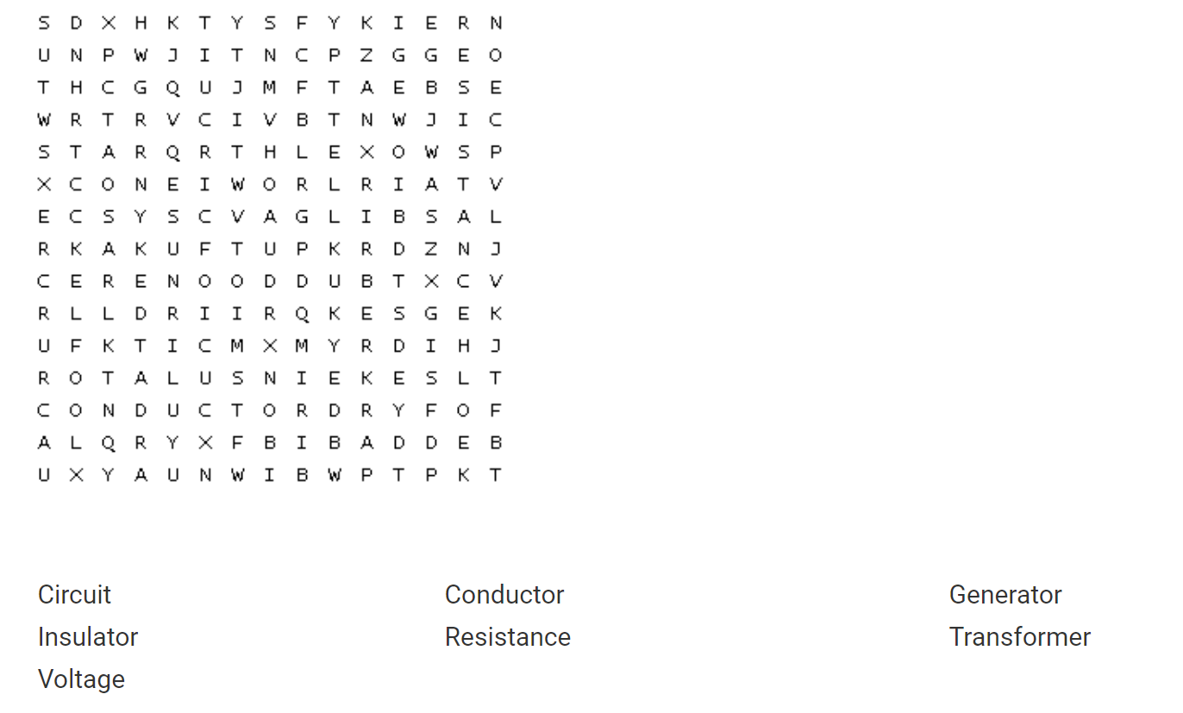

Reflection Exit Slip

In one sentence, describe what you learned in this lesson.

Today, I learned _______________________________________________________________.

Is one of the careers discussed today of interest to you? Why or why not?

I liked / did not like ____________________________________ career because___________

______________________________________________________________________________.

Is there anything you still need help understanding?

What’s one question you have?

Circle the emoji that shows how you feel about your mastery of content in this lesson.

😁 🤩 🥴 😭 😠
Happy Smart Confused Sad Angry

