72. Science, Technology, Engineering, and Mathematics Cluster - Astronomy Careers (4 hours)
Purpose/Abstract: To introduce students to the field of astronomy and the roles and responsibilities of astronomers.
NCCCS Adult Education Standards: R.3.1.5, W.5.1.5, M.2.2.3
Learning Objective:
By the end of the session, students will be able to:
- Explore potential careers in astronomy by researching the roles and responsibilities of astronomers and related professionals.
- Utilize digital tools to publish and share information about the solar system, demonstrating effective communication and teamwork.
- Apply time measurement skills by estimating and recording time intervals in minutes
Soft Skills | Enthusiasm & attitude | Resources | Being an Astronomer: Neil deGrasse Tyson | AMNH  Time to the Minute | Exercise | Education.com  Measuring Time Intervals  Physicists and Astronomers Career Video  Astronomers at My Next Move  Handouts:  Vocabulary Practice - one for each student
Additional Materials
- Vocabulary Practice Handout, one for each student
- Visual aids to help with reading and measuring time
- Art supplies (glue, glitter, markers, paint, etc.)
- Pencils, paper, and scissors
- Computers for student use
Icons | 💭 Activity ✔Check-In ⟲ Review

PREPARATION
- Review Being an Astronomer: Neil deGrasse Tyson | AMNH and prepare to explain new terms and concepts that students might not understand on their own.
- Review the exercise: Time to the Minute | Exercise and the worksheet Measuring Time Intervals on Education.com and prepare scaffolds for students.
- Review the Instructional Support Guide and print/prepare referenced scaffolds.
- Print handouts.
- Familiarize yourself with O*NET
- Familiarize yourself with Skills to Pay the Bills, though it won’t be used directly in this lesson.

INTRODUCTION (30 min)
Welcome students to the class!
Conduct a fun quiz for the students to pique their interest in astronomy before introducing the topic. Divide the class into three groups and ask the following questions. Give each group a chance answer before moving to the next one.
- What is the name of the big ball of fire in space that provides us with light and heat?
- Can you name the planet closest to the Sun in our solar system?
- Earth is also known as the "Blue Planet." Why do you think it's called that?
- What do we call the natural satellite that orbits Earth?
- How many planets are there in our solar system? Can you name at least three of them?
- What is the name of the largest planet in our solar system, known for its big red spot?
- Which famous spacecraft landed on the Moon in 1969 with astronauts Neil Armstrong and Buzz Aldrin?
- Can you name a constellation you've heard of or seen in the night sky?
- What do you find most fascinating or exciting about space or the universe?
Explain that this lesson will introduce students to careers in Astronomy. Share the objectives of the lesson.

Instructor Note:
VOCABULARY, READING & WRITING (60 min)

Share this link with students to read about Neil deGrasse Tyson: Being an Astronomer: Neil deGrasse Tyson | AMNH. Allow 20 minutes for reading. Students can choose to read in pairs or individually.

Tell students to pay attention to text elements such as subheadings, bold print and underlined words to understand how the information is presented. Once they have finished reading, have students write a 100-150 word summary of what they learned about Neil deGrasse Tyson. Encourage them to focus on the key ideas he’s shared through his answers that help learn more about his journey. Allow 15 minutes for writing.

Distribute the vocabulary practice handout. Allow time for completion. Provide students the option to complete the word search during the independent work section if they want to spend time discussing their big questions on space.

💭 REFLECTION (15 minutes)
✔ Have a few students read out their summaries. Ask students to share questions they have/ had about stars, galaxies, and other elements related to space and our universe. Facilitate a quick exchange of ideas and information as students share their big questions.

Lower Level | Higher Level
Encourage students to take notes as they read from the link. Tell them to jot down only the main idea from each answer. | Encourage students to click on hyperlinks in the answers to find more information to write in their summaries.

MATHEMATICS (30 min)

Introduce the concept of time measurement in space missions. Explain that in space, time must be precise for missions to succeed. Unlike on Earth, where we use hours and minutes, space missions often use seconds and tiny fractions of seconds. Highlight that space has vast distances and very high speeds. Even a small timing mistake can push a spacecraft far off course. For example, being just a fraction of a second late can mean missing a target by thousands of miles.

Transition to the math practice by telling students that to be able to measure time in space or for space missions it is essential to have strong foundations in time concepts such as measurement and
estimation of intervals of time. It is also important to master how to tell and write time to the nearest minute and measure time intervals in minutes.

Assign Time to the Minute | Exercise | Education.com to students and allow 15 minutes for completion.

💭 REFLECTION (5 minutes)
✔Review the answers with the whole class and clarify any doubts.

Lower Level | Higher Level
Provide time-telling aids such as a wooden clock, print-outs with different times displayed on them, etc. | Assign Measuring Time Intervals as enrichment practice.

GROUP WORK (75 min)

Inform students that they will create a digital travel brochure or advertisement for a celestial destination in our solar system, aligning with writing standard W.5.1.5, which involves using digital tools for collaborative writing and publishing.
Divide the class into 5 groups ensuring a good mix of students with different abilities.

Provide the following instructions and give explanations as required.

- Research:
- In your group, choose a celestial destination (e.g., Mars, the Moon, Saturn's rings, Europa, any other planet, etc.).
- Use the internet, or available books or encyclopedias to gather facts about your chosen destination, focusing on unique features, and attractions for potential tourists.
- Planning:
- Collaborate within your group to outline key points for your digital brochure or advertisement.
- Discuss and brainstorm creative ideas to make your destination appealing to future space tourists.
- Digital Creation:
- Use digital tools, such as Microsoft PowerPoint, Google Slides, or Canva, to design your travel brochure or advertisement.
- Collaborate within your group, make use of features in the digital tools for real-time editing and sharing.
- Incorporate persuasive text, colorful visuals, and create a professional layout.
- Demonstrate your collaborative writing skills by working together seamlessly within the chosen digital tool.

- Presentation:

- Present your digital travel brochure or advertisement to the class using a projector. Act as if you are real travel agents promoting your celestial destination.
- Ensure to maintain enthusiasm and a positive attitude during your presentation.
Inform students that they can use the following digital tools for collaboration:
- Microsoft PowerPoint or Google Slides for collaborative slide creation.
- Canva for designing visually appealing content.
- Access to computers or tablets for each group to work digitally.

Walk around and observe how students work with each other and step in with suggestions when required.
💭 REFLECTION (25 minutes)
✔Have each group present their travel brochure. Ask questions to understand the choices the group made about what to present and what to skip about their chosen celestial object. Encourage the rest of the class to provide constructive feedback after each presentation.

Instructor Note: Students can use a free version of Canva to get a brochure template. Help them find a template if they choose to explore Canva instead of PowerPoint or Google Slides which they might be more familiar with.

INDEPENDENT WORK TIME (15 min)

Play this video: Physicists and Astronomers Career Video and encourage students to take notes as they watch.

Share Astronomers at My Next Move and tell students to spend a few minutes reading the key points listed on the page about the career.

Instruct students to turn to a partner and share what they learnt about astronomer careers.

WRAP-UP & REFLECTION (15 min)
Ask students to reflect on what they learned about careers in astronomy and the importance of time measurement in space exploration. Encourage them to share their thoughts with the group.
Encourage students to share about their dream job in astronomy and space research and how they can find out more about this job.
Distribute exit slips to students.
Ask for a few volunteers to share their reflections.
Collect and review the answers.

Vocabulary Practice
Directions:
- Find the words listed below.

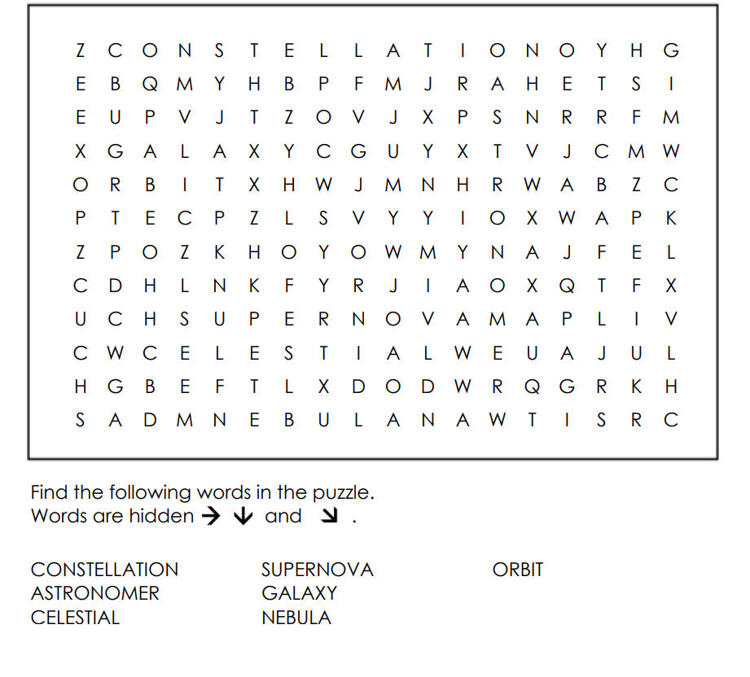

Reflection Exit Slip

In one sentence, describe what you learned in this lesson.

Today, I learned _______________________________________________________________.

Is one of the careers discussed today of interest to you? Why or why not?

I liked / did not like ____________________________________ career because___________

______________________________________________________________________________.

Is there anything you still need help understanding?

What’s one question you have?

Circle the emoji that shows how you feel about your mastery of content in this lesson.

😁 🤩 🥴 😭 😠
Happy Smart Confused Sad Angry

