76. Transportation, Distribution, and Logistics Cluster - Automotive Detailing and Repair Careers (4 hours)
Purpose/Abstract: To introduce students to automotive detailing and repair careers.
NCCCS Adult Education Standards: S.2.1.1, W.5.2.4, M.2.2.7
Learning Objective:
By the end of the session, students will be able to:
- Describe the role of Automotive Body and Related Repairers, emphasizing their responsibilities and express ideas clearly.
- Identify and explain the soft skills required for Automotive Detailing and Repair, gather information from resources, and categorize evidence effectively.
- Collaboratively analyze the 12 steps of detailing and discuss their relevance to the tasks performed by Automotive Body and Related Repairers.
Soft Skills | communication, enthusiasm & attitude, teamwork, networking, problem solving & critical thinking, professionalism | Resources | 12 Steps Of Detailing  Find perimeter when given side lengths (practice)  Automotive Body & Related Repairers at My Next Move  49-3021.00 - Automotive Body and Related Repairers  Handouts:  Parts of a car - one for each group  Vocabulary Practice - one for each group
Additional Materials
- Parts of a Car handout, one for each group
- Vocabulary Practice handout, one for each student
- Toy cars, one for each group
- Art supplies (glue, glitter, markers, paint, etc.)
- Pencils, paper, and scissors
- Computers for student use
Icons | 💭 Activity ✔Check-In ⟲ Review

PREPARATION
- Familiarize yourself with 12 Steps Of Detailing.
- Arrange for toy cars, one for each group for the group activity.
- Review the Instructional Support Guide and print/prepare referenced scaffolds.
- Print handouts.
- Familiarize yourself with O*NET
- Familiarize yourself with Skills to Pay the Bills, though it won’t be used directly in this lesson.

INTRODUCTION (30 min)
Welcome students to the class!
Divide students into groups of 4 and distribute one car parts worksheet to each group. Allow 10 minutes for students to identify and label all the parts in the image. Review their answers using the image below. 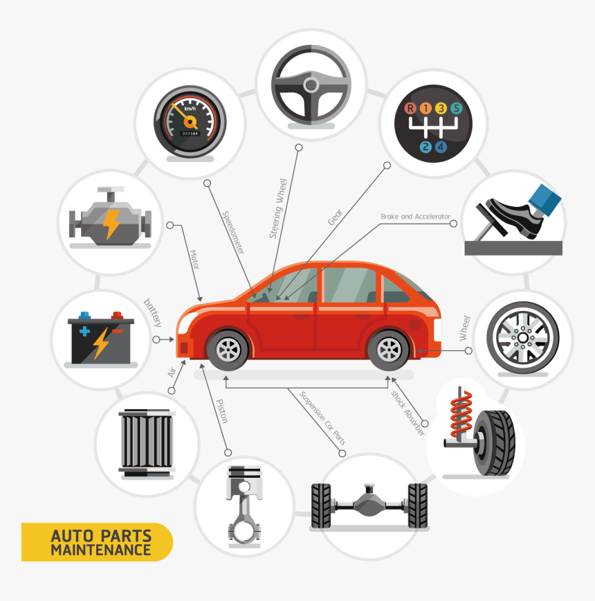
Explain that this lesson is the first lesson in the transportation, distribution and logistics cluster. The lesson will focus on automotive detailing and repair careers.
Play Automotive Body and Related Repairers Career Video and provide a summary of careers in automotive detailing and repair.

Share the objectives of the lesson.

VOCABULARY, READING & WRITING (45 min)

Distribute the vocabulary practice handout and allow time for completion. Inform students that these are common terms used in automotive careers.

Share Automotive Body & Related Repairers at My Next Move with students and tell them to read through the link to understand the responsibilities of repairers. If they want more information, provide the detailed link: 49-3021.00 - Automotive Body and Related Repairers.

Once students have read, ask them to write a brief summary on the responsibilities and skills required for this career. Encourage them to include any inferences they make on the type of people who might enjoy these jobs.

💭 REFLECTION
✔ Ask 2-3 volunteers to read their summaries. Conduct a quick poll to see how many students might be interested in this career. Encourage them to share the reasons for their choices.

Lower Level | Higher Level
Guide students on how to take notes from the easy-read link for each category to draft their summaries. | Ask students to write an extra paragraph on some challenges people in these roles might encounter.

MATHEMATICS (45 min)

Ask students to explain what a perimeter is.

Show students pictures or drawings of different car body shapes, such as a rectangle (common in car frames), a triangle (representing the shape of some car hoods), and irregular shapes (emphasizing real-world complexity).
Demonstrate how to calculate the perimeter of a shape by measuring the lengths of its sides and adding them together. Provide clear and simple examples.

Draw these shapes on the board and label the dimensions as given below. Give students time to calculate the perimeter of each shape individually.

Rectangle:
Length: 10 units
Width: 5 units
Square:
Side Length: 8 units
Triangle (Equilateral):
Side Length: 6 units
Triangle (Scalene):
Side 1 Length: 7 units
Side 2 Length: 5 units
Side 3 Length: 8 units
Irregular Shape (Trapezoid):
Top Base Length: 12 units
Bottom Base Length: 8 units
Height: 4 units
One Slant Side: 10 units
Other Slant Side: 6 units

Once students have completed the exercise, assign Find perimeter when given side lengths (practice) and provide adequate time to solve all the problems. Provide support as required.

Lower Level | Higher Level
Pair students up for these two exercises. | Challenge students to think about how they can calculate the perimeter of the whole car and how this information will help in automotive detailing tasks.

GROUP WORK (60 min)
Inform students that in this section, they will work in small groups to perform car detailing tasks like an automotive body repairer.

Form groups of 3-4 students each. Assign each group a toy car.
Provide the following instructions:

- Using the link: 12 Steps Of Detailing , study the steps together as a group.

- Discuss how each step in the detailing process might relate to the tasks performed by Automotive Body and Related Repairers.
- As a team, practice performing the steps of detailing on the toy car in the correct sequence.

- Be ready to share your group's experiences and insights with the class.

- During your discussion and hands-on practice, emphasize communication and teamwork among group members.

- Remember to actively participate, take notes on your group's progress, and ensure each group member has a role in the hands-on practice.

Walk around and check for understanding at various points during the activity to ensure everyone is engaged, comprehending the material, and successfully completing the hands-on practice.

💭 REFLECTION (15 minutes)
✔ Facilitate a discussion about students’ experience in the activity. Consider asking the following questions:
- How did your group effectively communicate and collaborate during the hands-on practice?
- Did you encounter any unexpected problems, and if so, how did your group solve them?
- How do you think the 12 Steps of Detailing are relevant to the tasks performed by Automotive Body and Related Repairers?
- Did this activity help you better understand the responsibilities and soft skills required in this career field?
- What soft skills, such as communication and teamwork, did you observe or practice during this activity?

INDEPENDENT WORK TIME (30 min)

Inform students that most careers require more than one soft skill in order to excel in them. In this section, students will analyze the role tasks and activities and shortlist the skills they find are best suited for these careers. Give them the following instructions.

- Using the information you’ve learned about the career so far and your observations from the group activity, write a short reflection on which of these soft skills you think are most relevant to automotive detailing and repair careers. Support your choices with examples. Feel free to review Automotive Body & Related Repairers at My Next Move and watch the video to help you shortlist the most relevant soft skills.
- Use this list of soft skills to help you choose: communication, enthusiasm & attitude, teamwork, networking, problem solving & critical thinking, professionalism.

💭 REFLECTION (10 minutes)
✔ Have a few volunteers read their reflections.

WRAP-UP & REFLECTION (15 min)

Ask students to share one new thing they found interesting in this lesson.

Distribute exit slips to students.
Ask for a few volunteers to share their reflections.
Collect and review the answers.

Parts of a Car
Directions:
- Identify the parts of this car that have been blurred out.

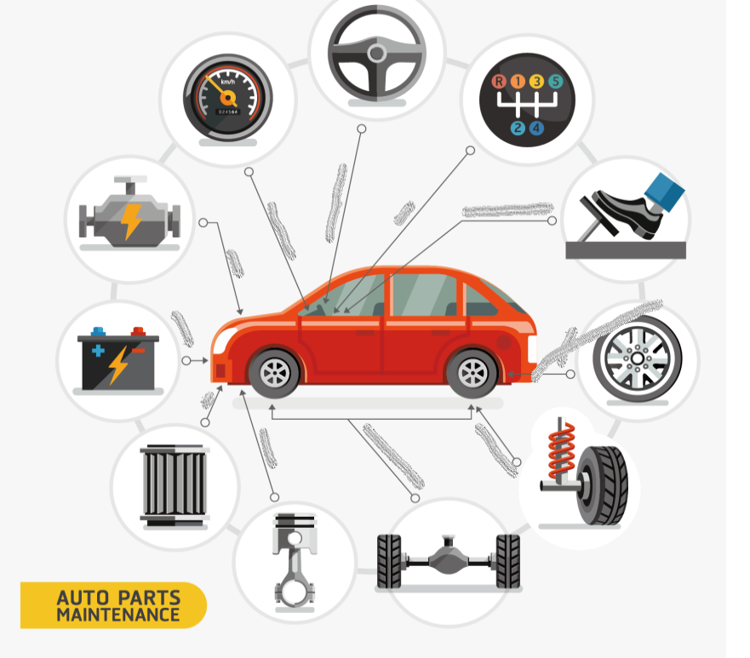

Source: Vector Car Parts, HD Png Download , Transparent Png Image - PNGitem

Vocabulary Practice
Directions:
- Complete the crossword puzzle with these words. Use the clues below to help you fill the puzzle.
  - Chassis, Dent, Wrench, Polish, Alignment, Sanding, Spark Plug, Detailing
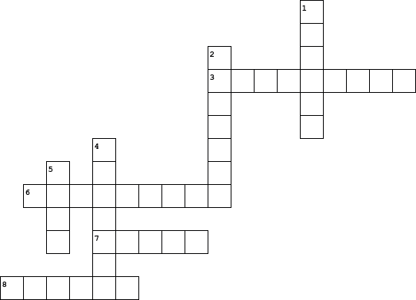

  Across
  3. | Adjustment of a vehicle's wheels to ensure they are parallel and pointing in the correct direction for safe and smooth driving.
  6. | Thorough cleaning, polishing, and restoration of a vehicle's interior and exterior to enhance its appearance and protect its surfaces.
  7. | Plug Component in an internal combustion engine that ignites the air-fuel mixture, essential for starting and running the engine.
  8. | To clean, shine, and improve the appearance of a vehicle's surface, typically using a special substance.
  Down
  1. | Tool used for tightening or loosening nuts and bolts in vehicle repair and maintenance.
  2. | Process of using abrasive materials to smooth or prepare surfaces, often used in vehicle repair and refinishing.
  4. | Framework or structure of a vehicle, including its frame, wheels, and suspension system.
  5. | Shallow depression or damage on the surface of a vehicle caused by impact or collision.
Reflection Exit Slip

In one sentence, describe what you learned in this lesson.

Today, I learned _______________________________________________________________.

Is one of the careers discussed today of interest to you? Why or why not?

I liked / did not like ____________________________________ career because___________

______________________________________________________________________________.

Is there anything you still need help understanding?

What’s one question you have?

Circle the emoji that shows how you feel about your mastery of content in this lesson.

😁 🤩 🥴 😭 😠
Happy Smart Confused Sad Angry

