78. Transportation, Distribution, and Logistics Cluster - Airline and Air Transportation Careers (4 hours)
Purpose/Abstract: To introduce students to entry-level careers in airline and air transportation.
NCCCS Adult Education Standards: R.3.1.1, W.5.1.4, M.2.2.3
Learning Objective:
By the end of the session, students will be able to:
- Analyze common airline and air transportation careers and write a summary on these roles using information from provided resources.
- Evaluate the responsibilities of Cargo and Freight Agents in the airline and air transport industry and demonstrate an understanding of how teamwork and professionalism play a crucial role in their work.
- Compare and contrast the job opportunities at Asheville Regional Airport, with the careers in the airline and air transport cluster.
Soft Skills | Teamwork and professionalism | Resources | Asheville Regional Airport jobs: https://flyavl.com/careers  43-5011.00 - Cargo and Freight Agents  49-3011.00 - Aircraft Mechanics and Service Technicians  53-6032.00 - Aircraft Service Attendants 53-2011.00 - Airline Pilots, Copilots, and Flight Engineers  53-2022.00 - Airfield Operations Specialists  Time | 3rd grade | Math | Khan Academy  Handouts:  Vocabulary practice - one for each student.
Additional Materials
- Vocabulary practice handout, one for each student
- Art supplies (glue, glitter, markers, paint, etc.)
- Pencils, paper, and scissors
- Computers for student use
Icons | 💭 Activity ✔Check-In ⟲ Review

PREPARATION
- Review the third grade time unit on Time | 3rd grade | Math | Khan Academy.
- Familiarize yourself with the current job postings at Career Opportunities | Asheville Regional Airport and prepare to help students during the independent activity.
- Review the Instructional Support Guide and print/prepare referenced scaffolds.
- Print handouts.
- Familiarize yourself with O*NET
- Familiarize yourself with Skills to Pay the Bills, though it won’t be used directly in this lesson.

INTRODUCTION (30 min)
Welcome students to the class!
Have students share their flight experiences or flight travel aspirations. Ask them where they would like to go if they had unlimited airline miles! Share your own experiences and dream destinations.

Introduce the lesson topic and provide a brief explanation on the different airline and air transportation careers that will be explored in the lesson.

Share the lesson objectives.

VOCABULARY, READING & WRITING (45 min)

Distribute the word search handout and give students 15 minutes to complete it. Briefly explain words that are new for students.

Project this informational passage on how teamwork and professionalism helps cargo and freight agents excel in their roles. Have students take turns reading out loud. Pause as required to ask probing questions on what’s being read to keep students engaged. Explain what the words in bold print mean and encourage students to use them in sentences.

Cargo and Freight Agents excel in their tasks and activities within the transportation industry by relying on teamwork and professionalism.

In their daily work, these professionals understand the value of collaboration. They closely collaborate with colleagues, clients, and various transportation companies to ensure the smooth movement of goods. Negotiating and arranging transport involves coordinating efforts with shipping and freight companies, a process where teamwork and effective communication are paramount. They consult with team members to guarantee that each step in the shipping process aligns seamlessly.

Cargo and Freight Agents uphold a high standard of professionalism in their interactions. When advising clients, they provide guidance on optimal shipping methods and rates. Prioritizing accuracy and precision, they meticulously prepare essential shipping documents such as bills of lading and invoices. Their commitment to professionalism is evident in tasks like estimating rates, taking orders, and tracking delivery progress with diligence.

By combining effective teamwork with unwavering professionalism, Cargo and Freight Agents create an environment where goods move efficiently and reliably. Their ability to work closely with others while maintaining a professional demeanor ensures that shipments reach their destinations without complications. This approach not only benefits their careers but also contributes to the overall success of the transportation industry, where collaboration and integrity are key.

💭 REFLECTION (15 minutes)
✔ Have a few students summarize what they read. Guide a discussion about how teamwork and professionalism will help in other careers in this pathway such as: Aircraft Mechanics, Aircraft Service Attendants, Airline Pilots, or Airfield Operations Specialists. Spend some time discussing each role.

Lower Level | Higher Level
Allow extra time for students to read out loud. | Challenge students to list out which other soft skills will help people in these professions and share their reasons.

MATHEMATICS (30 min)

Explain to students that telling time and measuring time are essential skills for the careers being discussed in this lesson because they ensure punctuality in flight schedules, help coordinate time-sensitive shipments, and enable efficient route planning in logistics. These skills are crucial for the success of many careers in the transportation and logistics industry.
Share Time | 3rd grade | Math | Khan Academy with students and assign the ‘Telling Time’ lesson to lower level students to revise and assign the ‘Telling Time Review’ to higher level students. Next, assign the practice to students.

Briefly check-in with students to see how many they got right out of the 7 questions and clarify misconceptions.

Assign Quiz 1 found in the same link to the whole class.

💭 REFLECTION (10 minutes)
✔ Have students share what was easy and what they found difficult.

Lower Level | Higher Level
Have students go through the video lessons before attempting the practice. | If students complete early, encourage them to create time calculation problems for each other.

GROUP WORK (75 min)
Divide students into 4 groups ensuring a balanced mix of abilities.

Assign each group one of the following careers:
- 49-3011.00 - Aircraft Mechanics and Service Technicians
- 53-6032.00 - Aircraft Service Attendants
- 53-2011.00 - Airline Pilots, Copilots, and Flight Engineers
- 53-2022.00 - Airfield Operations Specialists
This activity allows students to focus on a specific career path, gaining a deeper understanding of its intricacies and demands.
Provide the following instructions:

- Gather Information:

- Research and gather information about the assigned career. Use the resources provided earlier in the lesson.
- Focus on key work activities, skills required, and worker abilities for the chosen career.
- Summary Framework:

- Begin with an introduction that briefly describes the career and its importance in the airline and air transport industry.
- Highlight the core work activities that professionals in this career perform daily. Consider questions like:
  - What are the main tasks and responsibilities?
  - How do these tasks contribute to the industry?
- Discuss the skills and qualifications needed for this career. Ask yourselves:
  - What specific skills are crucial to excel in this role?
  - Are there any educational or certification requirements?
- Emphasize worker abilities essential for success. Consider questions like:
  - What personal qualities or abilities are valuable in this profession?
  - How do these abilities help professionals in their work?

- Collaborate and Create:

- Work together as a group to write a clear and concise summary based on your research findings.
- Ensure that each group member has the opportunity to contribute to the content.
- Encourage open communication within the group to clarify information and reach a consensus.
💭 REFLECTION (25 minutes)
✔ Have each group share their summaries. Encourage students to ask questions on the career being presented. .

INDEPENDENT WORK TIME (45 min)

Explain that students will explore career opportunities in a regional airport and compare the listings with careers they explored in the previous section.
Share Career Opportunities | Asheville Regional Airport with students.
Have students individually review the Asheville Regional Airport jobs (provided link) and compare these job opportunities with the careers they learned about earlier in the lesson. If there is no direct match between the careers, encourage students to compare the role summary and wages across the listed careers with what the ones they explored.

Inform students to write a short summary on what they discover. .
Allow sufficient time for students to read through listings that interest them and compare them. Walk around and answer questions or ask probing questions to check that students are able to extract the information required for comparing job postings and careers.

💭 REFLECTION (25 minutes)
For the last 10 minutes in this section, instruct students to turn to a partner and share their findings.
✔ Have a few volunteer pairs share their discussions with the whole class. Facilitate a short discussion on the common skills required for roles in the aviation industry.

Lower Level | Higher Level
Encourage students to identify similarities and differences between the job opportunities at the airport and the careers they studied. They can make a list. | Challenge students to write a brief essay discussing the job opportunities at Asheville Regional Airport and how they relate to the airline and air transport careers they analyzed earlier.

WRAP-UP & REFLECTION (15 min)

Emphasize the importance of communication, professionalism, and teamwork in these careers. Stress the value of staying curious and keeping up-to-date with careers that interest them from all the lessons so far.
Summarize the key learnings from the lesson.
Have students share one thing they found interesting in the lesson.

Distribute exit slips to students.
Ask for a few volunteers to share their reflections.
Collect and review the answers.

Vocabulary Practice
Directions:
- Find the words listed below.

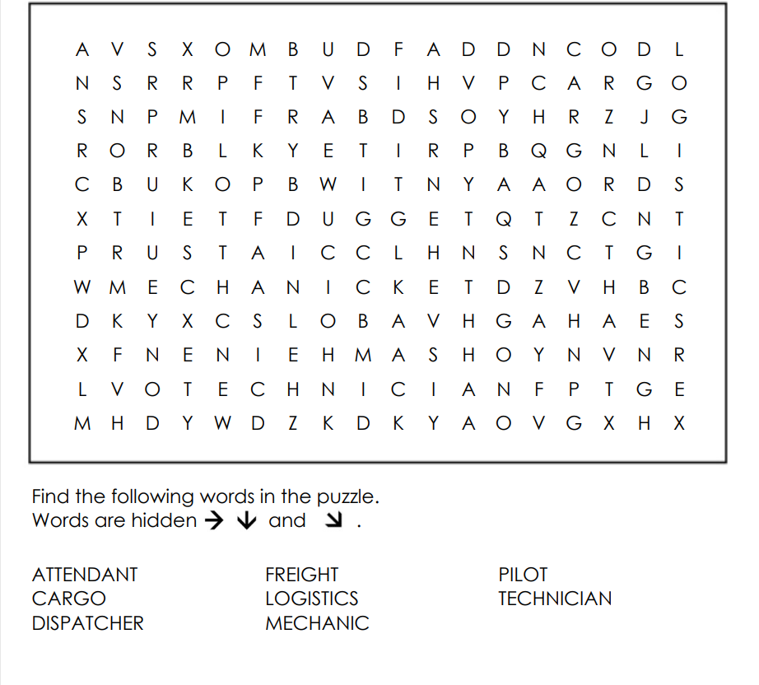

Reflection Exit Slip

In one sentence, describe what you learned in this lesson.

Today, I learned _______________________________________________________________.

Is one of the careers discussed today of interest to you? Why or why not?

I liked / did not like ____________________________________ career because___________

______________________________________________________________________________.

Is there anything you still need help understanding?

What’s one question you have?

Circle the emoji that shows how you feel about your mastery of content in this lesson.

😁 🤩 🥴 😭 😠
Happy Smart Confused Sad Angry

