Landscaping and Groundskeeping Careers (4 hours)
Purpose/Abstract: To introduce students to the different career families
NCCCS Adult Education Standards: R.3.1.5, R.3.3.5, W.1.2.4, W.5.1.1.,M.1.2.5
Learning Objective:
By the end of the session, students will be able to:
- Identify common objects used in landscaping and groundskeeping careers
- Describe the common duties of landscapers and groundskeepers
- Brainstorm potential avenues for employment as a landscaper or groundskeeper
Soft Skills | professionalism | Resources | Landscaping & Groundskeeping Workers at My Next Move (direct students to this link for the group activity)  37-3011.00 - Landscaping and Groundskeeping Workers (direct students to this link for additional information about the job)  Handouts:  - Vocabulary Words - 1 for each student  - Reading Comprehension - 1 for each student  - Role Play - Professionalism - 1 for each pair
Additional Materials
- Reading Comprehension handout, 1 for each student
- Vocabulary Words handout, one for each student
- Role play handout, one for each pair
- Old magazines, for the group activity
- Art supplies (glue, glitter, markets, etc.)
- Pencils, paper
- Computers for student use
Icons | 💭 Activity ✔Check-In ⟲ Review

PREPARATION
- Ahead of the lesson, assign students this game from Education.com to practice area calculations and download/print the following worksheets:
  - Shady Shapes: An Area Activity | Worksheet | Education.com
  - Area: Counting Unit Squares | Interactive Worksheet | Education.com
- Review the Instructional Support Guide and print/prepare referenced scaffolds.
- Print handouts.
- Familiarize yourself with the OneStop Career Clusters.
- Familiarize yourself with O*NET
- Familiarize yourself with Skills to Pay the Bills, though it won’t be used directly in this lesson.

INTRODUCTION (20)
Welcome students to the class!

Conduct a quick icebreaker activity such as ‘Name and Gesture’ to help students get comfortable in the classroom. Have students stand in a circle. The first student starts by saying their name and performing a simple gesture. The next student in the circle, repeats the first student’s name and gesture and adds their own name and gesture. This continues around the circle until all students have had a chance to participate.
Tell students that in this lesson they will continue exploring careers within the agriculture, food, and natural resources cluster.

Introduce the topic of landscaping and groundskeeping careers by asking students if they have ever worked in a garden, helped mow a lawn, or seen a park being maintained.

Ask what tools they remember seeing, what kind of work was being done, and who was doing it. If students are reluctant to share directly, encourage them to discuss their answers with someone next to them.

Explain that today's lesson will explore different jobs related to landscaping and groundskeeping, the tools and equipment used, and the skills needed to do the work.
Review the objectives and briefly explain what will be covered during the lesson.

Instructor notes:
Be sensitive to students’ needs and willingness/reluctance to share at any point, and verbalize that your classroom is a safe space.
VOCABULARY, READING, and WRITING (60 minutes)
💭 VOCABULARY (25 minutes)

Distribute handouts with key vocabulary words and corresponding images related to landscaping and groundskeeping, such as soil, mulch, edger, mower, hedge trimmer, and leaf blower.

Ask participants to cut out each image and word separately.
Instruct the participants to match each vocabulary word with the corresponding image by gluing them side by side on a blank sheet of paper. After all the words and images have been matched, review each word and image as a group and have students read through the definitions as a class.
Ask 2-3 volunteers to share how they might use these tools.

Instructor notes: Provide pre-cut images and words on a separate sheet of paper for students who might have low fine motor skills. Provide tape as an alternative to glue for students who might have difficulty using glue sticks.
💭 READING COMPREHENSION (25 minutes)
Pair students up for the reading comprehension activity.
Provide each pair with a copy of the comprehension passage and questions.
Instruct the pairs to take turns reading the article aloud to each other. Encourage them to stop and ask questions or clarify information as needed.
After each partner has had a chance to read the passage, ask them to individually write the answers to the comprehension questions in the handout.
Once the students have finished filling in the answers, have them share their answers with their partner and discuss any differences or similarities in their interpretation of the passage.
Allow 20 minutes for this activity.

💭 REFLECTION (10 minutes)
✔ Facilitate a short discussion about the passage and encourage students to share their responses to the comprehension questions.
Instructor notes: Not all students might be willing/able to write, so allow them to draw their responses or share them verbally.

Lower Level | Higher Level

Provide sentence starters to help them write the answers as specified in the handout. Allow students to draw their responses or share the answers verbally with their partner. | Encourage students to write a paragraph about the safety measures they can take while working with landscaping tools.

MATHEMATICS (45 min)

Introduce students to the concept of area in relation to landscaping and groundskeeping and inform them that they will be practicing calculating the area of a plane figure using square units.

Explain that area is a way to measure the size of a space or a surface. In landscaping and groundskeeping, it is important to understand the concept of area because it helps us determine the amount of materials we need to cover a certain surface, such as soil, mulch, or grass. By knowing the area of a space, we can also calculate the amount of time and effort it may take to complete a task, such as mowing the lawn or trimming hedges

Share a few examples on the board as given in this worksheet to explain these concepts:
- A square with a side length 1 unit, called “a unit square,” is said to have “one square unit” of area, and can be used to measure area.
- A plane figure which can be covered without gaps or overlaps by n unit squares is said to have an area of n square units.
- Measure areas by counting unit squares (square cm, square m, square ft and improvised units).
Assign this worksheet to students to solve by themselves, and once they are finished, review the answers with the whole class.

Assign the following game to students to provide additional practice and answer any questions they have.
- Game 1
💭 REFLECTION (10 minutes)
✔ Have 2-3 volunteers share what they understand about the area and how to calculate the area of a plane figure.

Wrap up this section by asking students to share why this knowledge is important in landscaping and groundskeeping occupations.
Lower Level | Higher Level
Consider pairing students up if required. | Encourage students to use rulers to measure the area of objects around the classroom, like desks, their notebooks, the board, and other flat surfaces.

GROUP PROJECT (60 min)

💭 RESEARCH and PRESENTATION

Tell students they will work in groups to read about landscaping and groundskeeping jobs and apply what they read to create an advertisement for these jobs.

Divide the class into groups of 4 and share this easy read link with each group. Tell them to select one job title from the list on the page to create the advertisement. Encourage students to refer to this link to get more information about the tasks, activities, and skills required for the jobs.
Give each group access to materials such as paper, markers, colored pencils, scissors, glue, magazines, and any other art supplies they may need. Alternatively, allow groups to design their advertisements digitally using graphic design software or online tools if they’re comfortable using them. Instruct the groups to create an advertisement that stands out visually. Encourage them to use colors, images, and fonts that are attention-grabbing but still maintain readability. Remind the groups to prominently display the selected job title in their advertisements. They can use bold or larger font sizes to make it more noticeable.
Instruct the groups to include key information about the tasks, activities, and skills required for the job. They should clearly and concisely communicate what the key tasks of the job are and what qualifications are necessary. Encourage the groups to include any other relevant information they think would appeal to potential applicants. This could include the perks or benefits of the job, career growth opportunities, a brief description of the company or organization, or any unique selling points that make the job attractive.

While working in their groups, ask students to reflect on how professionalism will help them excel in these roles. Tell them to think about what professionalism might look like while performing tasks in these jobs.

Allow 35 minutes for this activity.

💭 REFLECTION (20 minutes)
✔ Have each group present their advertisement to the rest of the class.

Ask students to brainstorm where they can get employment as landscapers or groundskeepers, and have a few students share their answers. Add to students’ answers with this list and guide a short discussion about how they might apply for these jobs.
- Private landscaping companies: Private landscaping companies offer a range of services, such as lawn maintenance, tree care, hardscaping, and garden design. They may specialize in residential or commercial properties, or both, and often hire groundskeepers and landscapers to perform various tasks, such as mowing lawns, planting flowers, pruning trees, and installing outdoor features.

- Government agencies: Government agencies, such as parks and recreation departments, public works departments, and schools, often employ groundskeepers and landscapers to maintain outdoor spaces, such as parks, playgrounds, athletic fields, and campuses.

- Golf courses: Golf courses require extensive groundskeeping and landscaping to maintain the greens, fairways, and other outdoor areas. They often hire groundskeepers and landscapers to perform tasks such as mowing, fertilizing, and watering the grass, maintaining sand traps and hazards, and planting flowers and trees.

- Residential or commercial properties: Many homeowners and businesses hire groundskeepers and landscapers to maintain their outdoor spaces, such as lawns, gardens, and patios.

- Self-employment: Some groundskeepers and landscapers choose to start their own businesses and offer their services to residential and commercial clients.

Lower Level | Higher Level

Consider assigning roles within the groups to ensure all students contribute to creating an advertisement. Allow more time for reflection on the importance of professionalism in these jobs. | Encourage students to look for career growth opportunities in these jobs and share the information wit the rest of the class.

PARTNER WORK TIME (45 min)
Reiterate why professionalism is an important skill while working in landscaping and groundskeeping careers, and share a few examples of what might happen if the worker is not professional.

Pair students up and have them practice the role play on professionalism, taking turns to play the role of Jade.

Allow 20 minutes for the role play.

After both partners have had a chance to act, bring the class back together and ask the following questions to guide a discussion. Encourage students to share additional reasoning for their answers.

- What might have happened if Jade had argued back when she received the feedback?
- What would happen if Jade was regularly late for work?
- Why is it important for Jade to speak politely to her clients?
- How would you respond if a client told you that your work on their lawn was not good?

Ask students to share how they might demonstrate professionalism in their jobs. What are some actions they can take? How might it look every day on the job?

Lower Level | Higher Level
Allow for extended time for the role play and discussion. If necessary, repeat the role play and provide guidance as needed. Consider modeling how to use the script for the role play. | If there is additional time, build upon the initial role play by introducing more complex scenarios that require higher-level thinking and problem-solving skills. For example, present a situation where a client is dissatisfied with the work and the worker needs to navigate a challenging conversation to resolve the issue while maintaining professionalism.

WRAP-UP & REFLECTION (10 min)
⟲REVIEW
Ask students to share what they find most exciting about the occupations they researched today.
Encourage them to share what challenges they anticipate in these jobs and how they might overcome them.
Distribute exit slips to students.
Ask for a few volunteers to share their reflections.
Collect and review the answers.

Instructor notes:
Inform students that the reflection slip will be the same after every lesson. Take some time to review each question on the slip and pause for student questions. Provide any assistance completing the slips for this and the next few classes until students are comfortable with the process.

Vocabulary Words
Name: ______________________ Date: _________________

Directions:
- Cut the given images out and paste them on a blank piece of paper.
- Label each image with the right word from the list below.
- Read through the definition of each word and think about how you will use it during landscaping and groundskeeping tasks.

Words and Definitions

Edger | An edger is a gardening tool used to create clean, sharp edges along garden beds, walkways, and other areas where grass meets a hard surface like concrete or pavement.
Shovels | These are used for digging holes, moving soil, and planting.
Leaf blowers | Leaf blowers are used to blow leaves and other debris off of lawns, sidewalks, and other surfaces.
Mulch | Mulch is a layer of organic or inorganic material that is spread over the soil to help regulate temperature, conserve moisture, suppress weed growth, and improve soil health.
Wheelbarrows | Wheelbarrows are used for moving heavy loads of soil, rocks, and other materials.
Soil | Soil is the natural material that covers the earth's surface and is made up of organic and inorganic matter. It is the foundation for plant growth and serves as a home to many different types of living organisms.
Hedge trimmer | A hedge trimmer is a gardening tool used to trim and shape hedges, bushes, and other plants. It typically has a set of sharp blades that move back and forth, allowing the user to make precise cuts and create a clean, uniform look.
Mower | A mower is a gardening tool that is used to cut grass or other plants to a desired height. It can be powered by electricity, gasoline, or human effort, and is commonly used to maintain lawns, fields, and other outdoor areas.

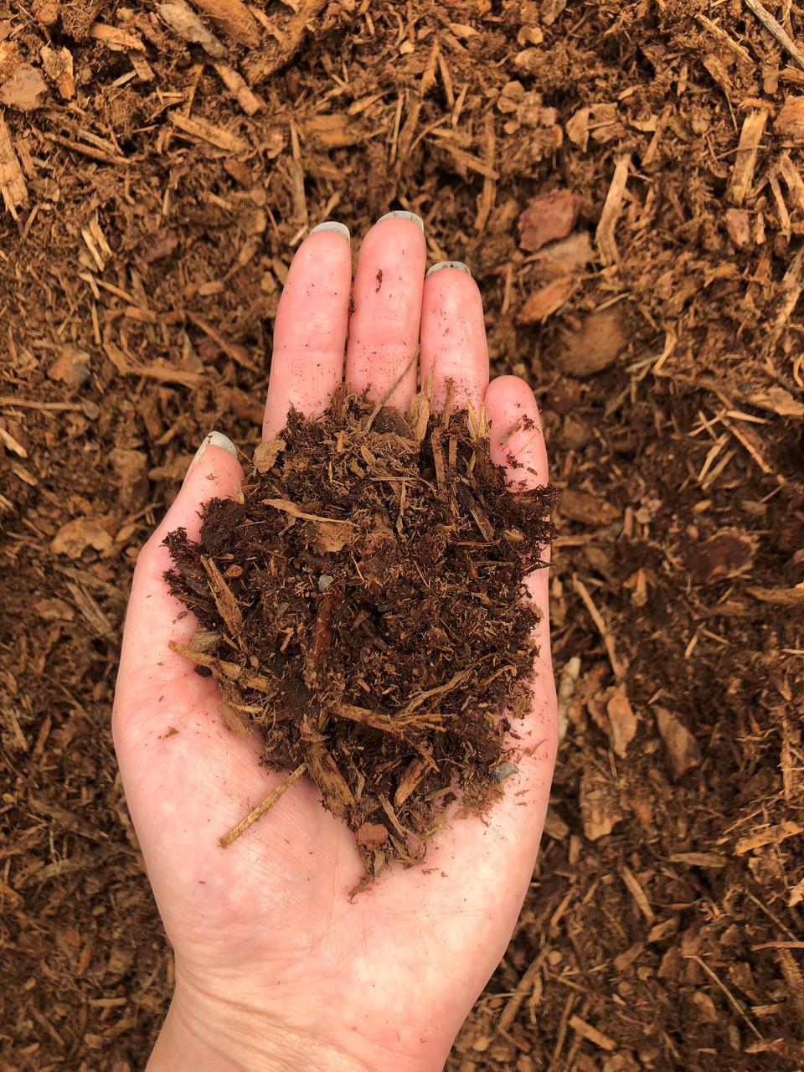 | 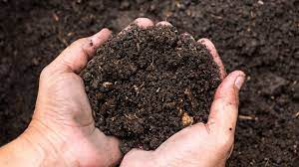
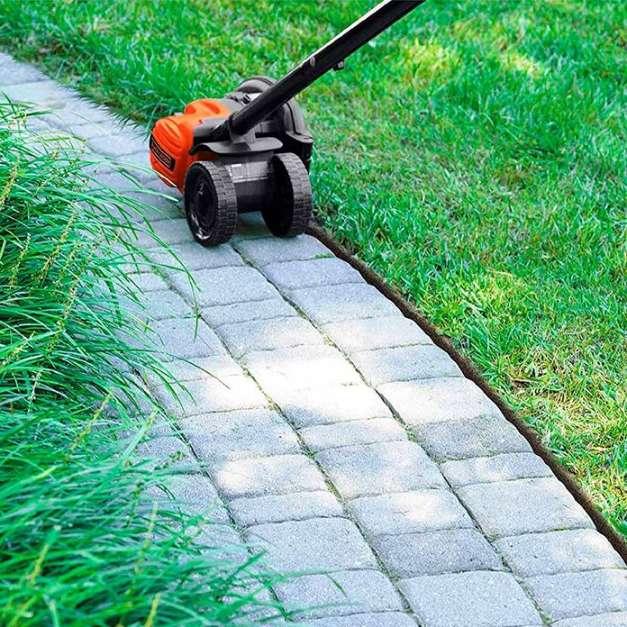 | 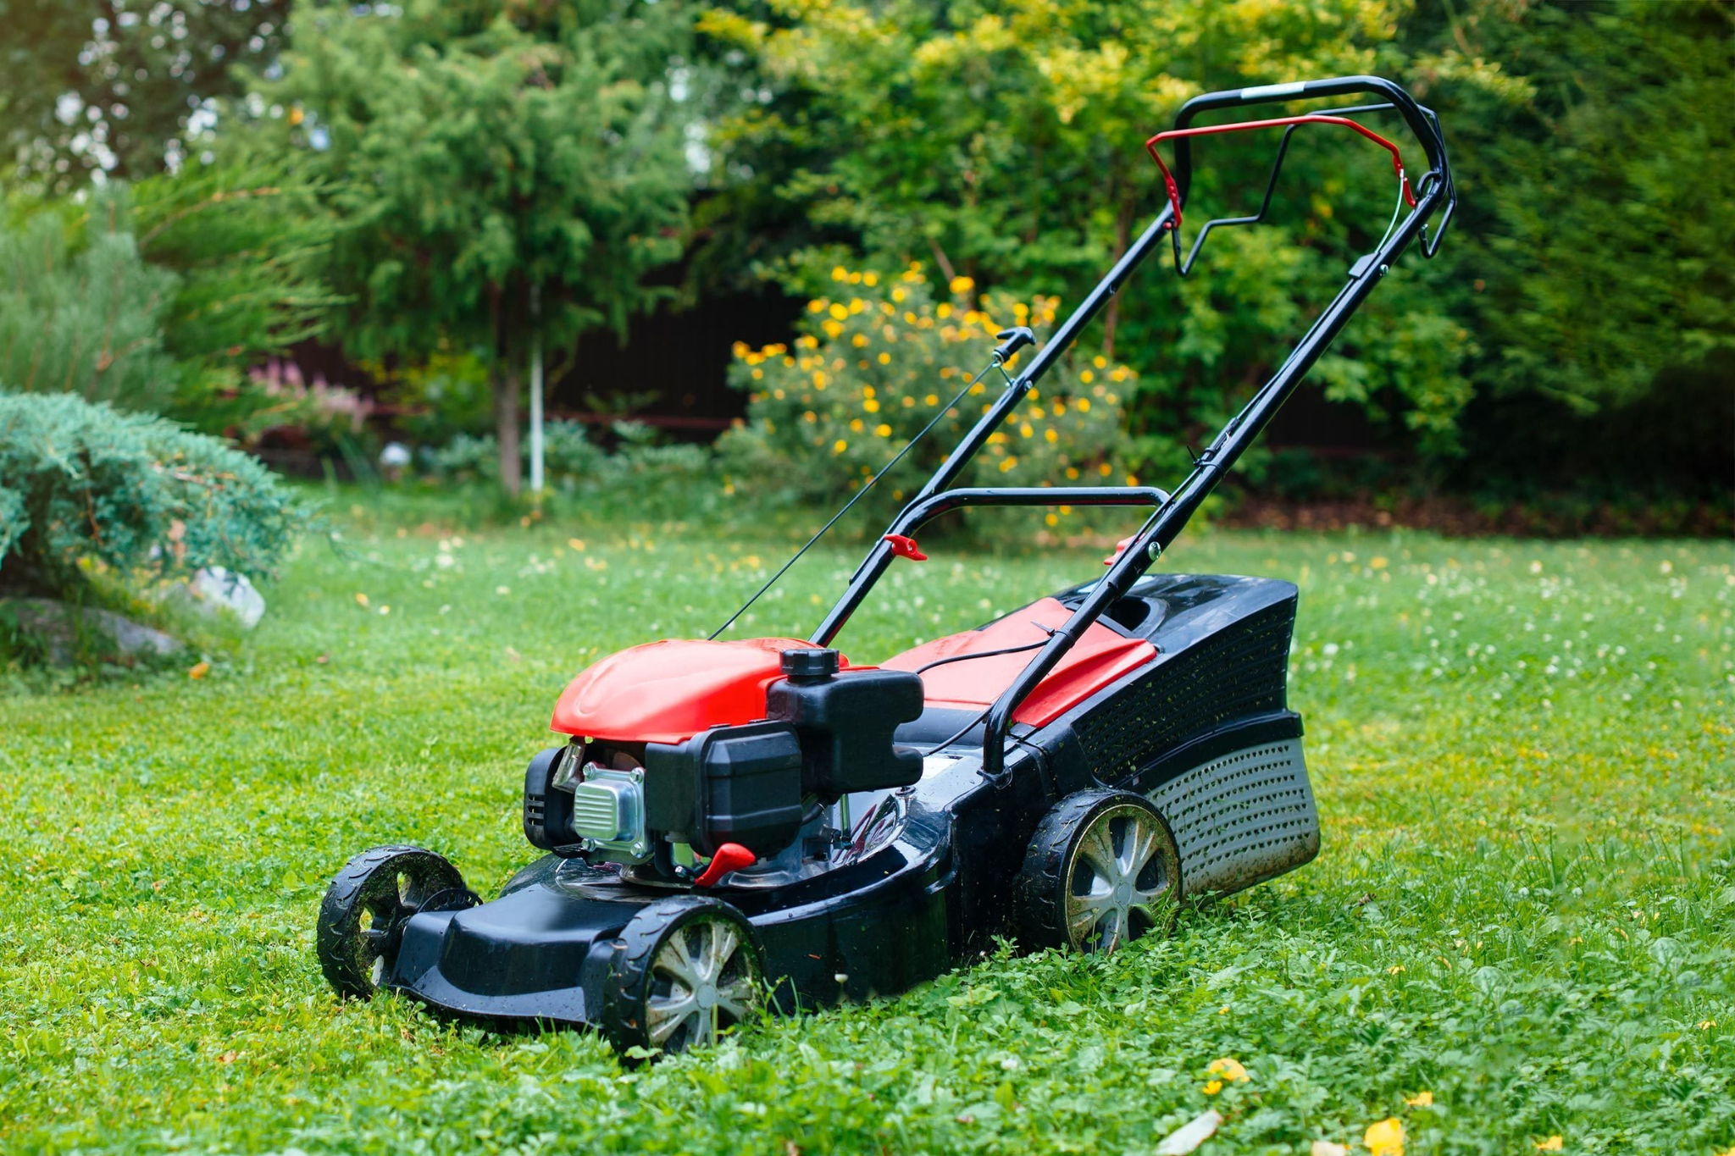
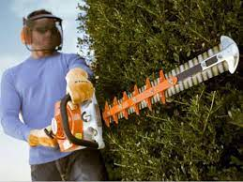 | 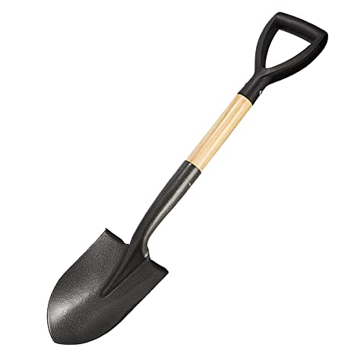
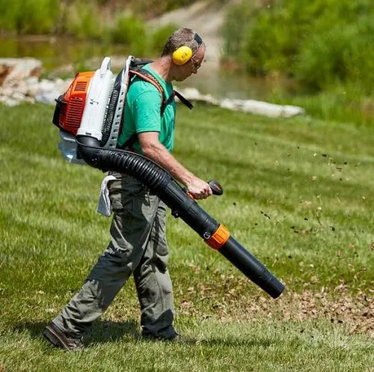 | 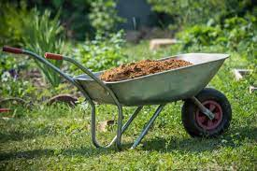

Reading Comprehension
Name: ______________________ Date: _________________

Directions:
- Read the passage out loud to your partner.
- Write down the answers to the questions in the space provided, independently.
- After writing all the answers, discuss them with your partner.
- Ask your instructor for help if you need it.

The Job Duties of a Landscaper or Groundskeeper

A landscaper or groundskeeper is someone who takes care of outdoor spaces like parks, gardens, and yards. They do a lot of different things to keep these spaces looking nice and healthy.

One of the main job duties of a landscaper or groundskeeper is mowing the lawn. They use a special machine called a lawn mower to cut the grass to a certain length. They also use edgers to trim the grass around sidewalks and trees.

Another job duty is planting flowers, trees, and bushes. Landscapers and groundskeepers choose the right plants for the space and climate, then dig holes and plant them. They also water and fertilize the plants to help them grow.

A third job duty is pruning or trimming trees and bushes. This involves cutting off branches that are dead or overgrown, so that the plant stays healthy and looks neat.

Landscapers and groundskeepers also do other jobs like raking leaves, picking up litter, and clearing snow in the winter. Their work is important because it helps keep outdoor spaces safe, healthy, and beautiful for people to enjoy.
Questions:
- What is pruning ?
- Who is a landscaper or groundskeeper?

- What are some of the main job duties of a landscaper or groundskeeper?
- What does the word "fertilizer" mean in this passage?
a) A tool used to cut grass
b) A chemical used to make plants grow better
c) A type of flower
d) A piece of equipment used to move dirt

Reading Comprehension
Name: ______________________ Date: _________________

Directions:
- Read the passage out loud to your partner.
- Write down the answers to the questions in the space provided, independently.
- After writing all the answers, discuss them with your partner.
- Ask your instructor for help if you need it.

The Job Duties of a Landscaper or Groundskeeper

A landscaper or groundskeeper is someone who takes care of outdoor spaces like parks, gardens, and yards. They do a lot of different things to keep these spaces looking nice and healthy.

One of the main job duties of a landscaper or groundskeeper is mowing the lawn. They use a special machine called a lawn mower to cut the grass to a certain length. They also use edgers to trim the grass around sidewalks and trees.

Another job duty is planting flowers, trees, and bushes. Landscapers and groundskeepers choose the right plants for the space and climate, then dig holes and plant them. They also water and fertilize the plants to help them grow.

A third job duty is pruning or trimming trees and bushes. This involves cutting off branches that are dead or overgrown, so that the plant stays healthy and looks neat.

Landscapers and groundskeepers also do other jobs like raking leaves, picking up litter, and clearing snow in the winter. Their work is important because it helps keep outdoor spaces safe, healthy, and beautiful for people to enjoy.
Questions:
- What is pruning ?
- Who is a landscaper or groundskeeper?

- What are some of the main job duties of a landscaper or groundskeeper?
- What does the word "fertilizer" mean in this passage?
a) A tool used to cut grass
b) A chemical used to make plants grow better
c) A type of flower
d) A piece of equipment used to move dirt

Role Play - Professionalism

Professionalism
Scenario: Jade has her first job mowing lawns. She works for her best friend’s brother, who owns a landscaping company. She’s had the job for about three weeks and really feels like she’s getting into the groove. In fact, it’s the perfect job for her: she loves being outside and appreciates the fact that she can work on her own and even listen to her favorite podcast! Jade arrives early at Mr. Z.’s house (her first customer of the day) and gets ready to begin mowing.

Mr. Z.: You’re finally here!

Jade: Hi, Mr. Z. Yes, I’m here to mow your lawn.

Mr. Z.: Well, you didn’t do a very good job last week.

Jade: I’m sorry, Mr. Z. I wasn’t the one who mowed last week, but what did you not like about how it was mowed?

Mr. Z.: It was just a mess!

Jade: Can you be more specific? How was it a mess?

Mr. Z.: Well, it looked just awful.

Jade: I really want to make sure whatever upset you last time doesn’t happen again. If you tell me exactly what you didn’t like, I can be sure your lawn is mowed just how you like it.

Mr. Z.: Well, the cut grass was left on the lawn, and the edges weren’t straight.

Jade: Okay, I understand. You want us to be sure we rake and remove the cut grass and do a better job on the edging. Is that right?

Mr. Z.: Yes, that is exactly what I expect!

Jade: Mr. Z., I will be sure to do those things today. Thank you, sir!

Mr. Z.: Thank you very much.

How does Jade demonstrate professionalism when speaking with Mr. Z?
Reflection Exit Slip

In one sentence, describe what you learned in this lesson.

Today, I learned _______________________________________________________________.

Is there anything you still need help understanding?

One question I have is…

Circle the emoji that shows how you feel about your mastery of content in this lesson.

😁 🤩 🥴 😭 😠
Happy Smart Confused Sad Angry

